**OBJECT AND FACE RECOGNITION**

**Visual imagery**

Visual imagery: ability to visually recovers some images in our brain

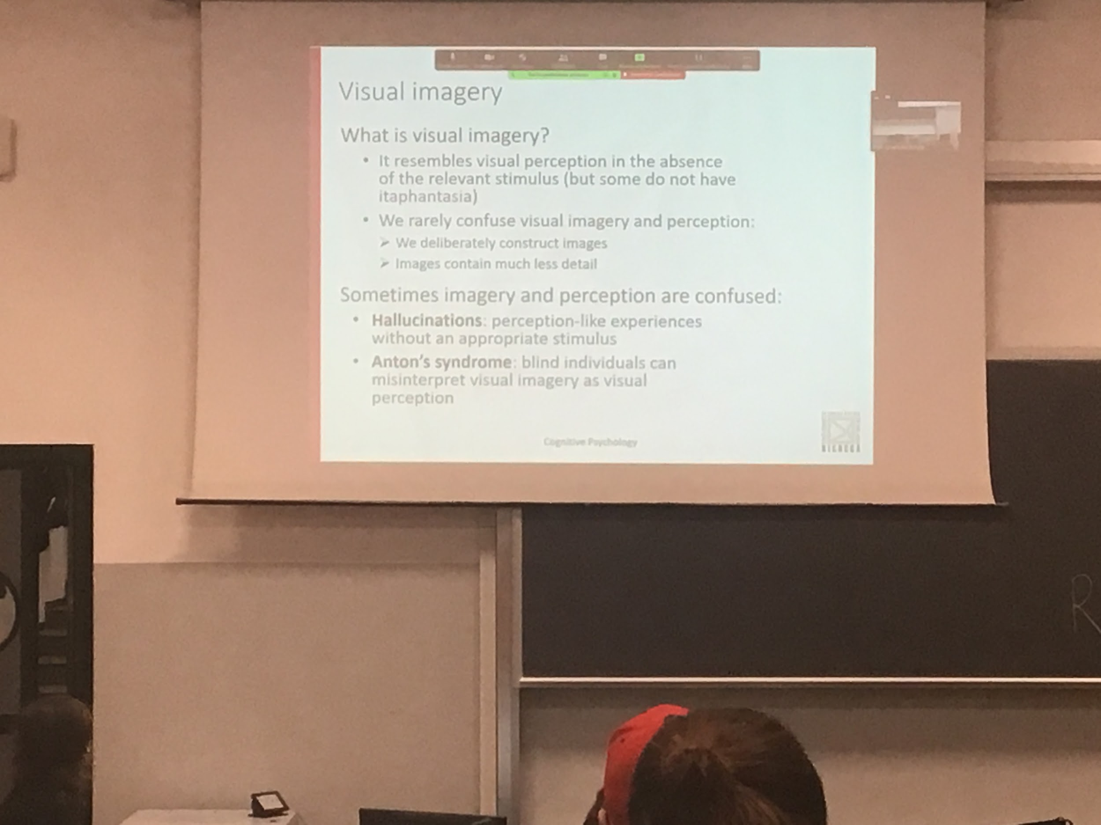

There is differences on how we feel

**Visual imagery**: our ability to visually recovers some images in our brain, visual representation without stimuli from the outside word

Without eyes close we can recall some visual imagery, but we know is not real even if we have many details

**Imagery is not allucionation**: hallucination is we think there is something in front of us, these happens with some psychiatric disease

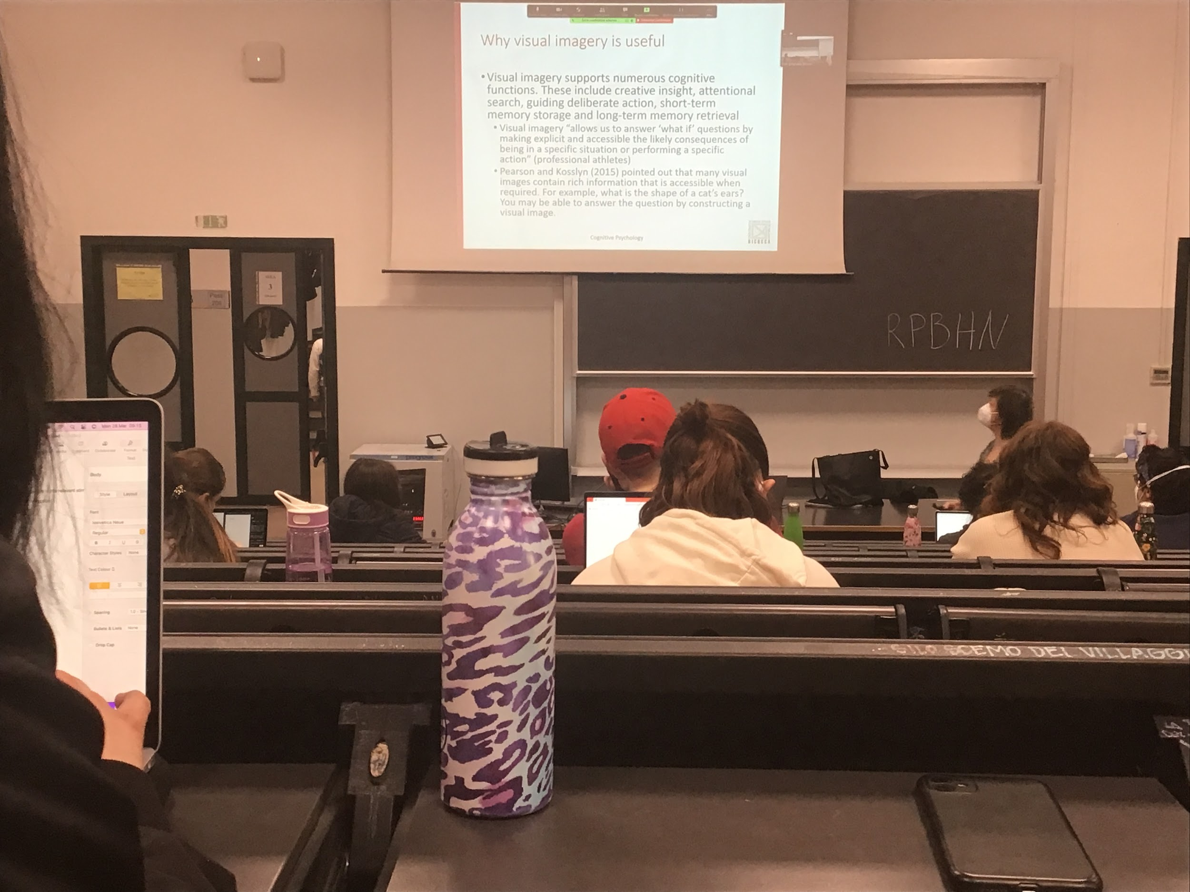

Being able to recall some visual imagery help us in reasoning, looking for some informations in real life, do prospective, programming what is going to happen soon

Visual imagery is used a lot in professional athletes, in many sport

They immagine what they will do, this is training to improve performance

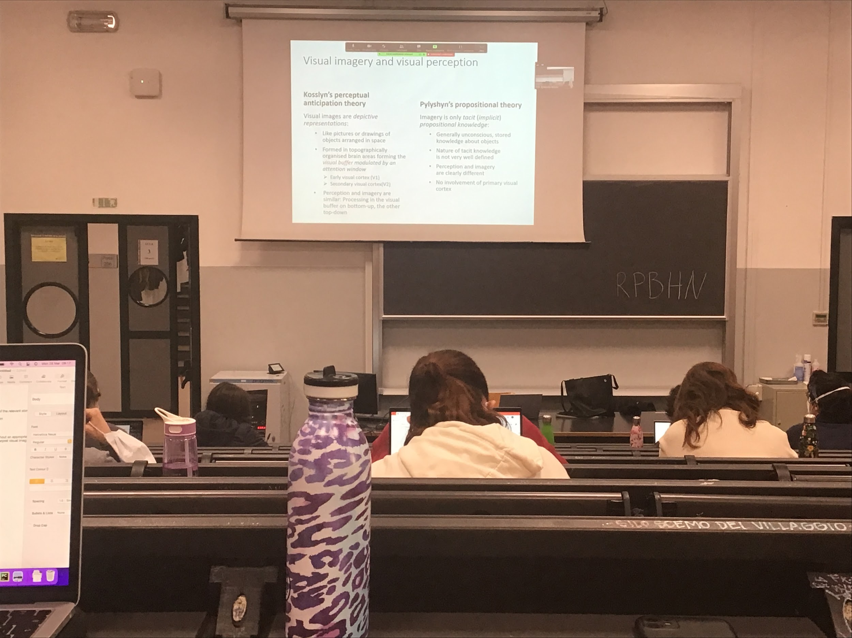

Two different theories to explain what visual imagery is

Most famous interpretation: **Kosslyn *perceptual anticipation theory***. Visual images are real mental representations. We recreate in our brain images that are very similar to what happens when we look at something directly (we perceive it directly) in our visual images, objects are spatially arranged and we maintain distances in this mental representation that we have.

In early visual cortex (V1) and secondary visual cortex (V2) right after the informations arrive from the eye there we have first representation of imagery

There is some kind of structured *visual buffer, a place* where there is information coded topographically. When I look at a scene I know that objects in the top right in the visual field will be represented in a specific position in my visual cortex. Correspondence between what is out there and where in the primary visual cortex there is activation

**Perception and imagery are the same**, only difference where the original signal come from

* Perception: from the outside, go to the LGN and activities primary visual cortex
* Imagery: information come from memory and go down to primary visual area, activating the same kind of cells

Data in favour of Kosslyn theory:

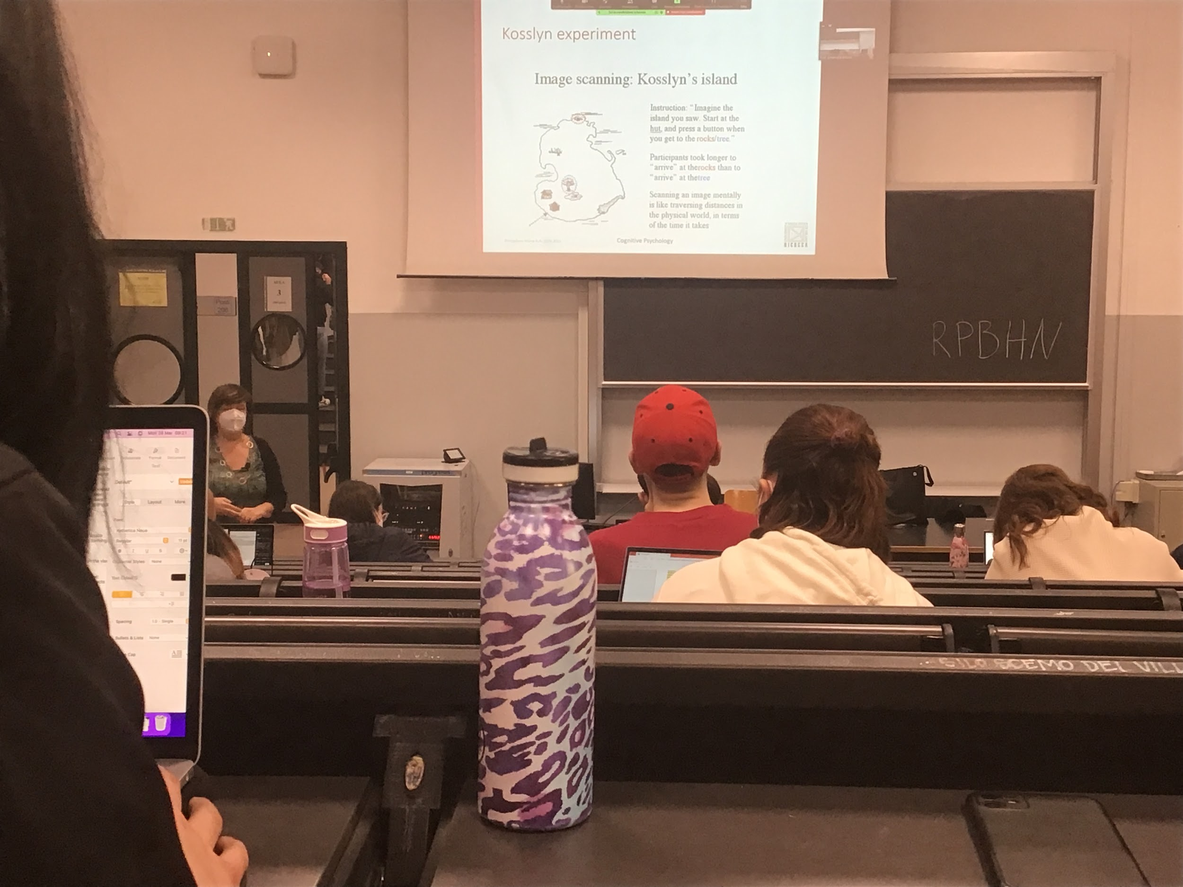

DO TEST ONLINE

Kosslyn wanted to show that imagery and perceptions work in the same way. The mental representation maintains distances between two objects

Asking people to memorise the island structure with the different landmarks

After some time I will show the island without any landmark, and I ask to position the landmark

The time tasking to mentally navigate from one position to another, in favour of the fact that we maintains this topographical coding

------

**Pylyshyn propositional theory**.

We create a kind of representation, we bring out from long time memory some kind of representation on which we will work on, but the information that we will work on is not really visual. We take out from memory the information that we know and we bring up those propositional knowledge

*I know there is an island and there are many objects there are this objects and that the house is close to the tree…*

I build statement that I save in memory and that is what I bring up, it seems to be visual but in reality it is not, is just propositional information

According to this proposal perception and imagery are clearly different and there is no involvement in primary visual cortex, there is no need to involve primary visual cortex because the information is not purely visual

In psychology there is no clear answer

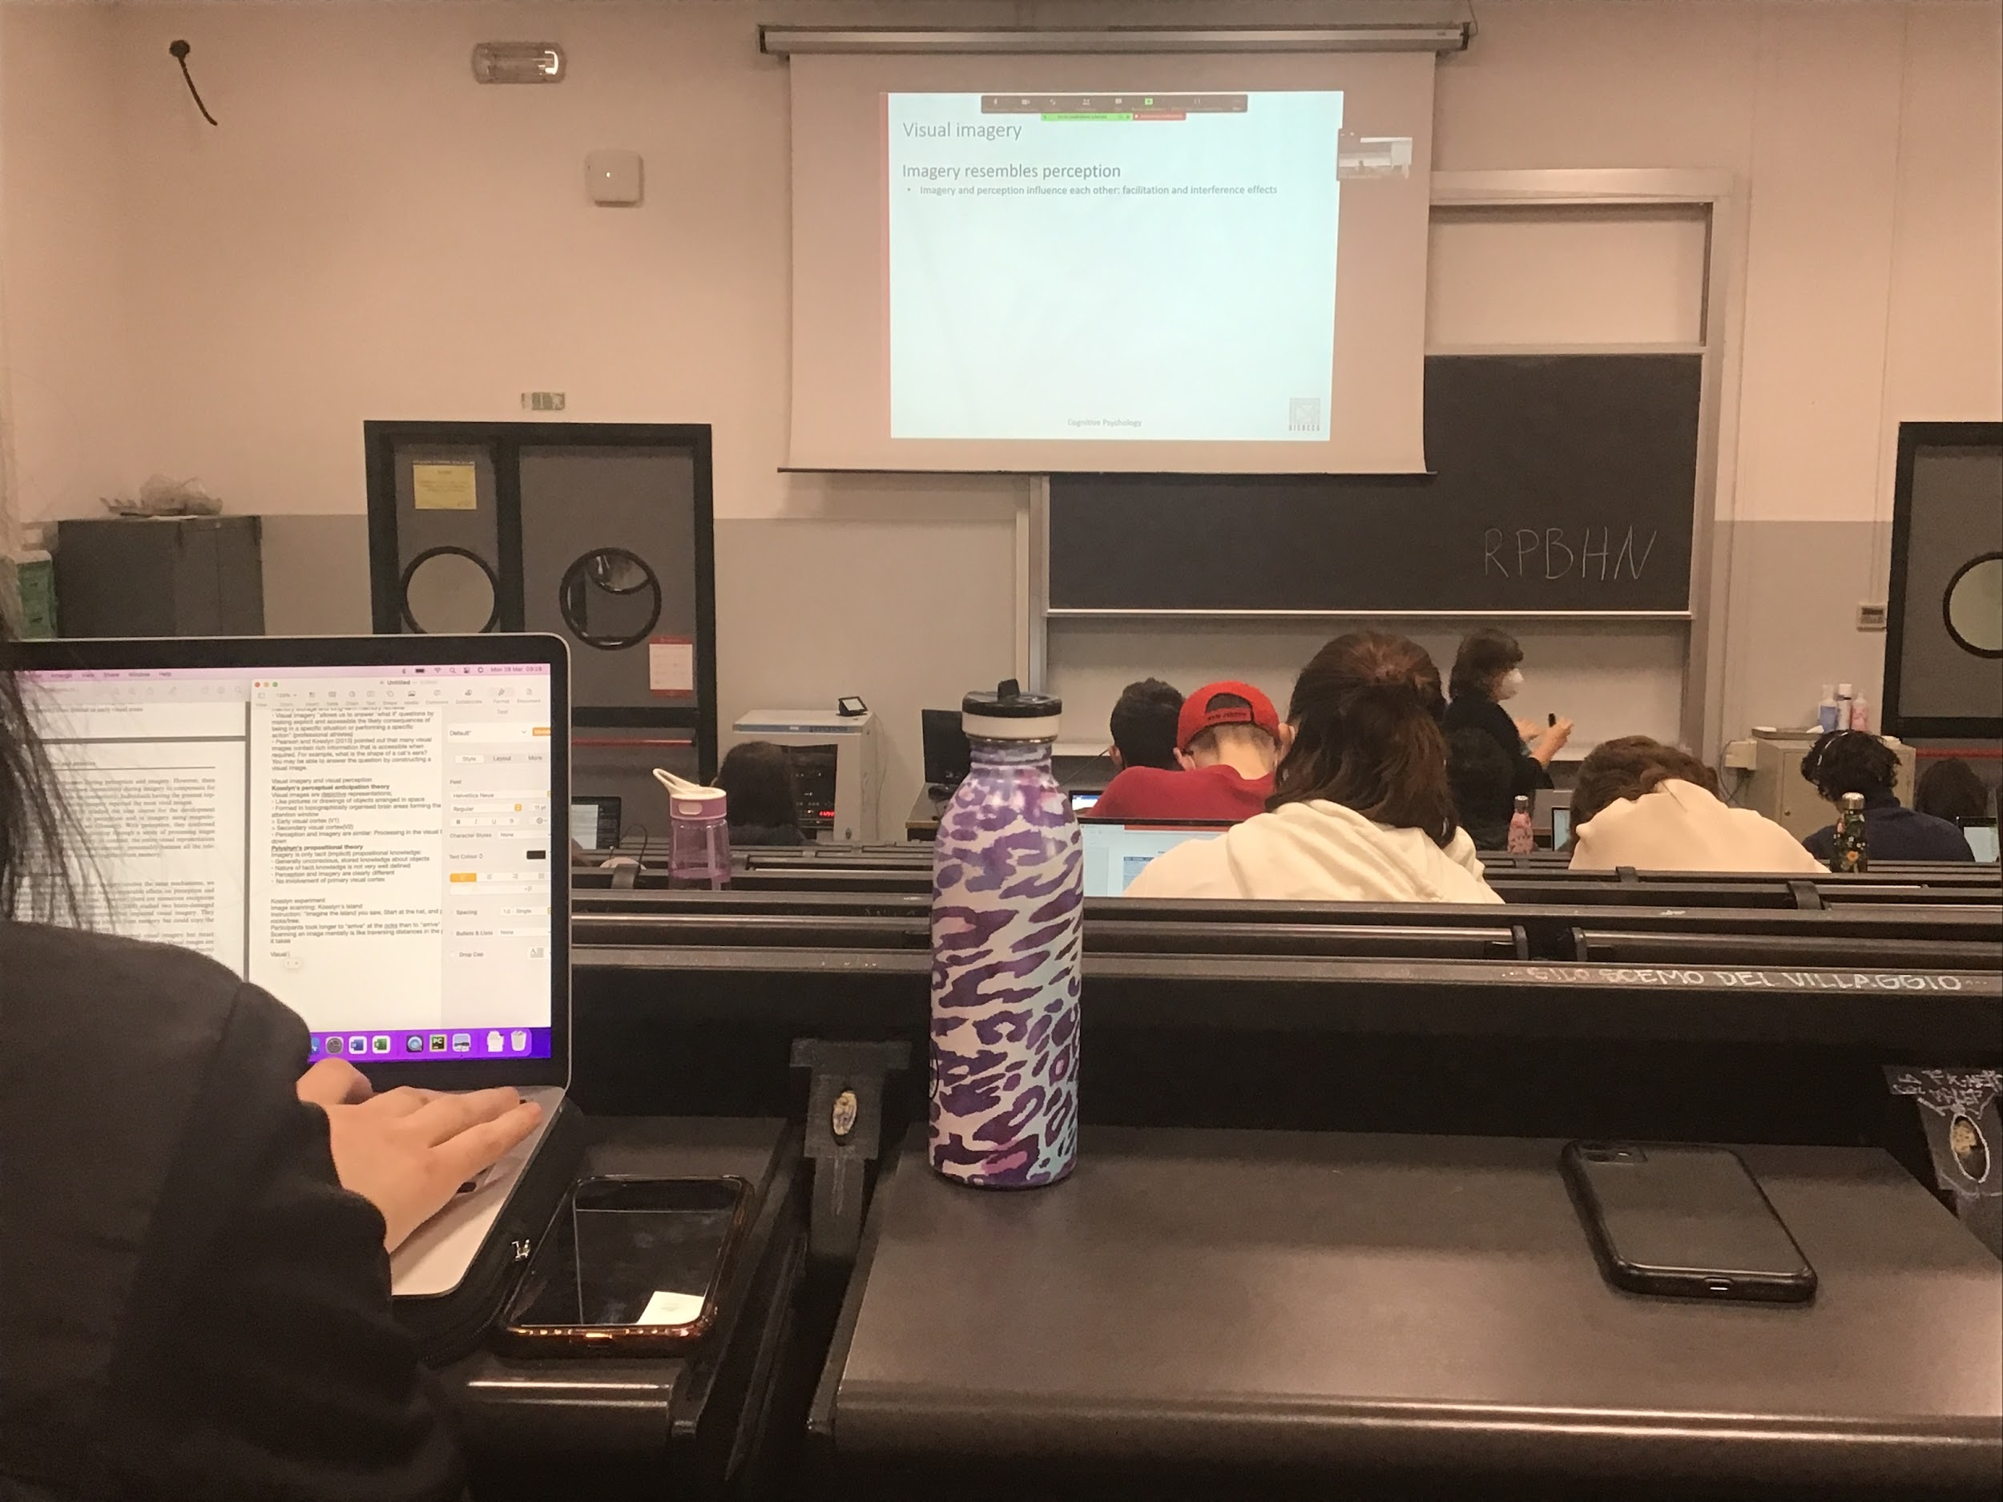

According to Kosslyn (name to remember!!!) How can you demonstrate the fact that imagery and perception are the same thing? This should happen if one interfere (or facilitate) with the other

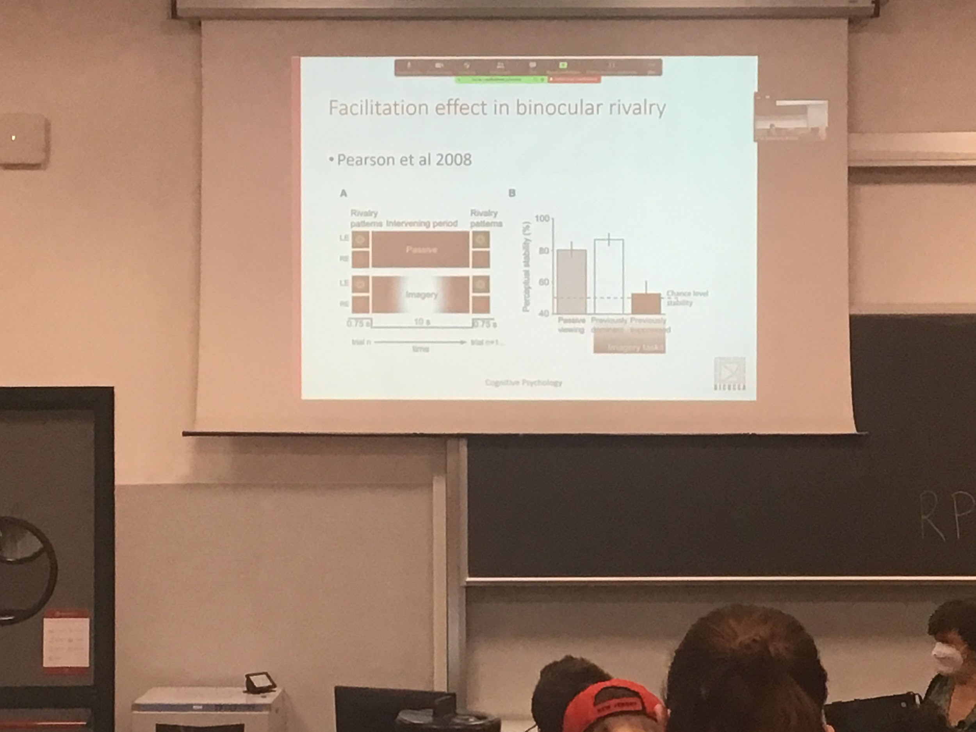

Stereotypes: ability to use two eyes to see depth (see others lectures). The informations from the two eyes are put together to see depth

**Binocular rivalry**: when we present two different images at the two eyes and so they are rival, one against the other

The interpretation that the system does you don’t see a combination (or overlapping) of the two but you see one or the other, in alternation and there are intermediate periods in which we see pieces

Left and right eye two different stimuli, one green one red, one vertical one horizontal

You see that imagery influences perception

Your visual imagery facilitates one of the two interpretation influences your visual perception, data in favour of Kosslyn idea, imaging have influences what we actually see in real life

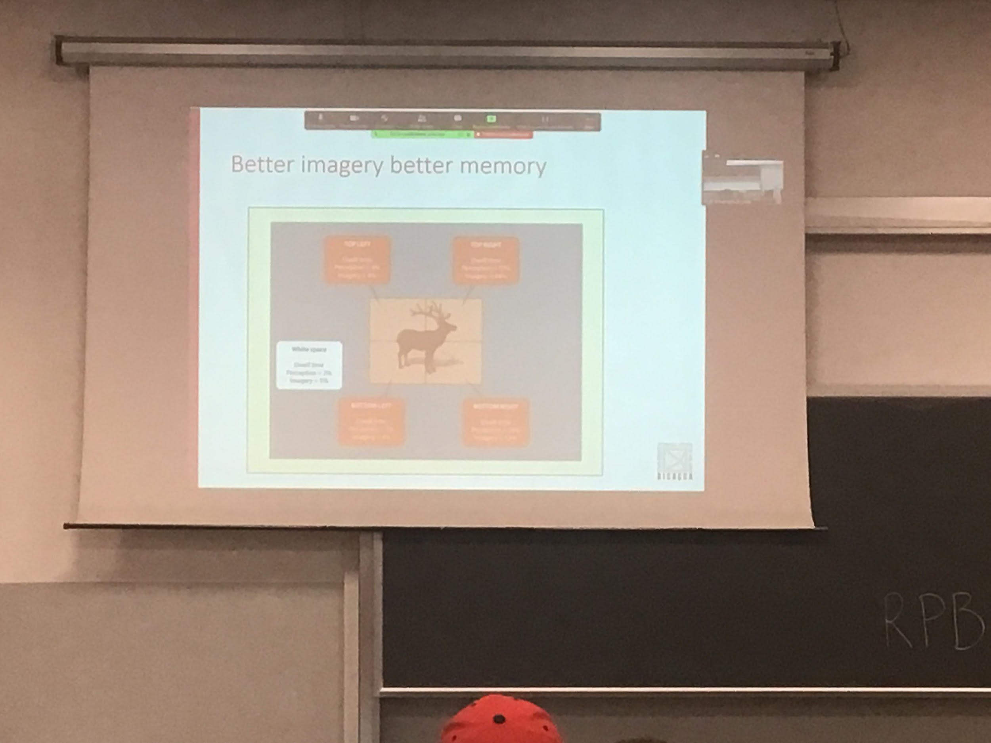

You show people an outline of animals that the image disappear and you have to keep in memory

Ask people to look at the black screen as the image was there and you measure eye movement. How much time you stay in that specific area

The percentage of time the people spends in specific quadrants (region of interests) is the same for image and perception, people are looking more at the part of the image that is more interesting

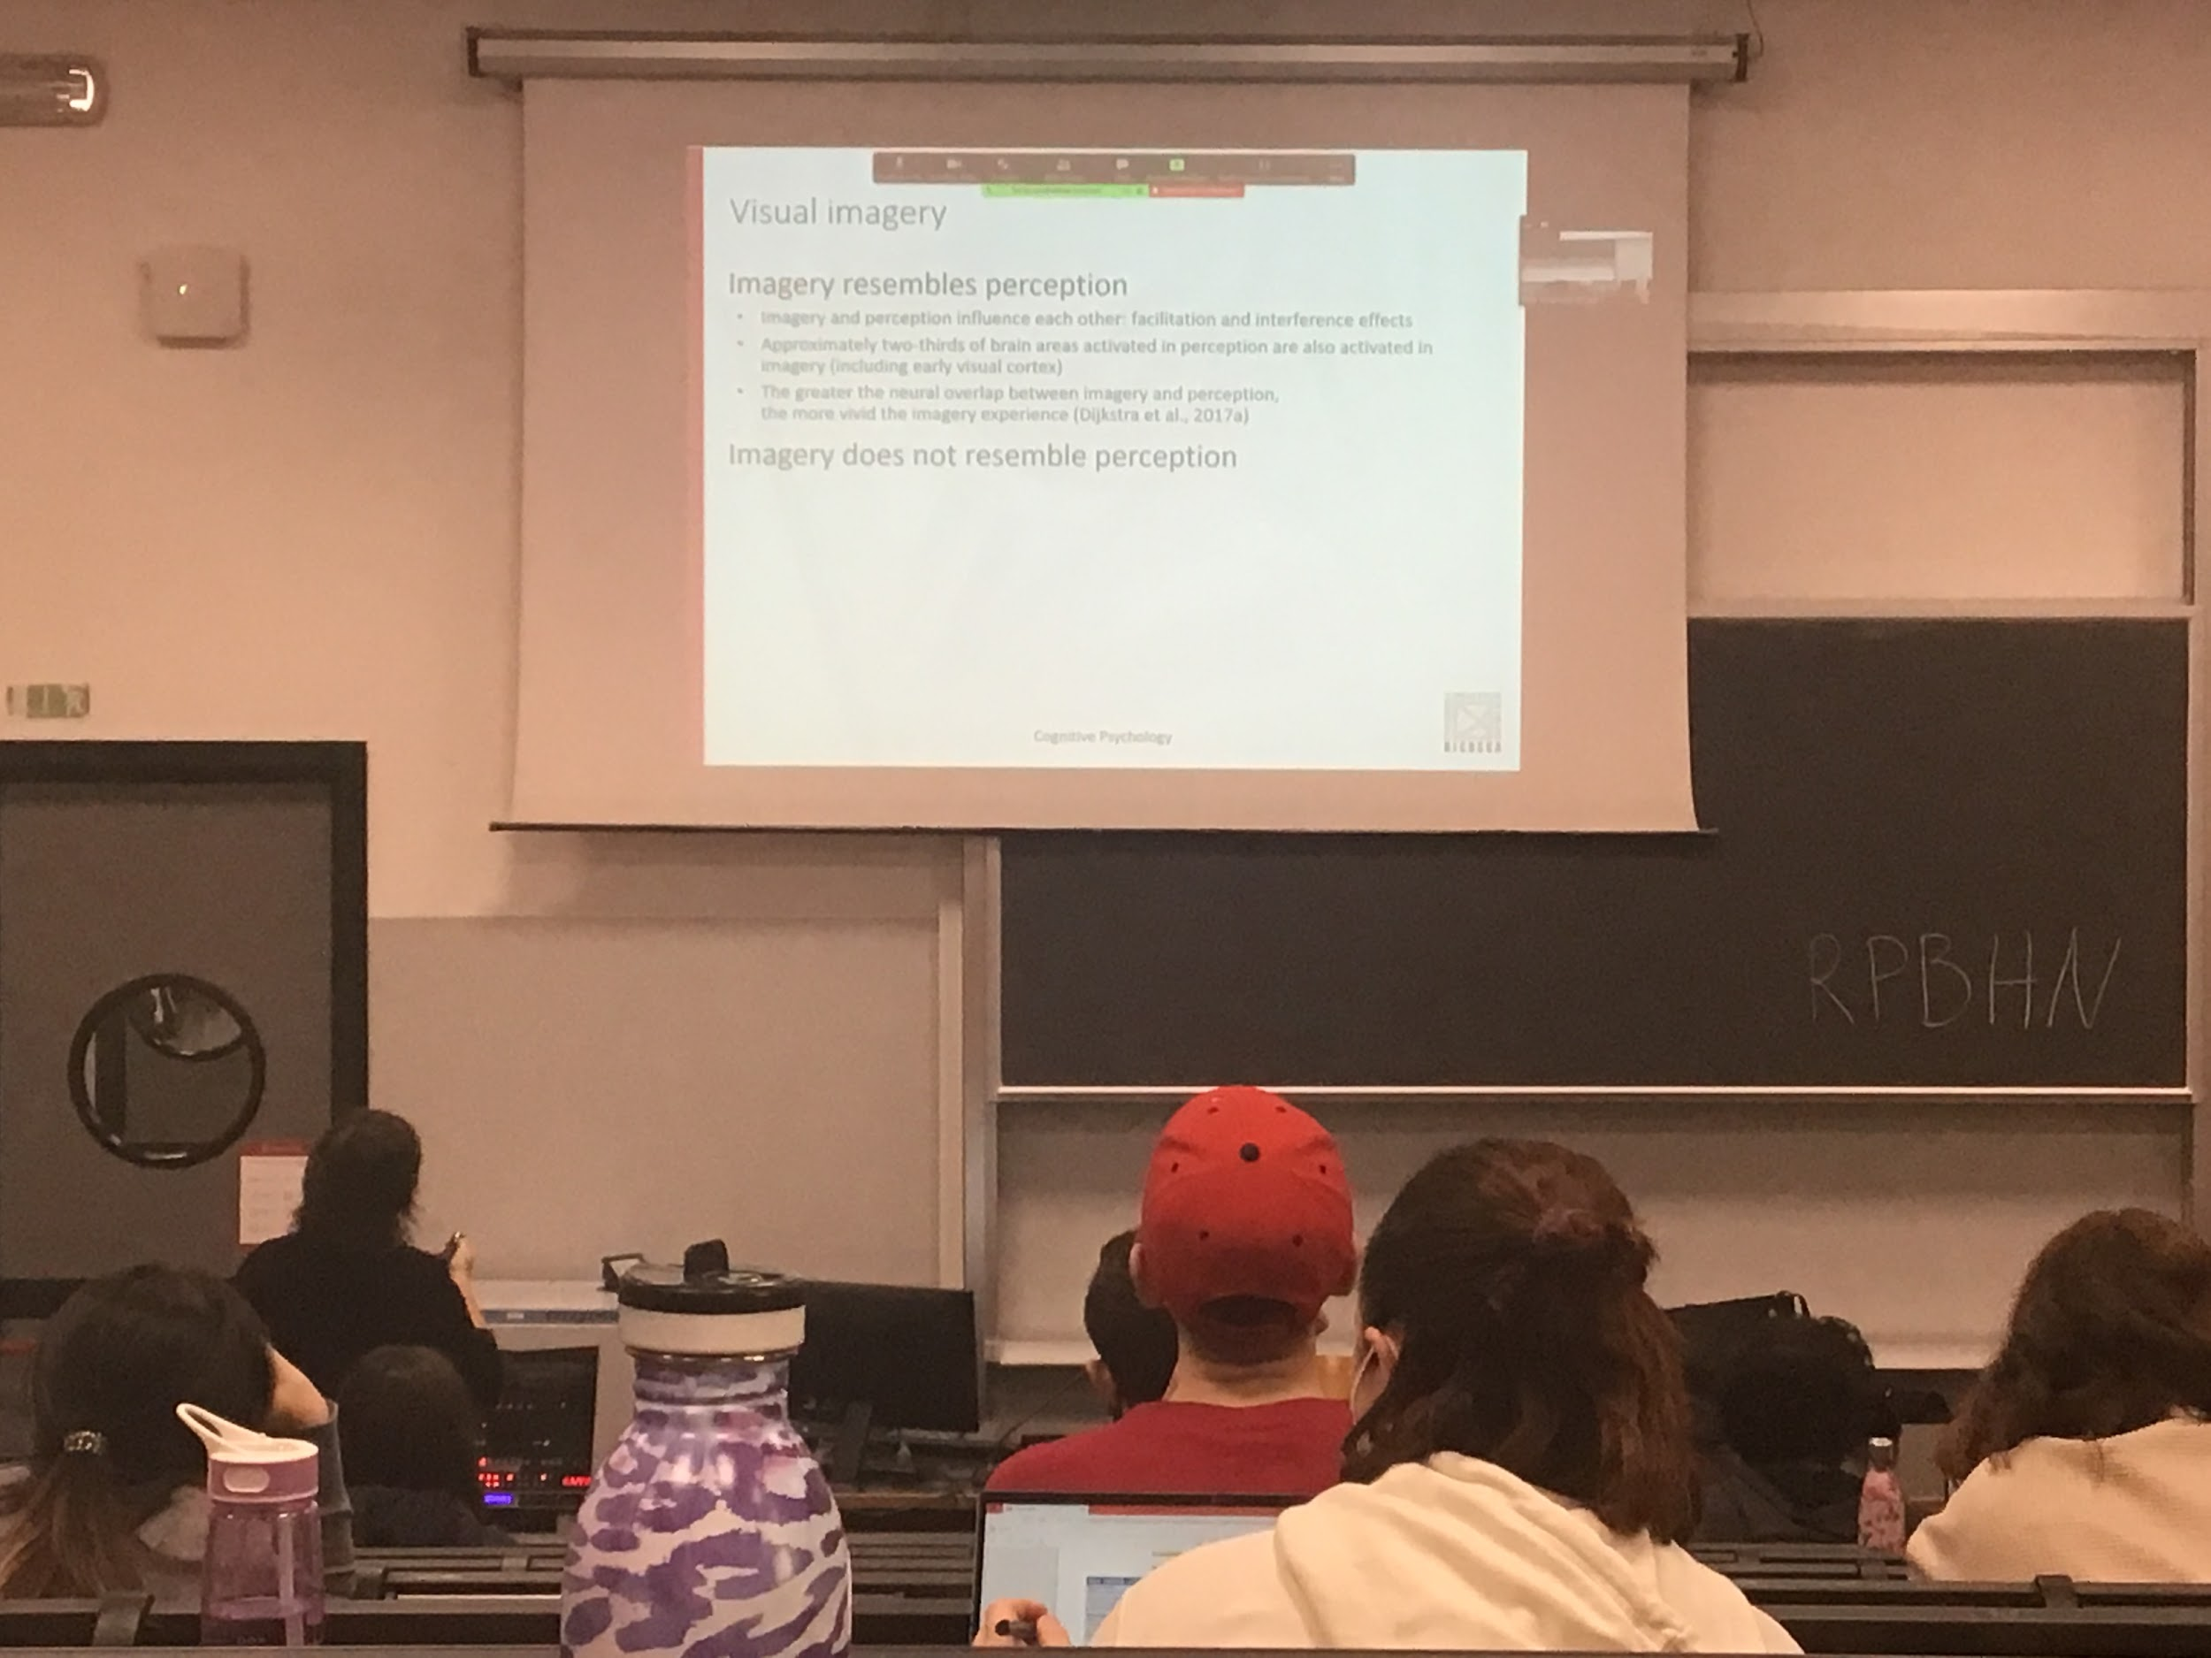

Other data in favour that imagery resemble perception is that when you look at areas active during perception of an image and during imagery of an image there is a lot of overlap

The people with greater overlap are people with greater imagery

There is also some data that is in favour that imagery is not exactly perception

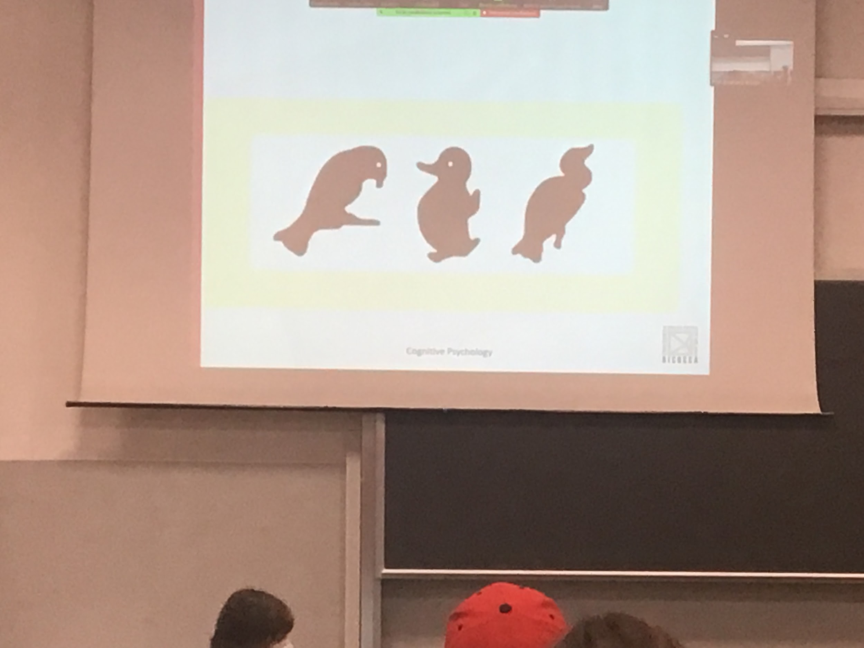

Look at first image and rotate it mentally 90 clockwise and try to imagine what you see

For people to describe what they see if the image is rotated 90 clockwise is very hard

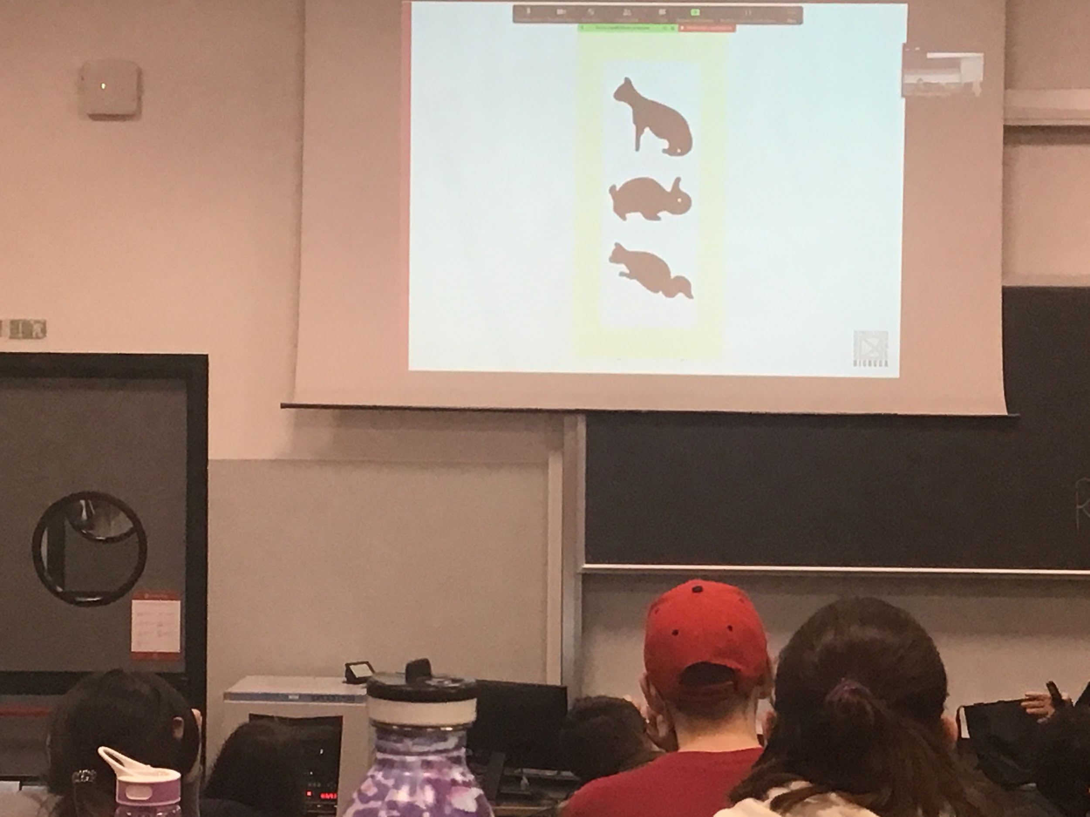

Mental rotation does not work so well as physical rotation

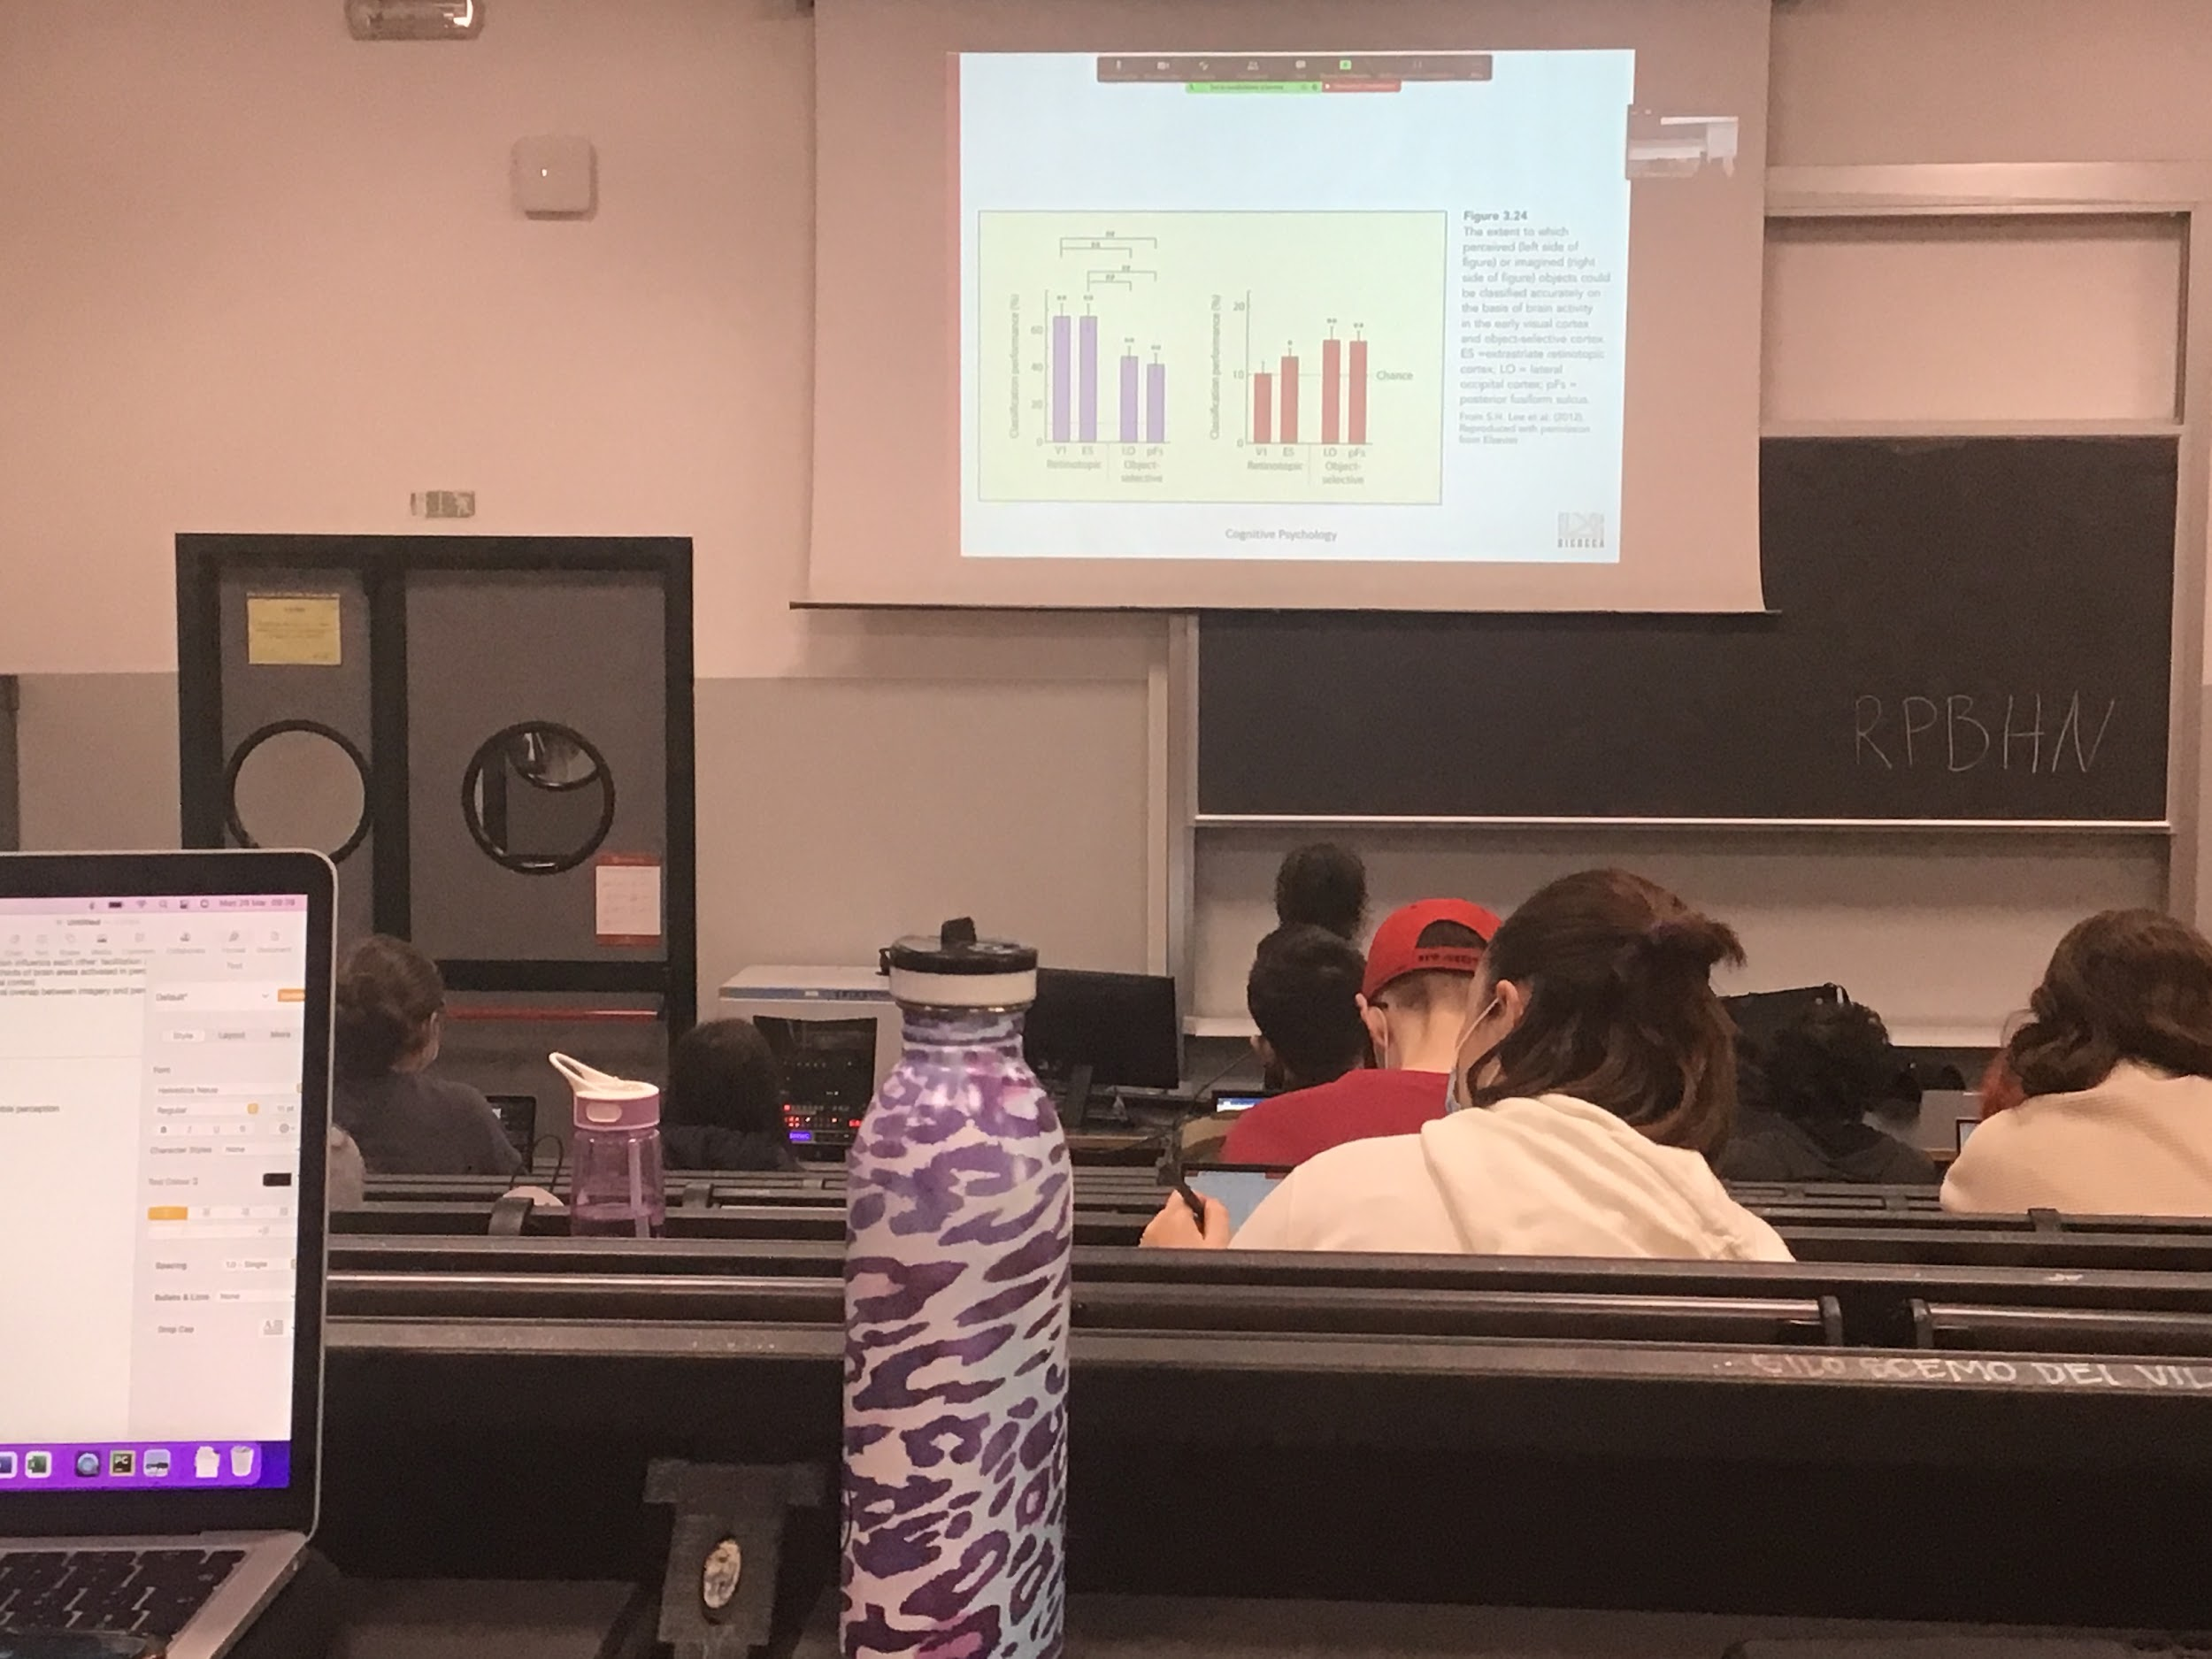

Data on brain activity

The data in favour of imagery as visual perception says that there are many high areas active in both situations, but is this activity equivalent?

The authors tried to use a classification network that was trying to decide what the people were looking at (or imaging) using only brain activity. From the brain activity try to guess what people were looking at

Classification performance is much higher for real objects, able to understand what people were looking at using brain activity

In the case of imagery the activity was much lower, when you are doing real perception, classification is much easier when you use the lower areas while if you can classify in the cases of imagery you can do only with higher areas.

Both areas are active in both conditions but activity in perception seems to be more focus and more easily delectable

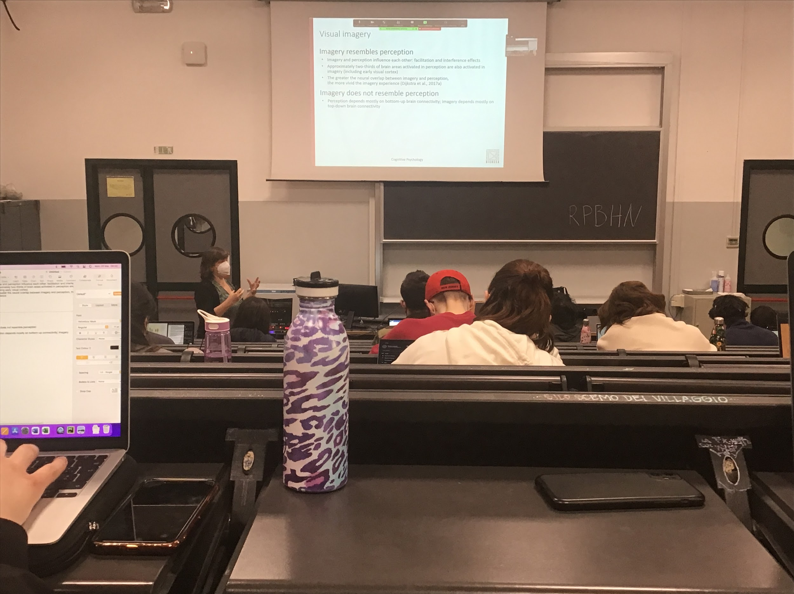

Is the connectivity different?

What we see from the data is perception depends most on bottom-up connectivity and imagery depends on top-down connectivity. The more details the easy is to discriminate are in the higher level

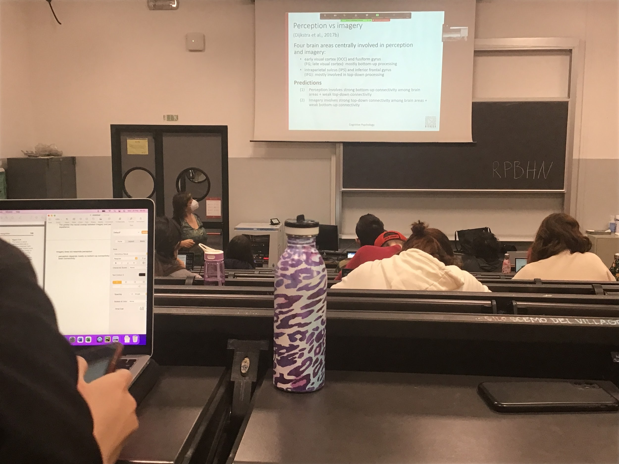

Recorded activity when people were doing perception or imagery and show that 4 brains are involved.

Are these connectivity differently for the two conditions?

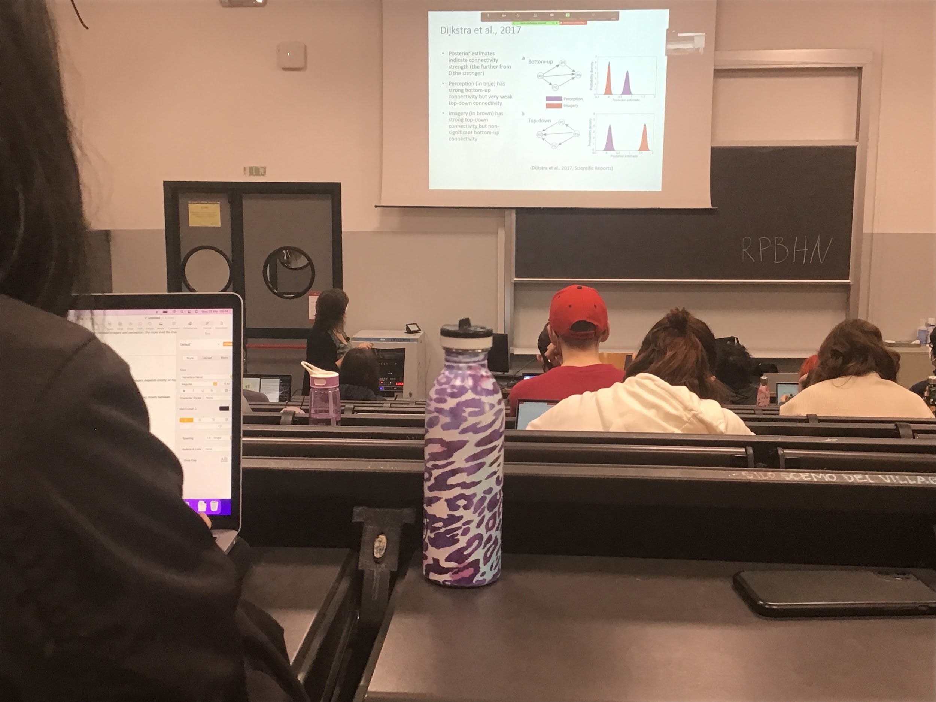

Perception involve strong bottom-up connectivity and weak top-down connectivity while is opposite for for imagery

There is activity equivalent in many brain areas, but different activity in perception and imagery

Perception: use more bottom up informations, able to discrimate between objects

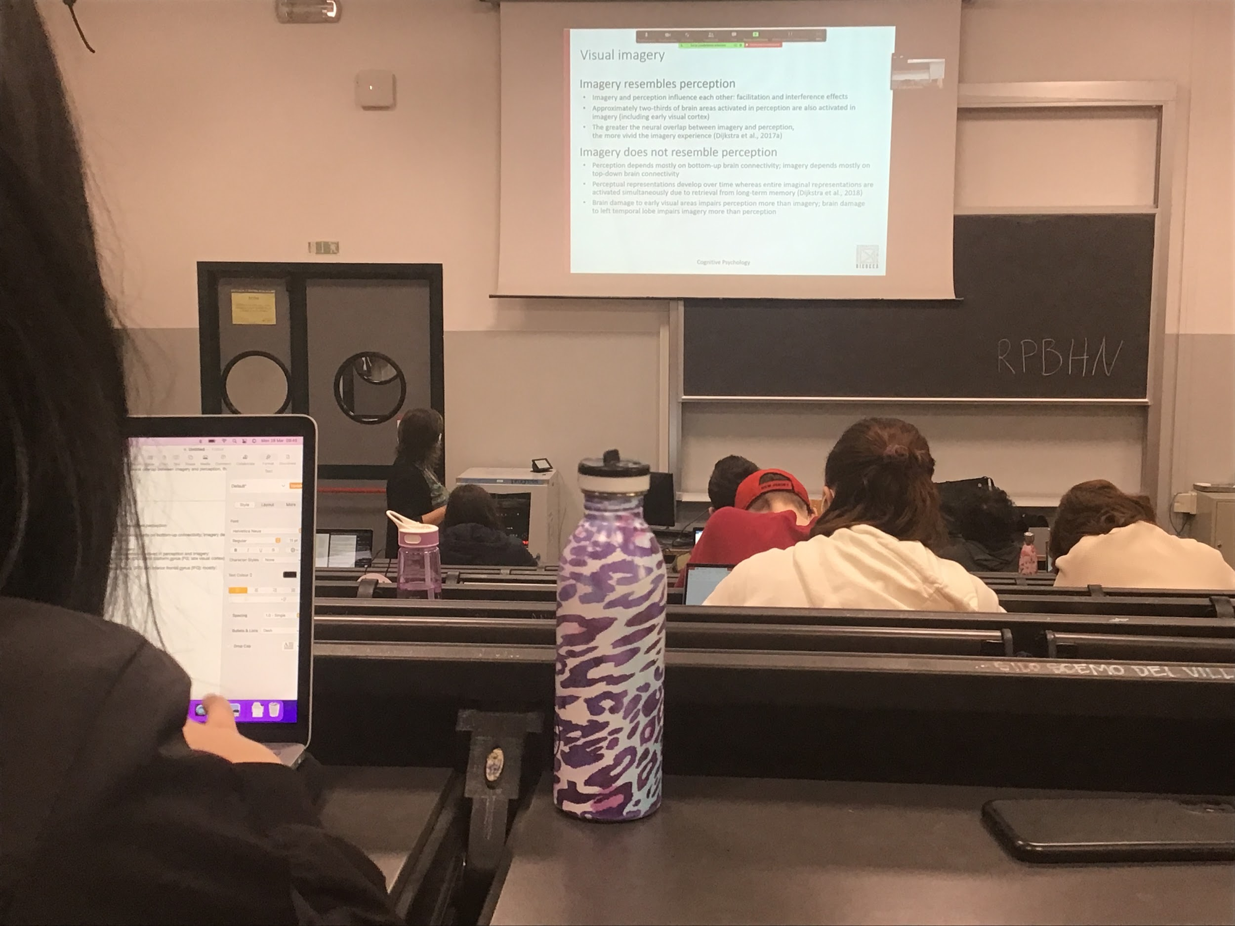

Also difference in timing of activity

When we do perception the build up representation come with time

While with image the activation come strightforward

Also dissociation in neuropsychology

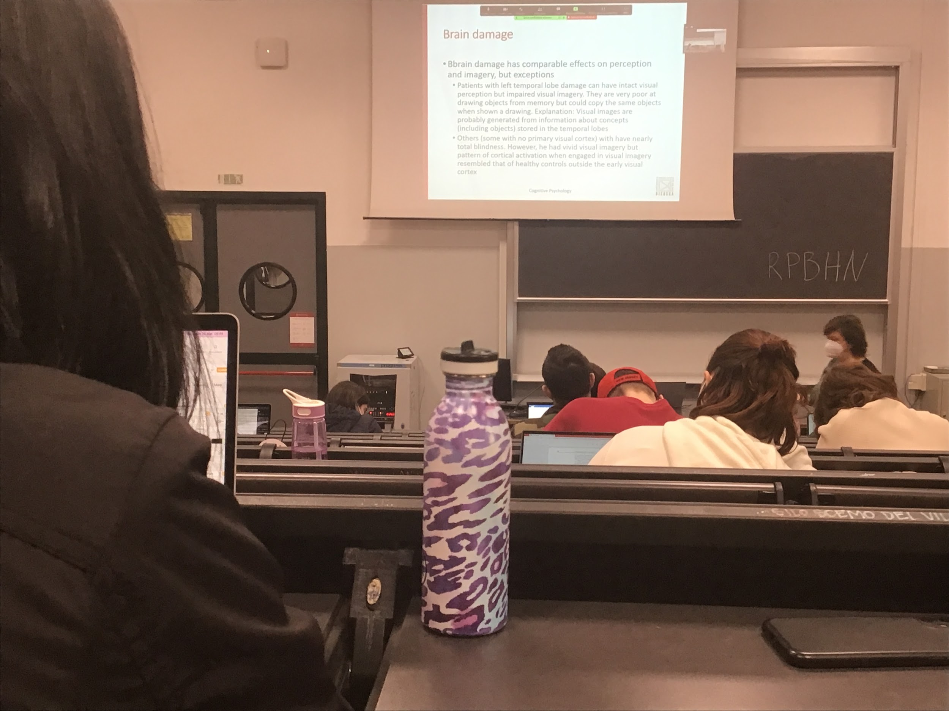

Brain lesion influences both perception and imagery

After a while patients with left temporal damage can have intact visual perception but impairs visual imaging, very good at drawing object for memory but can copy imaging from drawing

**CHAPTER 4**

**Motion perception and action**

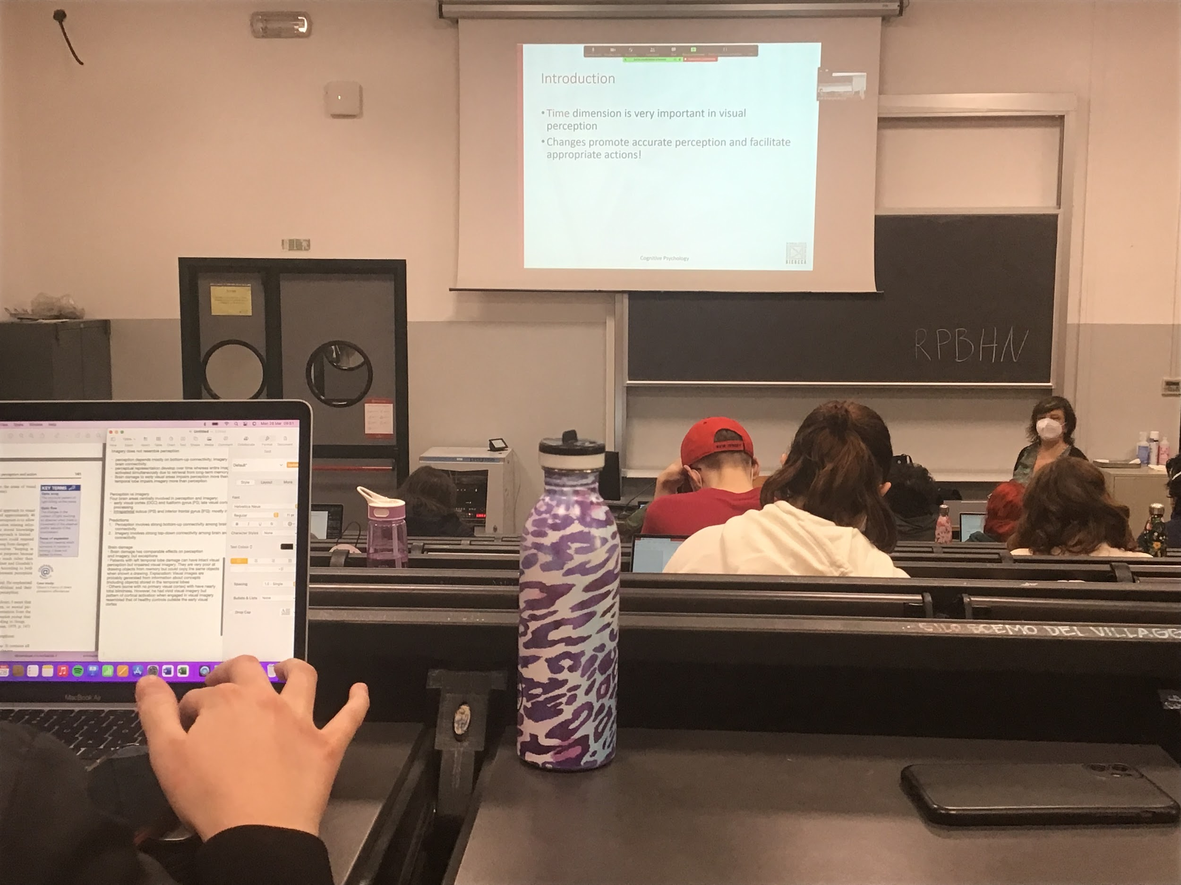

The visual system has do deal with more complex informations that simple static images

Informtions changes every time, everything is always chaining and moving in our visual field. We move, the object move our eyes move.

Time is important, especially for prediction

Continues computation of predicting what will happen to be able to interact correctly with the environment

Changes are useful, also they can allow us to see objects in different ways. As soon as I move I have much more informations in tridimensions

Moving help us get more informtions about everything is out there and getting a better representation of the filed

In the retina there is constant movement. I move, the eyes move the word moves. I have to constantly decided from movements from the retina what is moving. I am moving or is the object is moving

**Biological motion**: we are very good at detection motion of animals and of humans

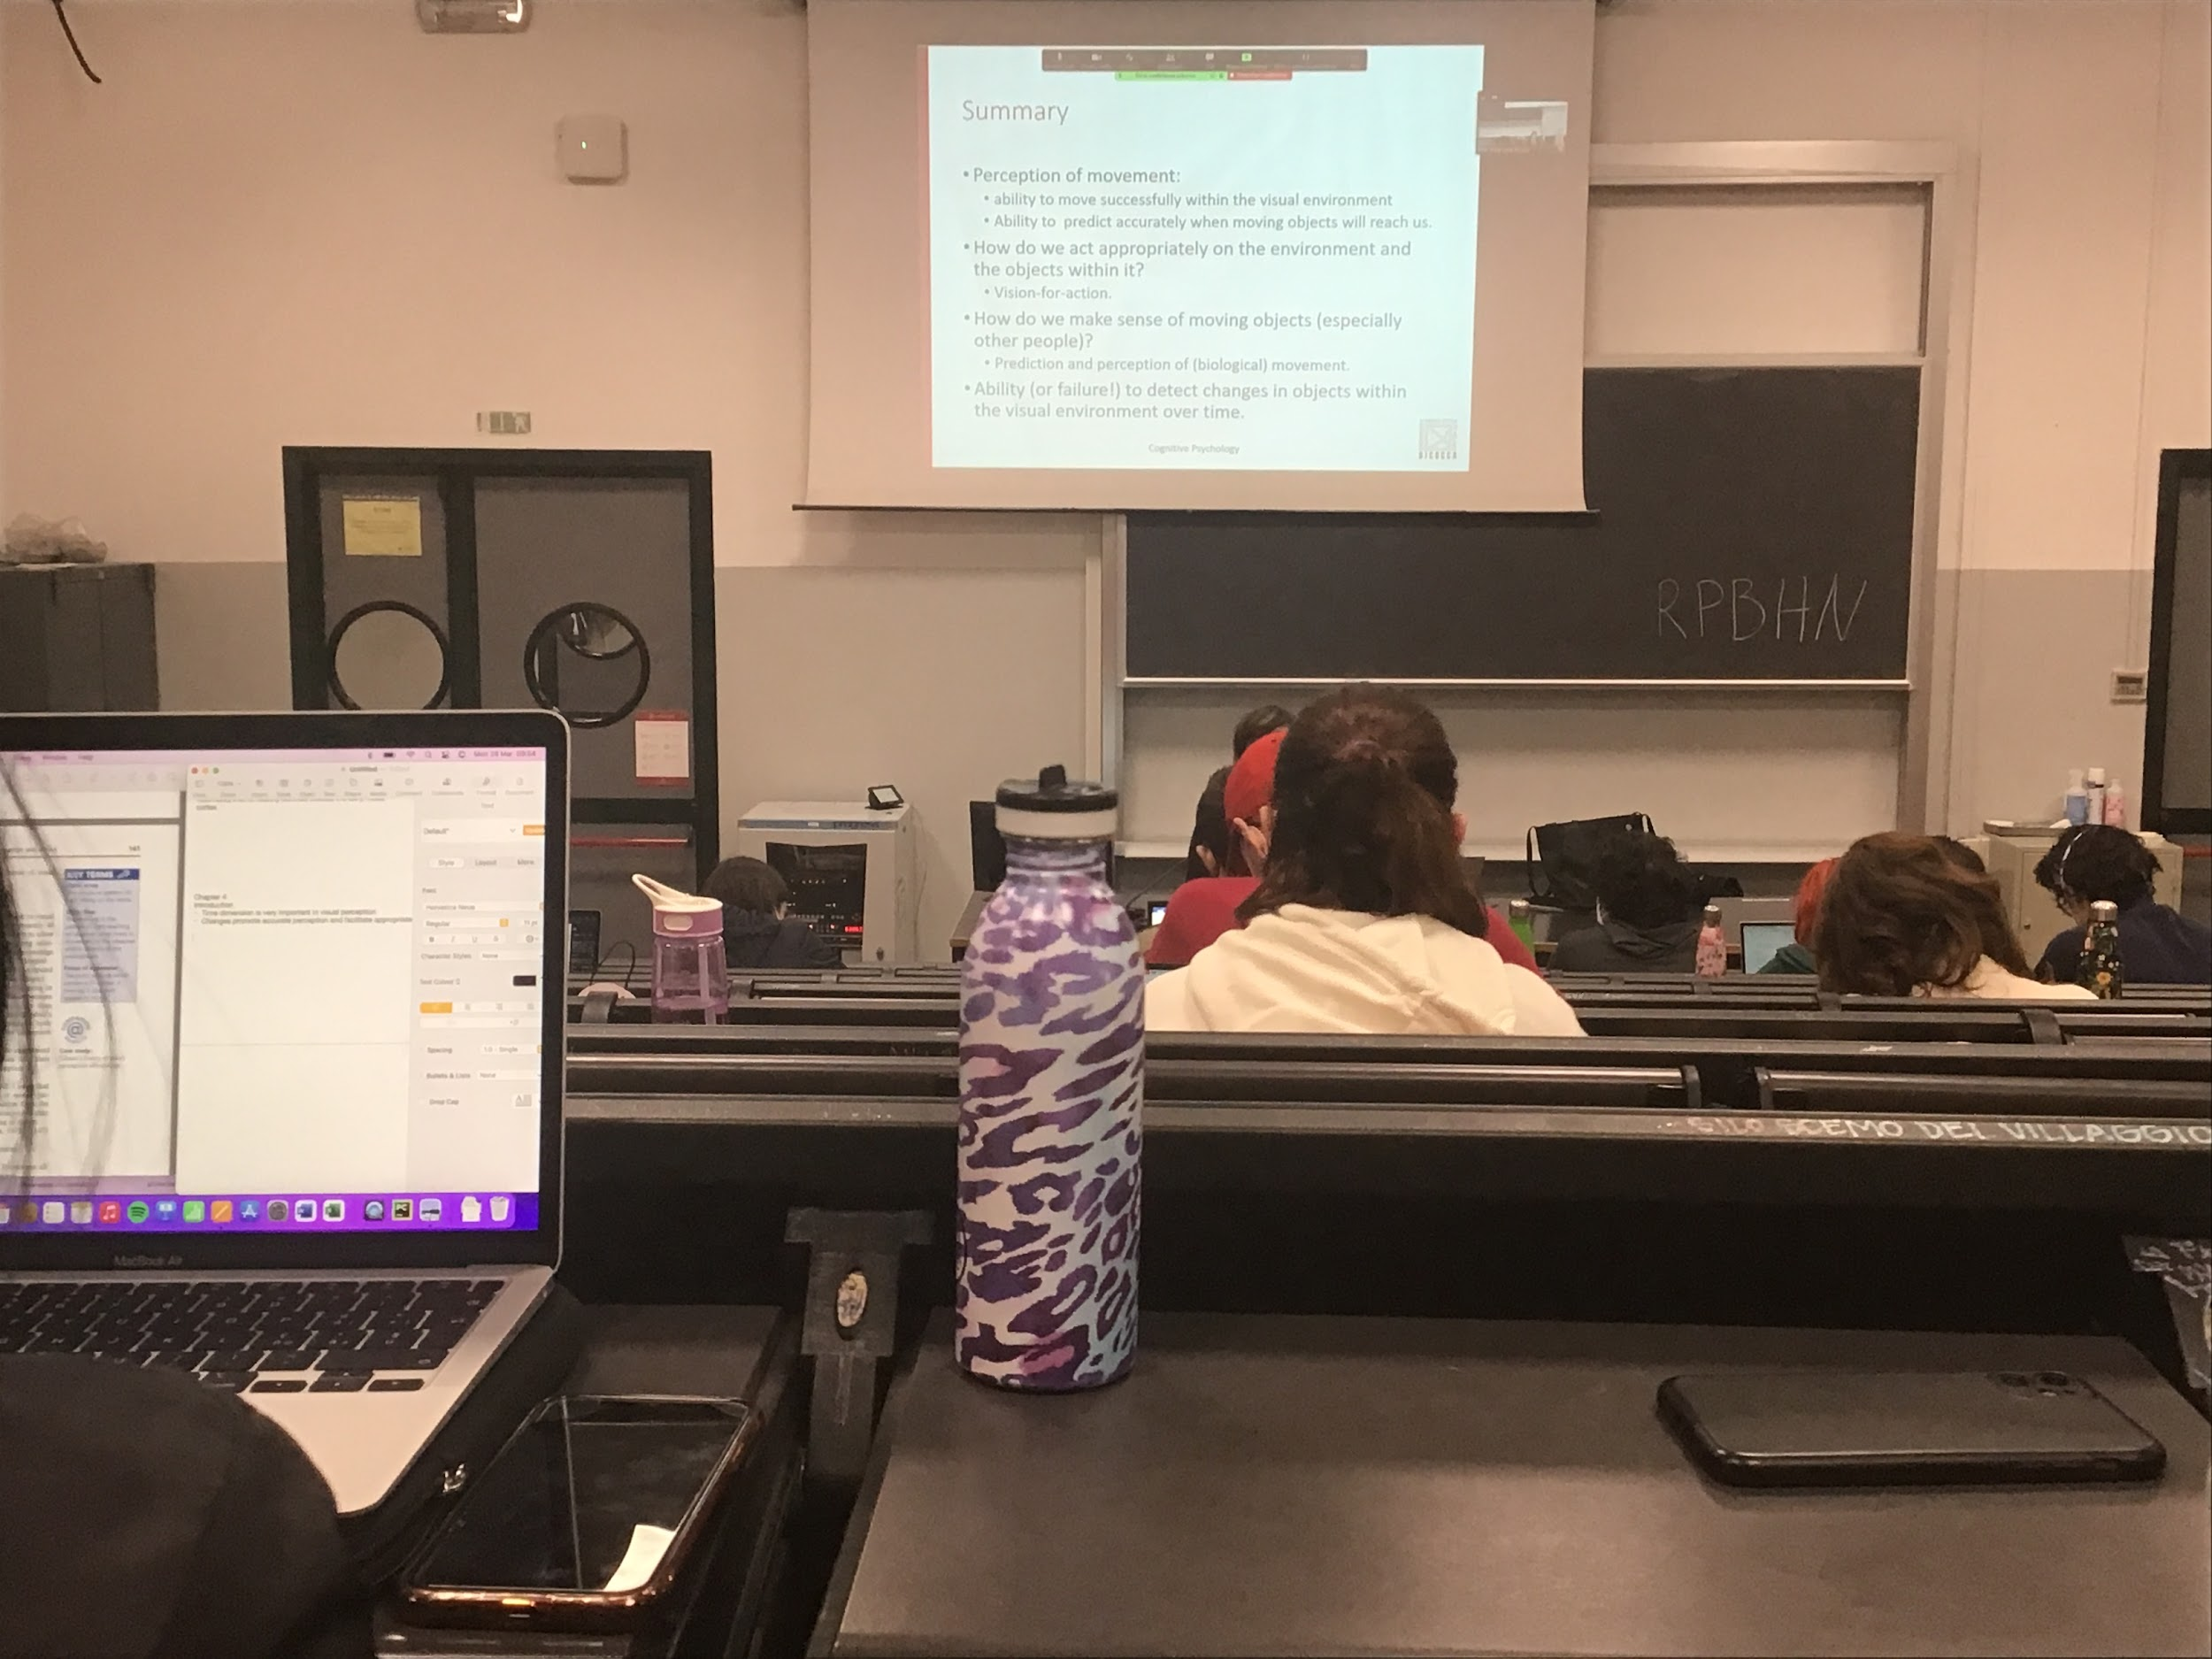

Registrazione n.2

**MOTION PERCEPTION AND ACTION**

**GIBSON’S DIRECT PERCEPTION**

Gibson important role in psychology

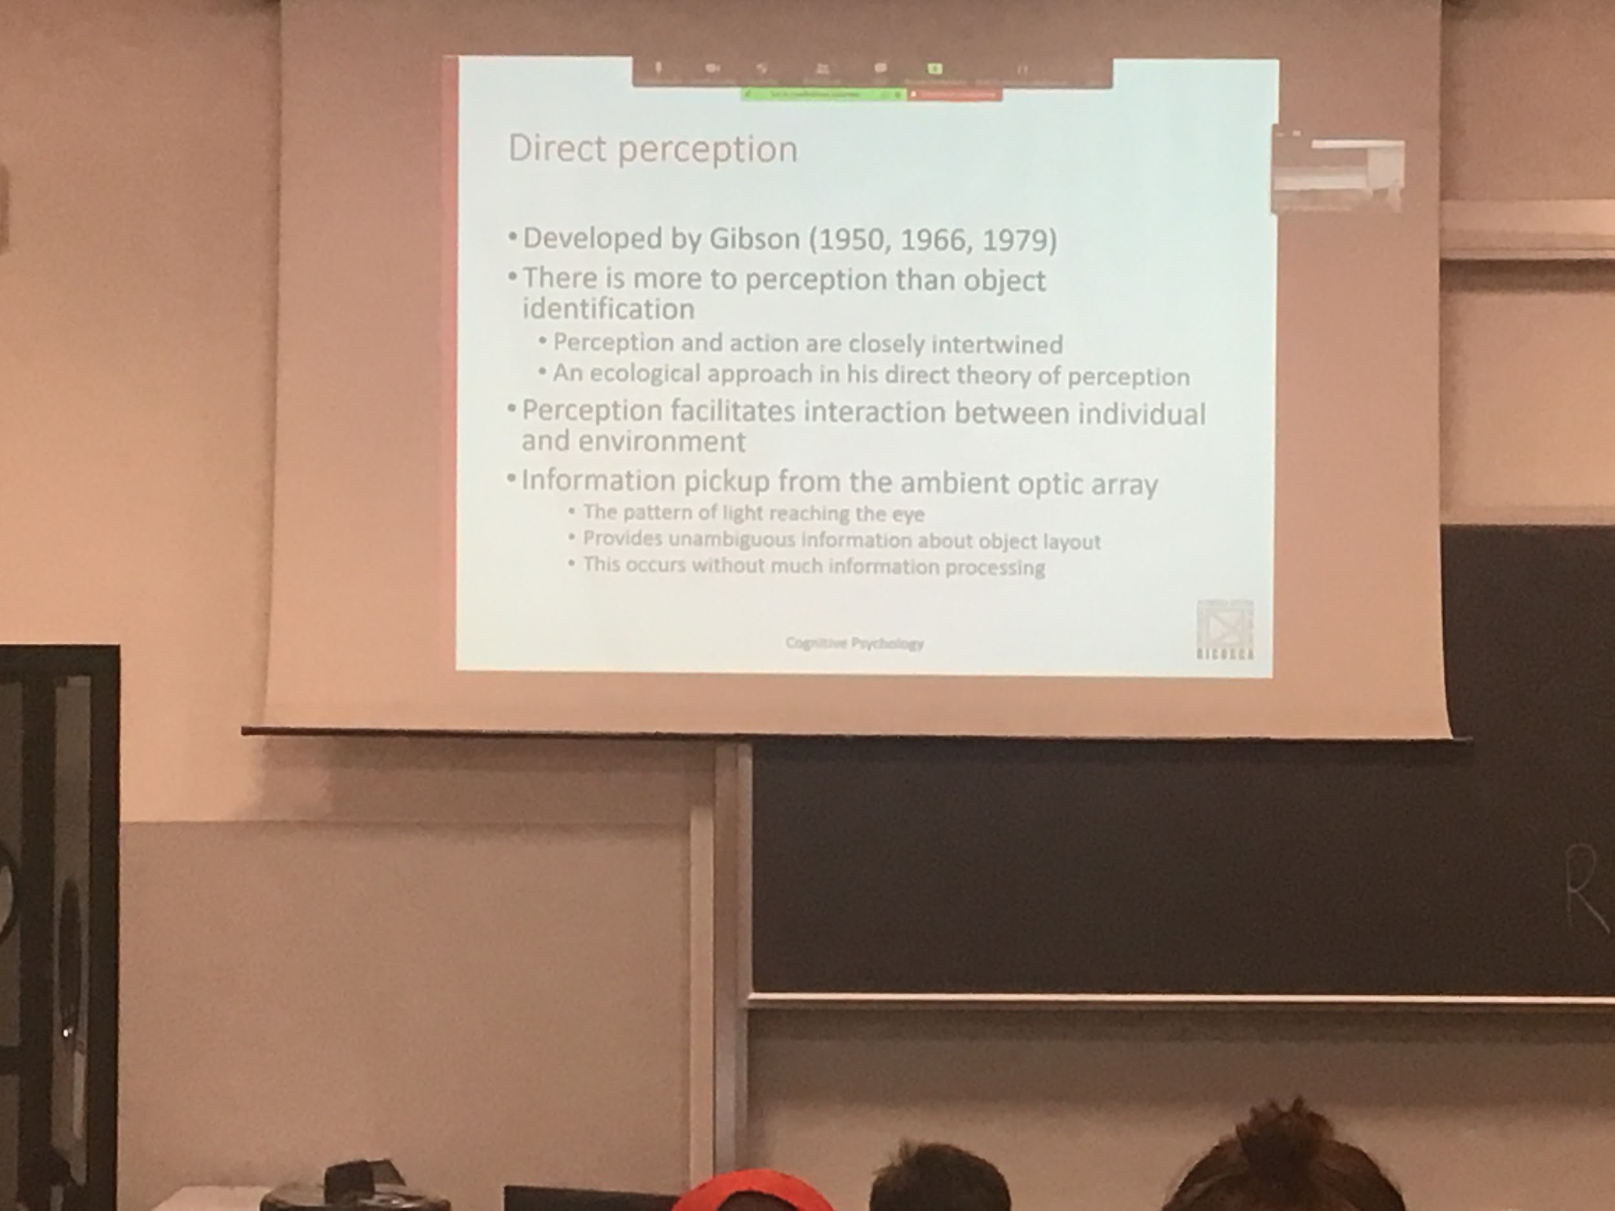

His idea was very important, idea not able to explain all details of perception but was very important for the point he focus on

For post psychologist: Perception was just object representation

They were missing that Perception is what we used to perform action, perception and action are closely inverwise

**Gibson**:

In reality there is no much need to do all these calculation and object representation... What is in the image on our eyes is enough information to guide our movement, we do not need to do multiple representation in the brain

Perception help us to interact with the environment

We do not need much information processing, there are things in the optical array that we can pick immedialty without computation

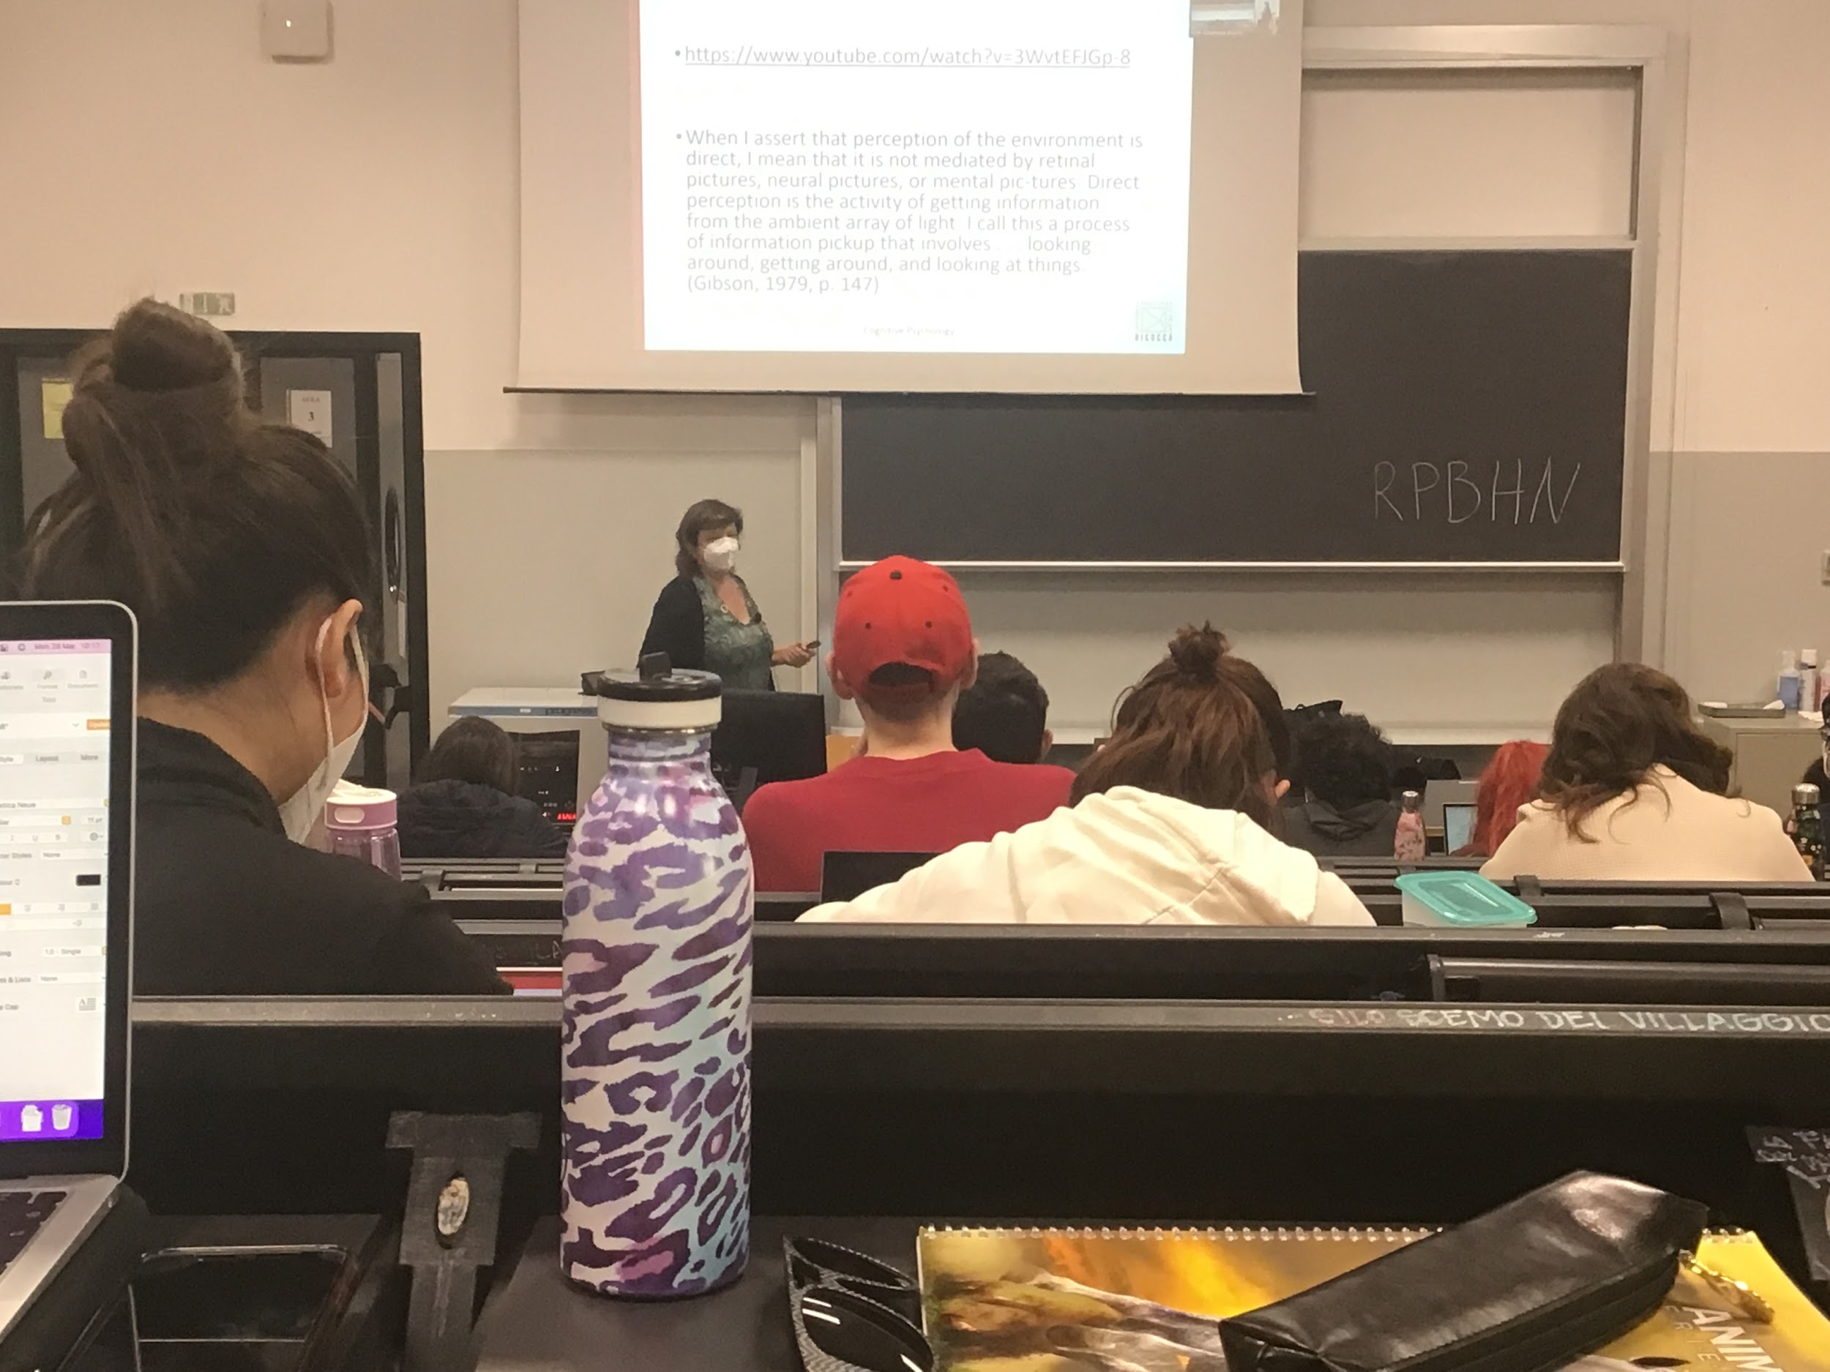

Baby one a desk, one part of the table is transparent one is no, he sees depth but don’t realise it is glass. The baby move toward the mum when she is in the safe side, but he stops in front of the glass. With depth perception he thinks that there is a hole

Idea of Gibson:

Perception was develop in early days, is innate

I get this change in pattern of information from that I can extract directly some informations and it is innate

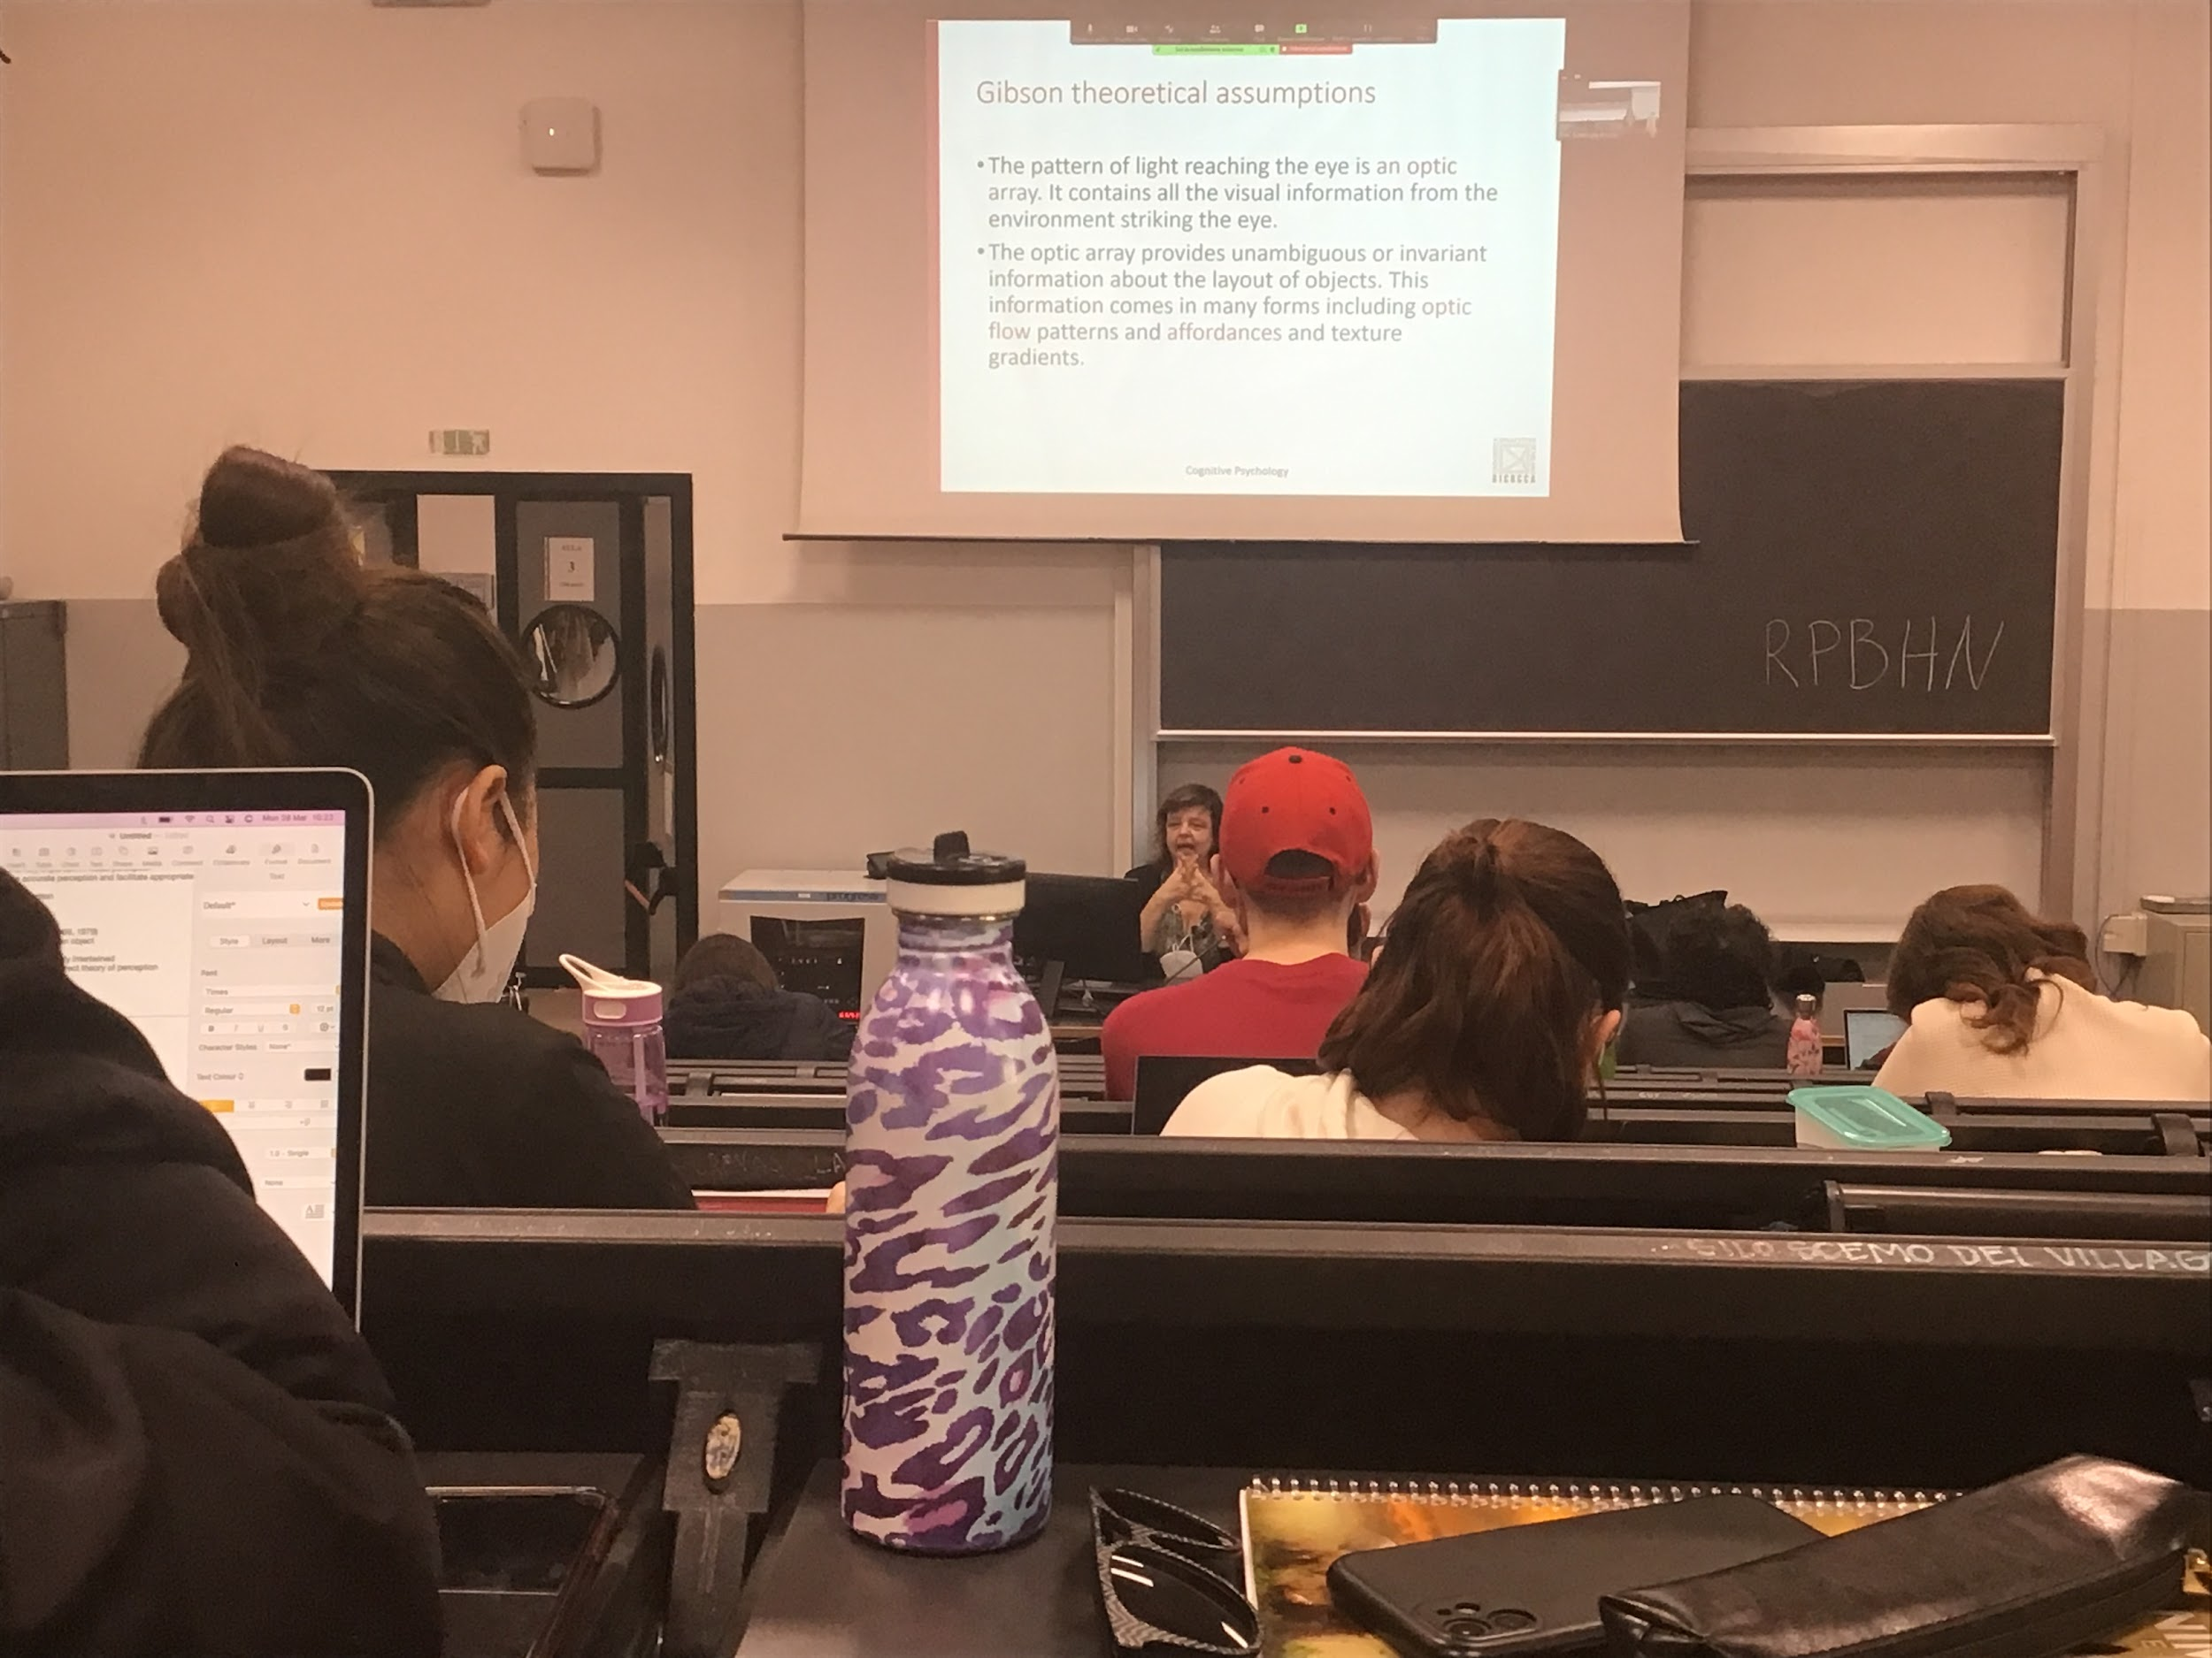

The pattern of light that reaches the eye is optic array, contains all the informations that we need. Two main information chategory

* Optic flow pattenrs
* Affordaces and texture gradients

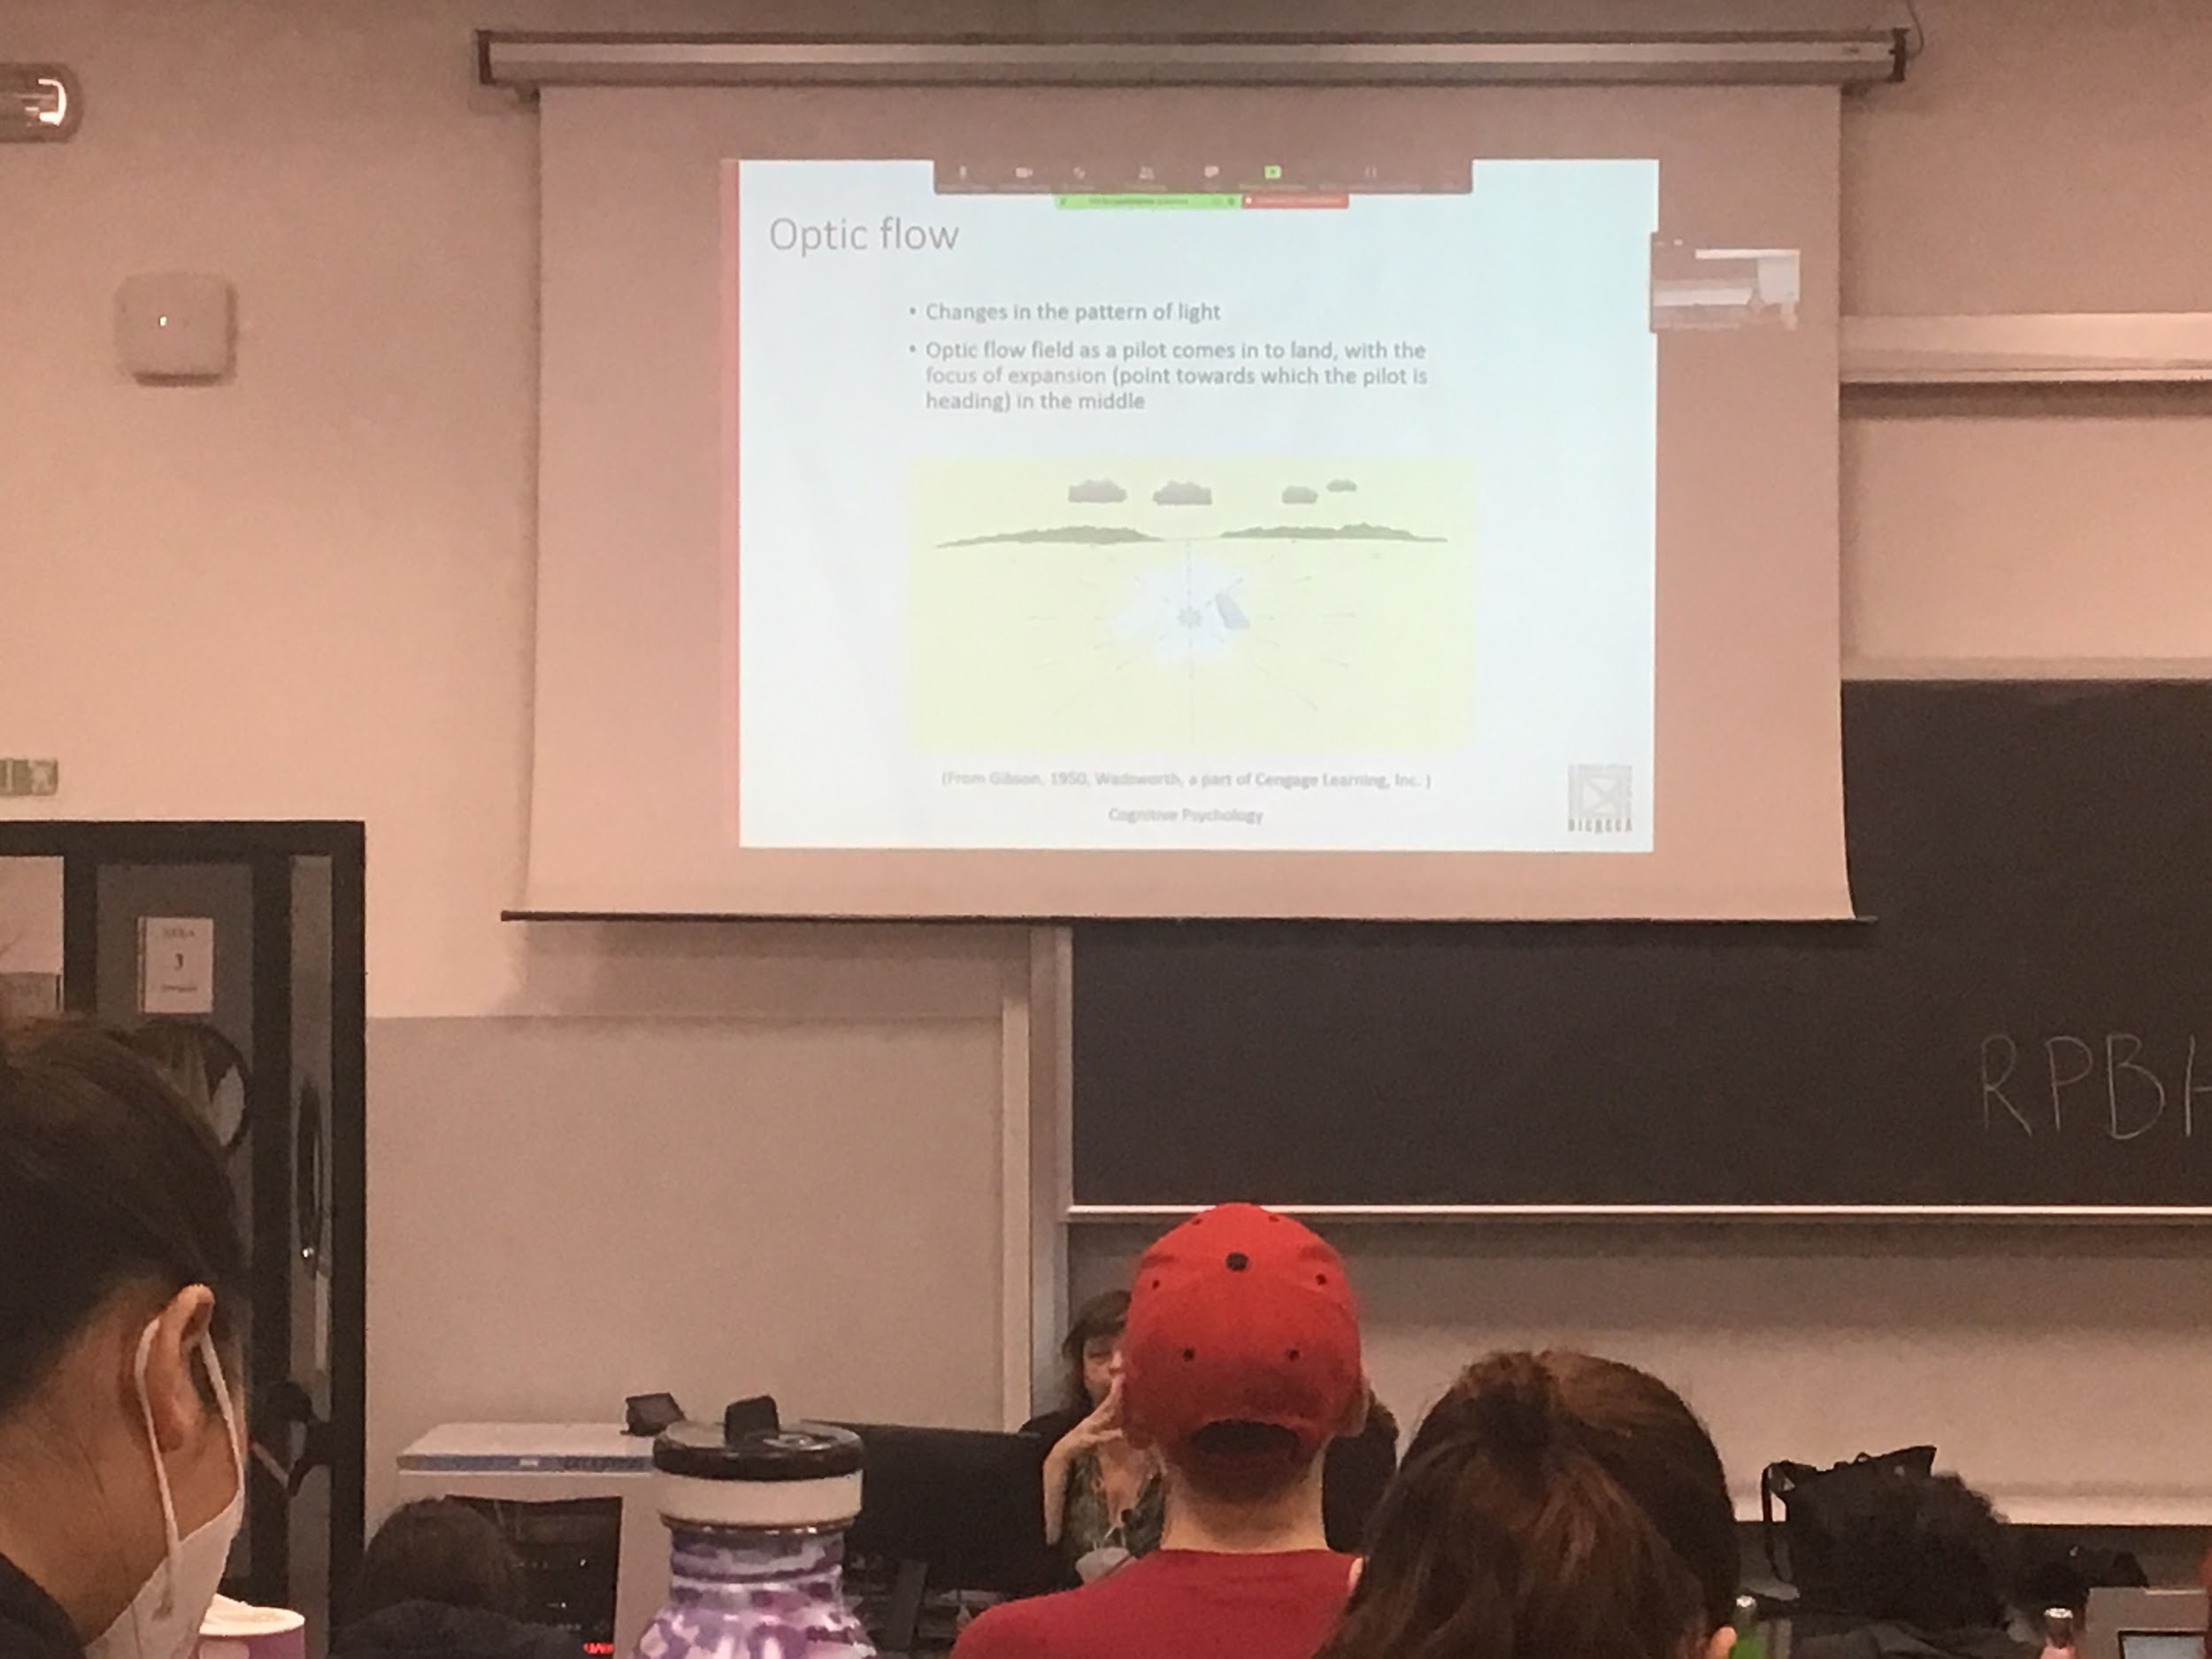

When you try to land you have to understand if you are alligned with the air street (pista d’atterraggio)

The informations you get changes very fast, you are not computing object representation and all the complex calculus

You just need to use the optic flow field, there are some points that does not change they are called *the focus of expansion*

There is 1 point in the visual field that does not change (focus of expaition)

We **walk toward a point and that point is not moving**, is in the **center of the visual field**, everything else is moving laterally. This is the optic flow. Flows from one focus of expansions laterraly

Gibson idea: this is what you need to compute, that you match if to your target

You perform a move to allgin the focus of expansion

Closer to the center move slower

Then brain computes what is called invariants

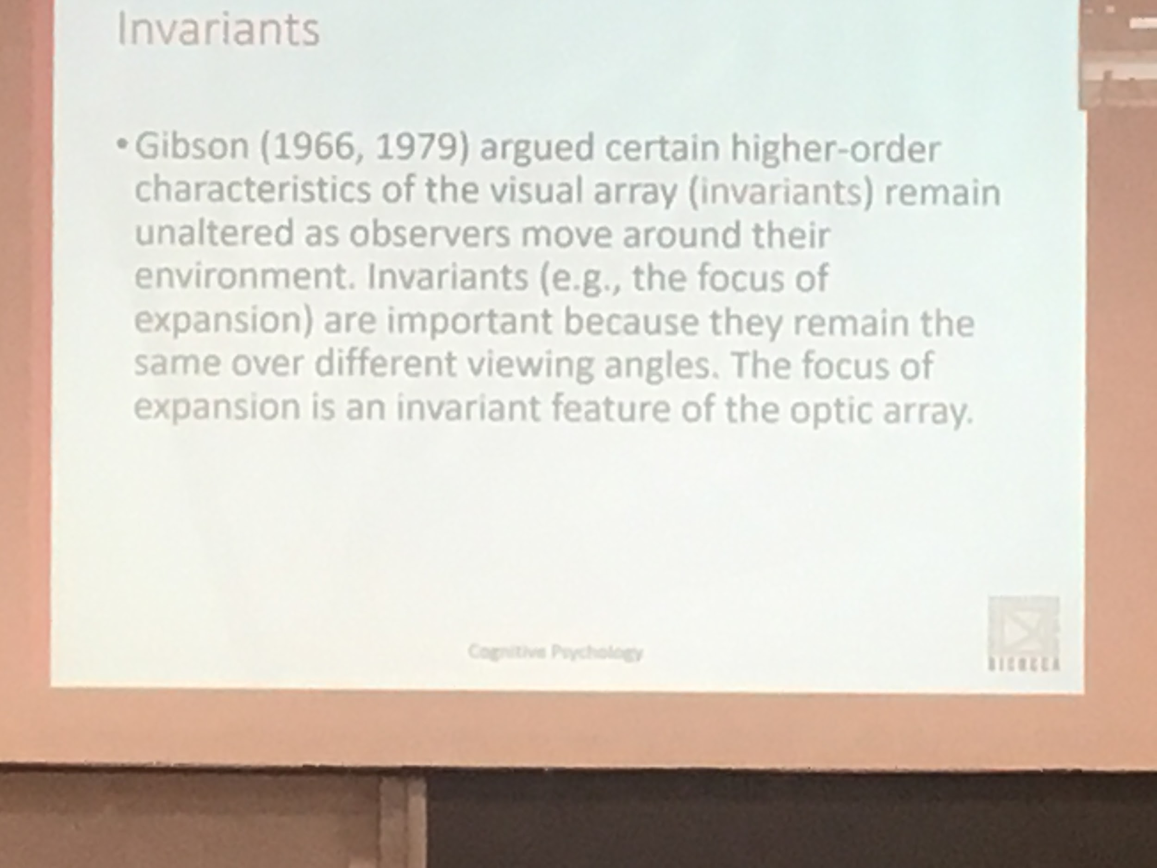

Focus of expantion does not change

Remain the same over different frames



We have to take in consideration **affordances**

Is important to build objects that are easy to use by the people

The system automatically computes affordancy, each objects has some characteristic, that are associated automatically by the system with some specific movement

Having a specific form, people knows how to hold

Even if somebody never saw an hammer before he knows how to hold it, having a specific form, know how to pick it up, the gable is automatically coded to be the way to grasph the object

There are physical chapteristic of objects that automatically are associated in the brain with some specific movement. This is affornaces for Gibson

Is not that when I see something I automatically perform that movement but if I have to perform an action with that object I will chose that specific movement

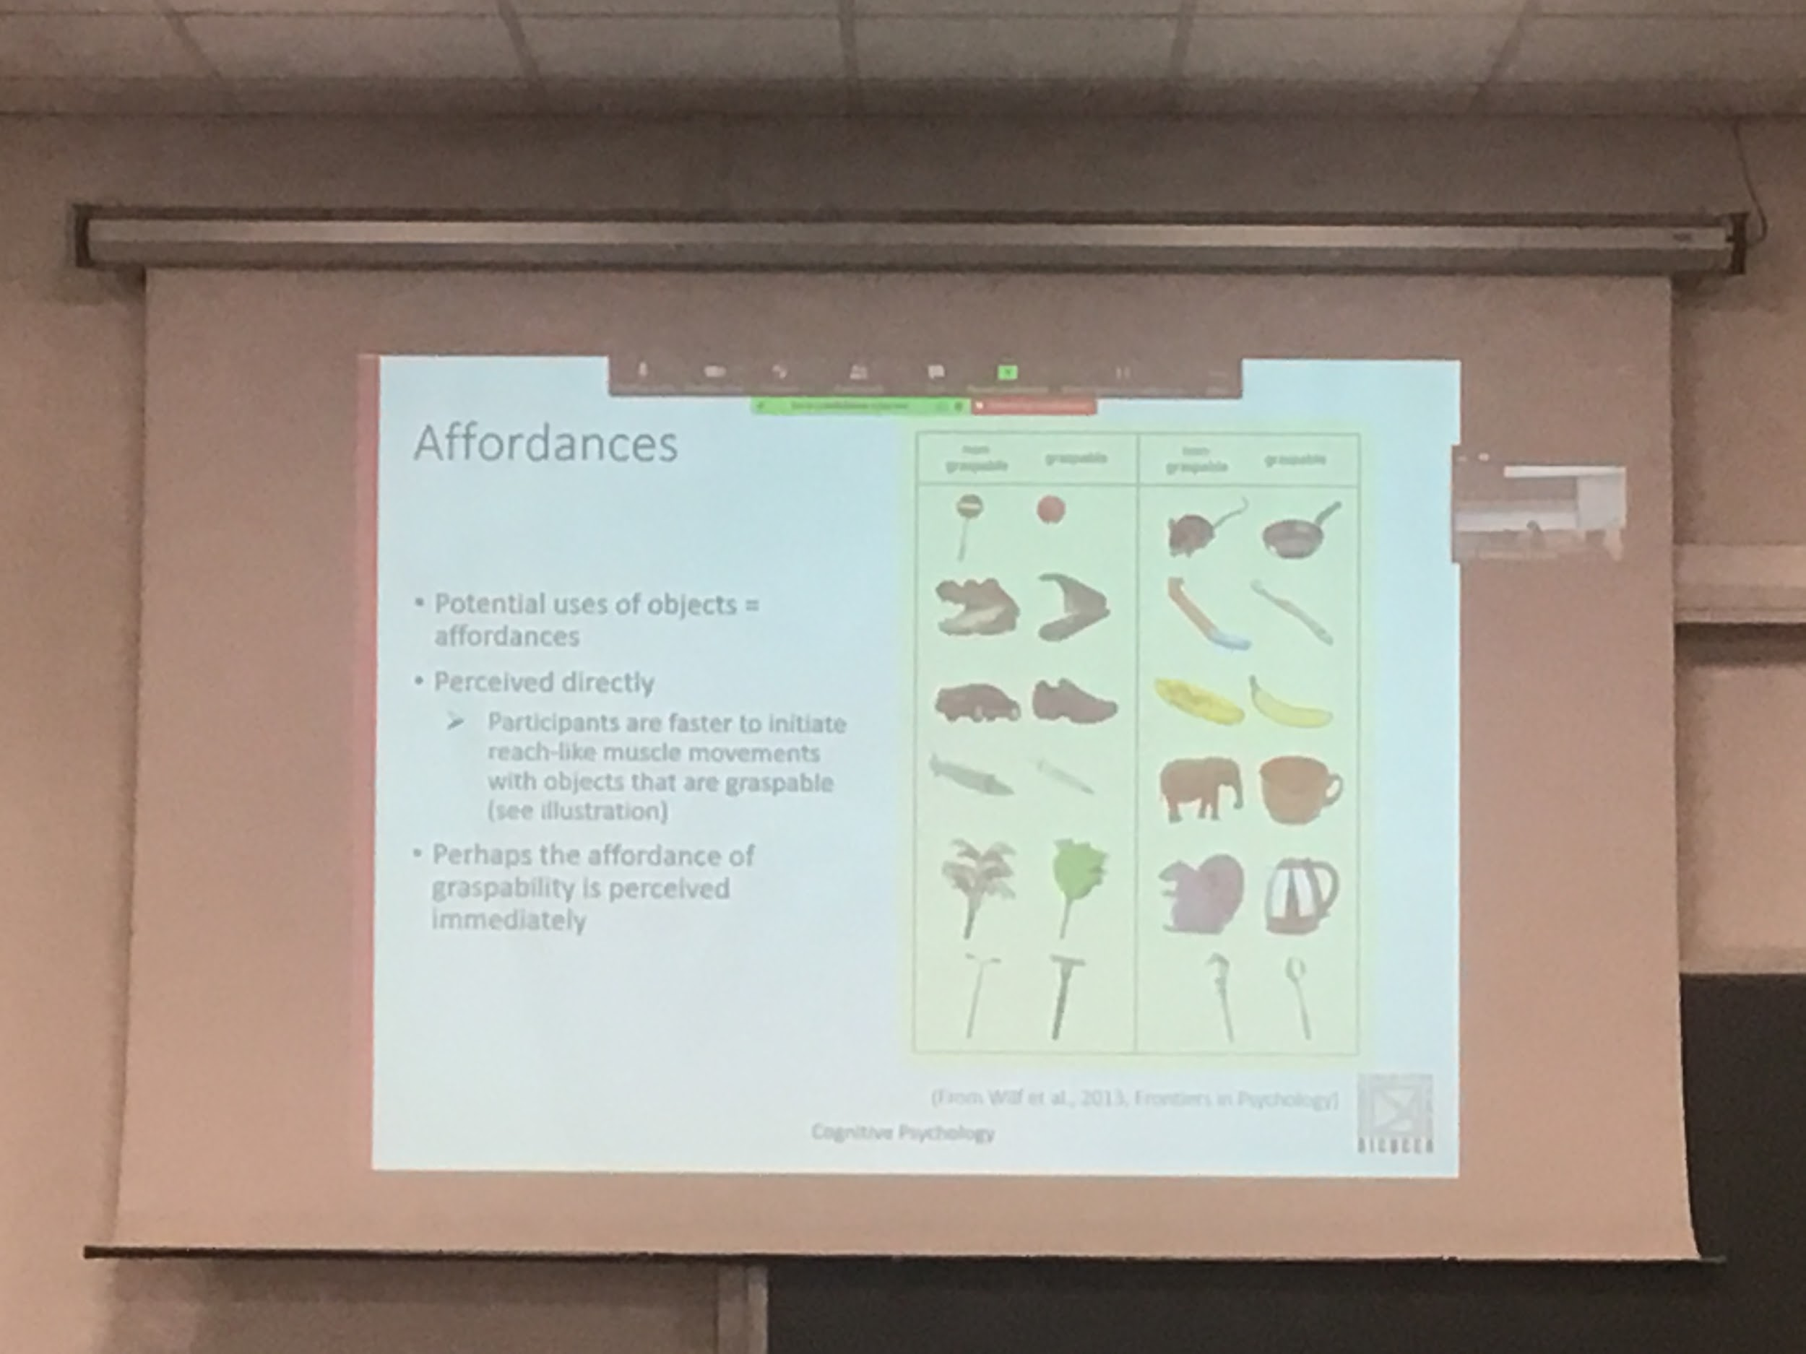

Try to test the idea of affordances, try to see if this information is easly coded by people

People wher shown similar obejcts,some of them graspable some of them not

More or less similar general shape

People were ask to move toward and pick the object up. Faster in their movements when the object was actually graspable. Our brain associates familiar shapes wit some specific movement

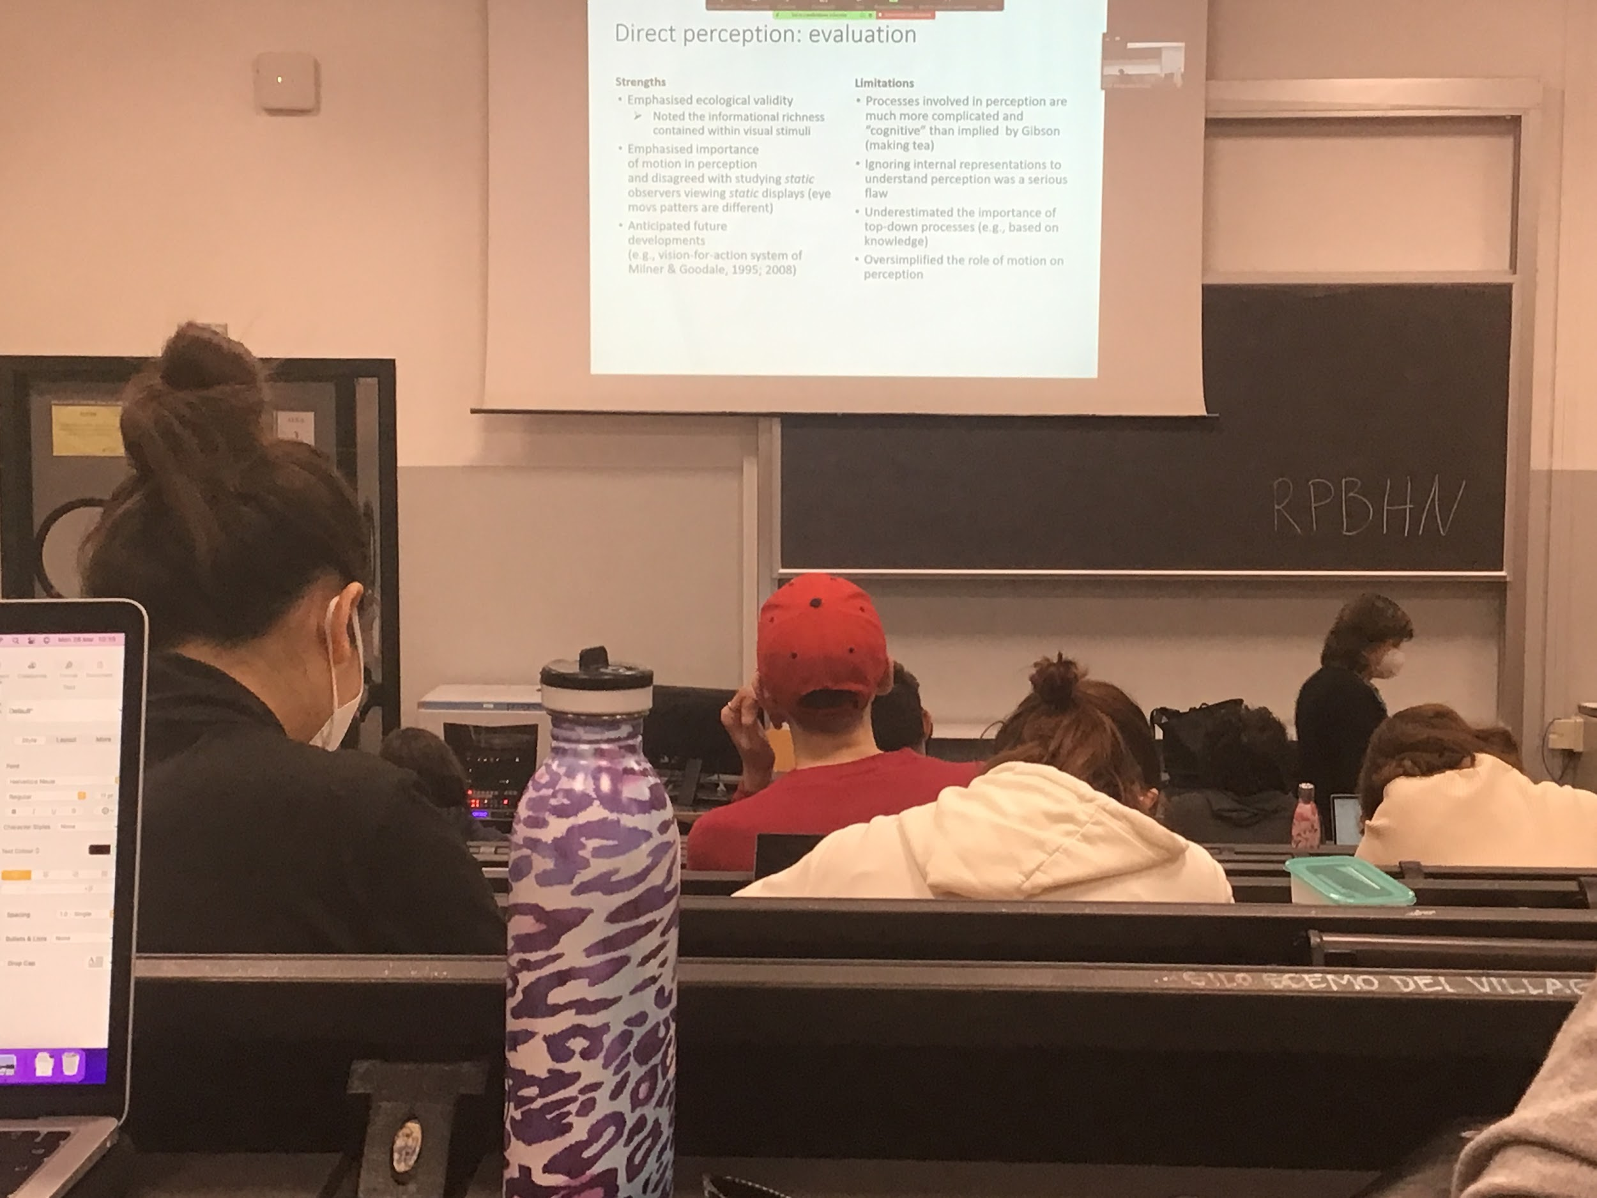

According to Gibson there are some infiormations that the system computes that do not requires multiple representation, that are automatically almost immediately present in the optical array. Called *direct perception* or *virtual theory of Gibson*

Informations is already there as informations that help interact with the object. It is very important

Not considering the other part, focusing on the visual paraption part

Performing tasks is much more complex

You know how to grasp the tea cup, but to make a tea you need a lot of sequences of action that you have to perform in the correct order

A representation means that you are in some way extracting informations from the image and build a metal representation, what you need is already in your brain. You don’t need to extract information about the visual field

**Motion perception and action**

**Visually guided movements**

Real life application of Gibson approach

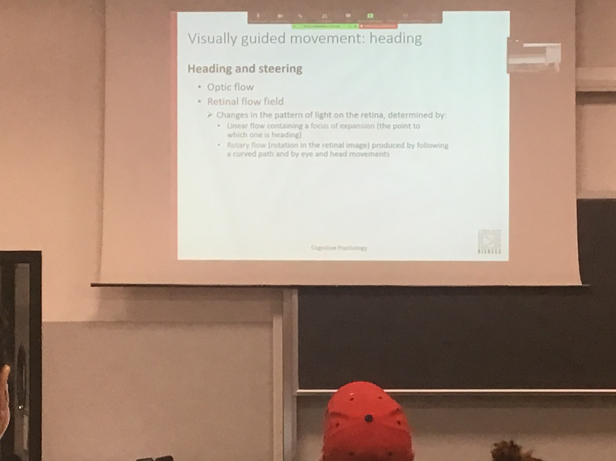

Heading: Understanding where we are going, most of experiment done by driving, because there the speed of the brain is much higher, push the brain to the highest speed

Gibson interpretation: optic flow of informations coming to you, on the retina there is flow of informations, changes on the retina are of two types

* Linear flow: starting from the focus of expansion (point where I am going to)
* Rotary flow: moving my end and moving my eyes but the car is moving straight

First thing that the systems has to do is to discount eyes information

When driving a car you can change what you are looking at but the brain has to be able to separated thins types of movement information

There are data in favour of this ability of the brain to calculate in different areas this types of motion

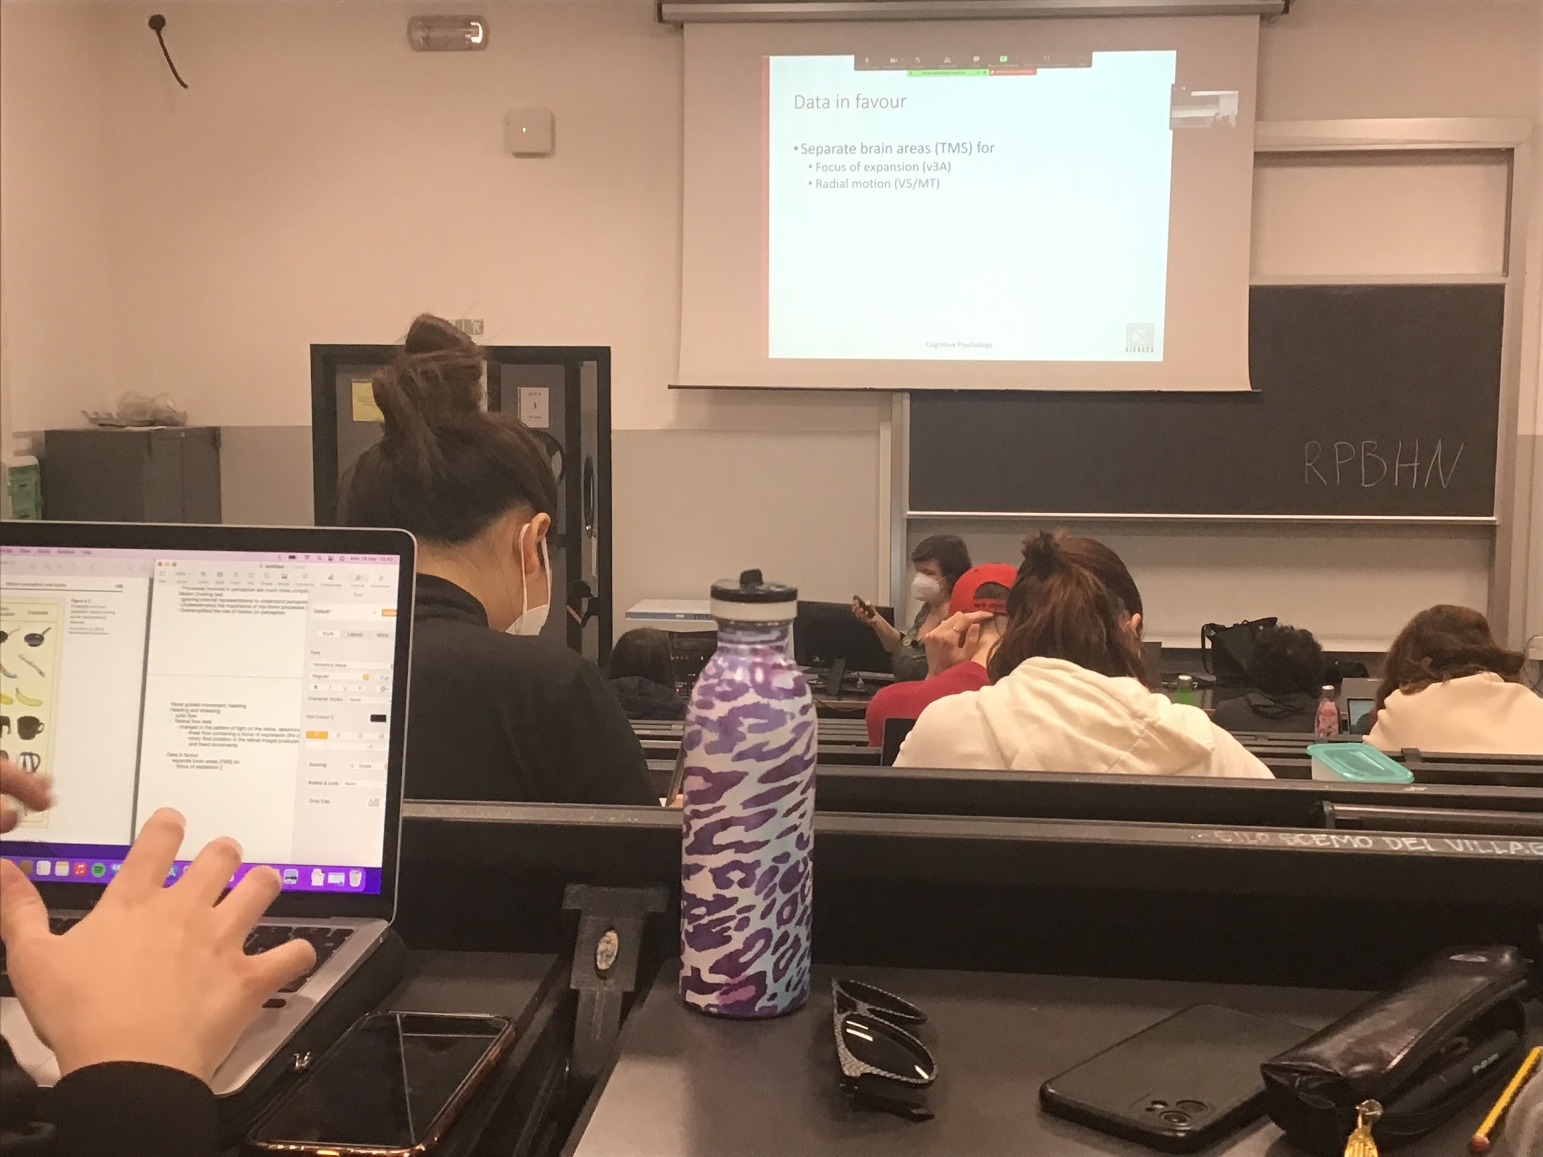

If you apply TMS in area V3A we are unable to detect the focus of expansions

Different areas code different types of information

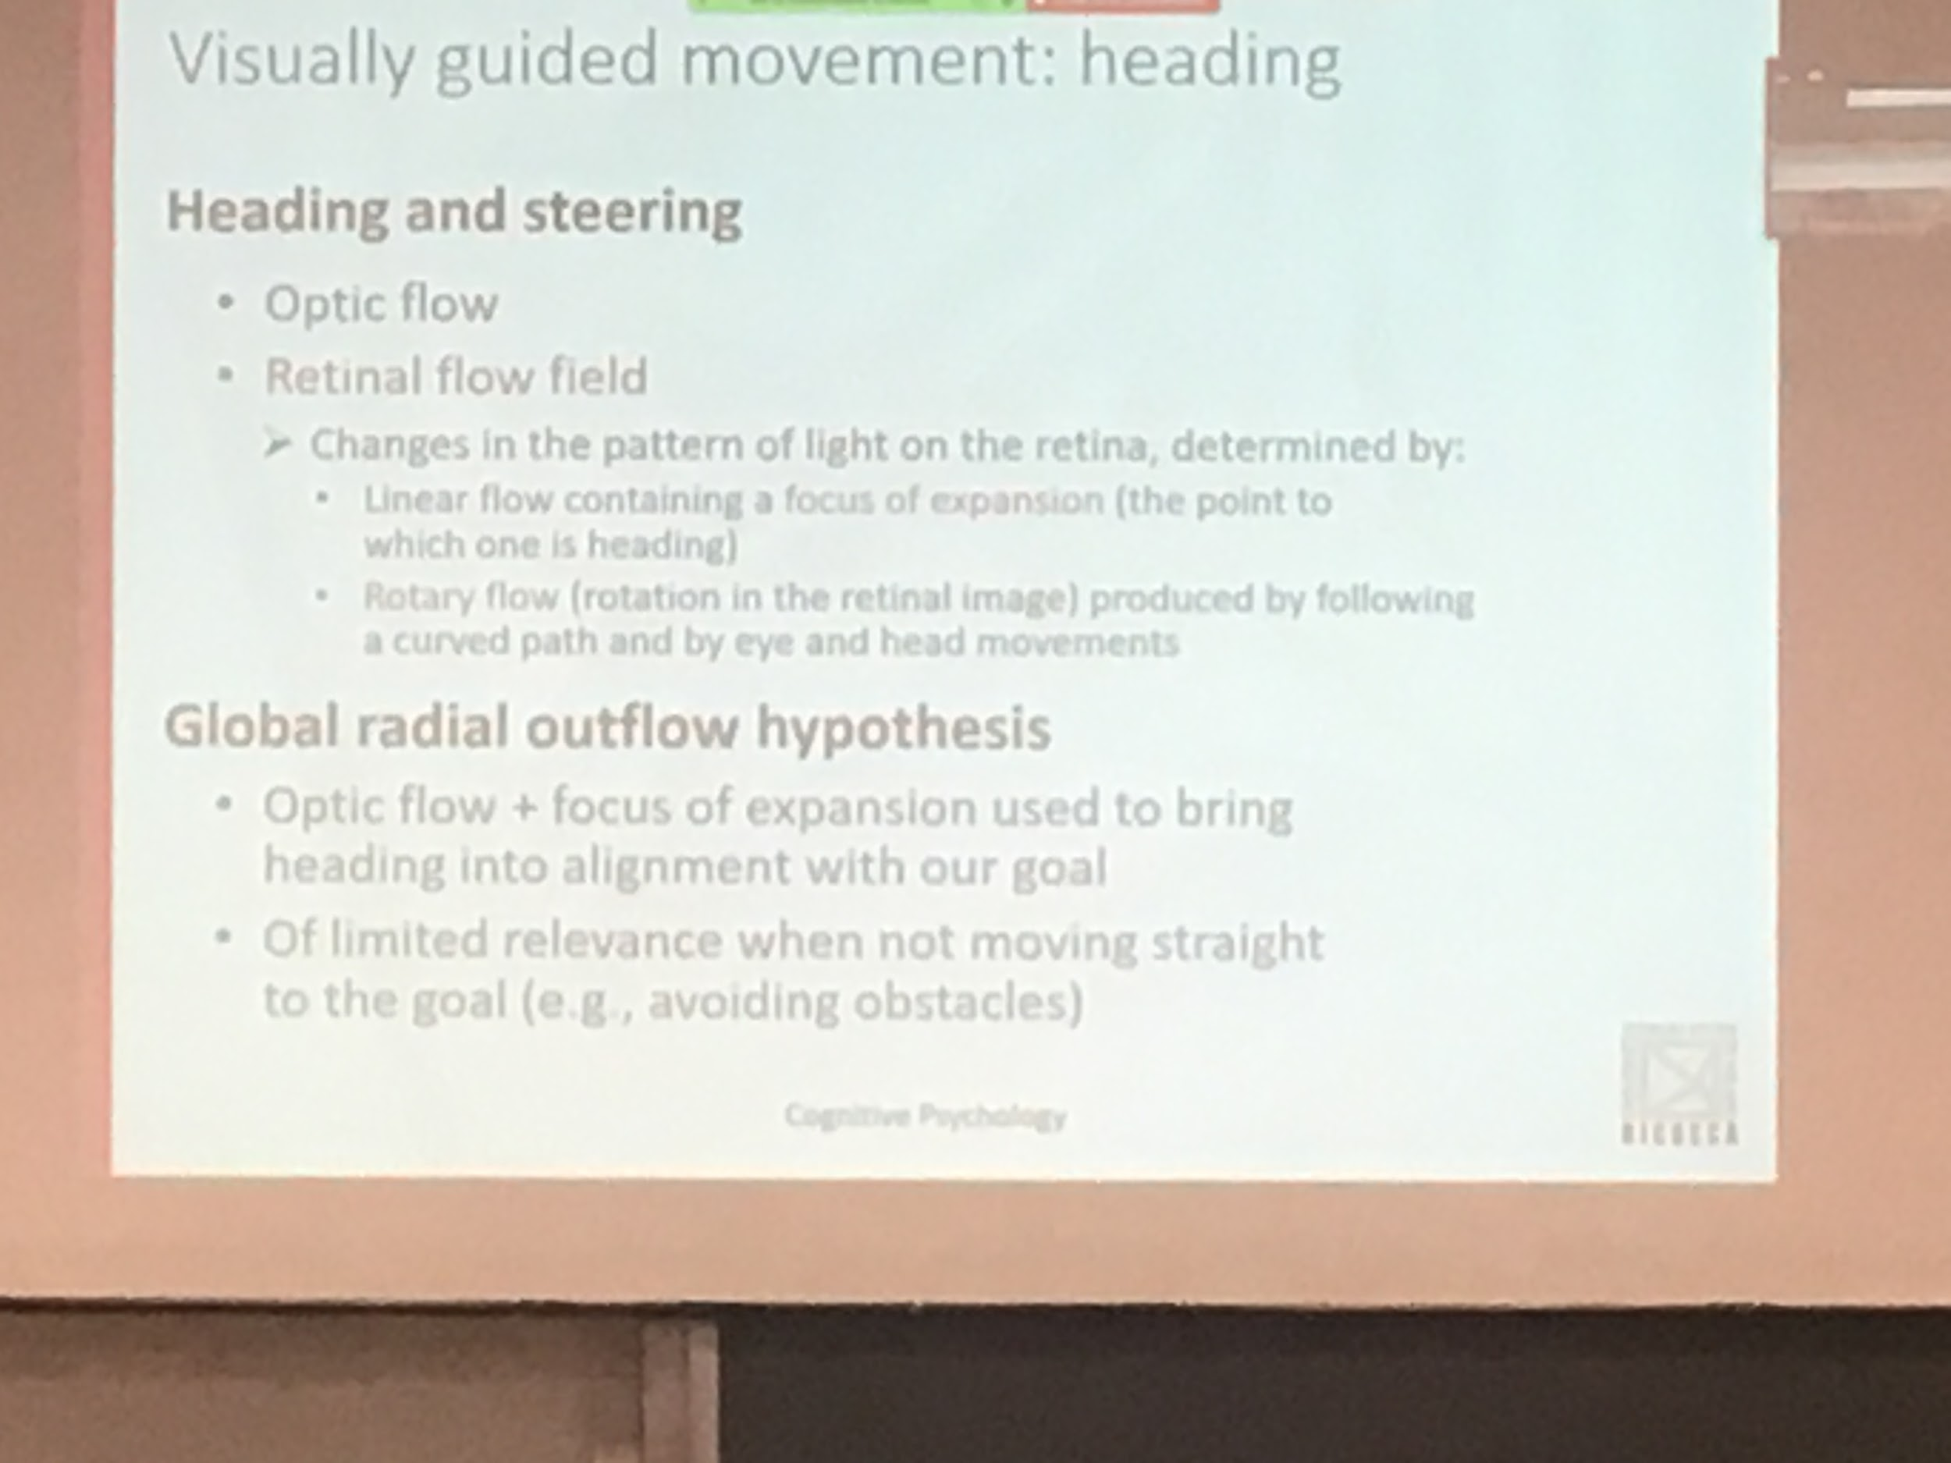

If I ask you to wear glasses that moves our perception laterally of x degrees you actually correct your movement thinking you are going a different direction

If I give an incorrect focus of expansion you correct going toward the incorrect focus of expansion. If you change the other type of informations you don’t care, you think you are going wherever you are going

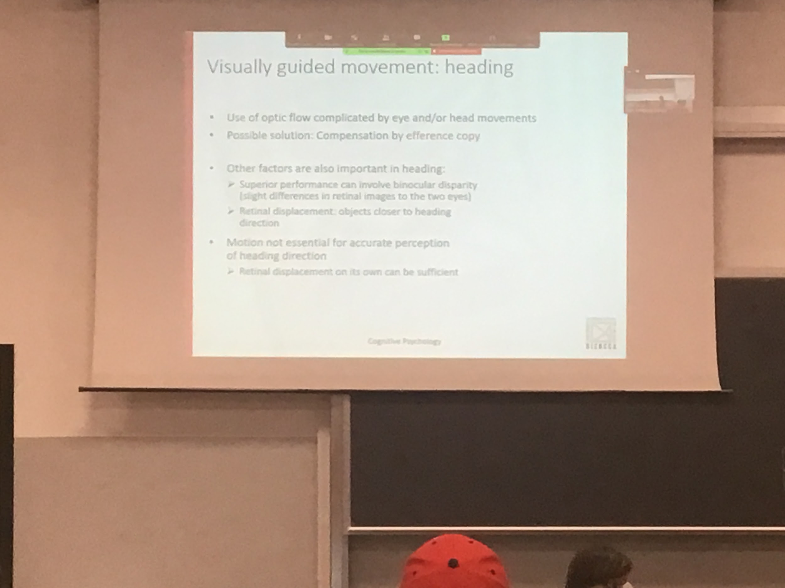

The system is able to disregard information about the eye and head, how does it do it?

Use the efference copy: when I am telling my eyes to move from a position to another, I can give the same information to the visual system

What is register in the retina can be updated

There are not only these types of informations that are computed from the system, there are others factors

Heading: going straight toward a position

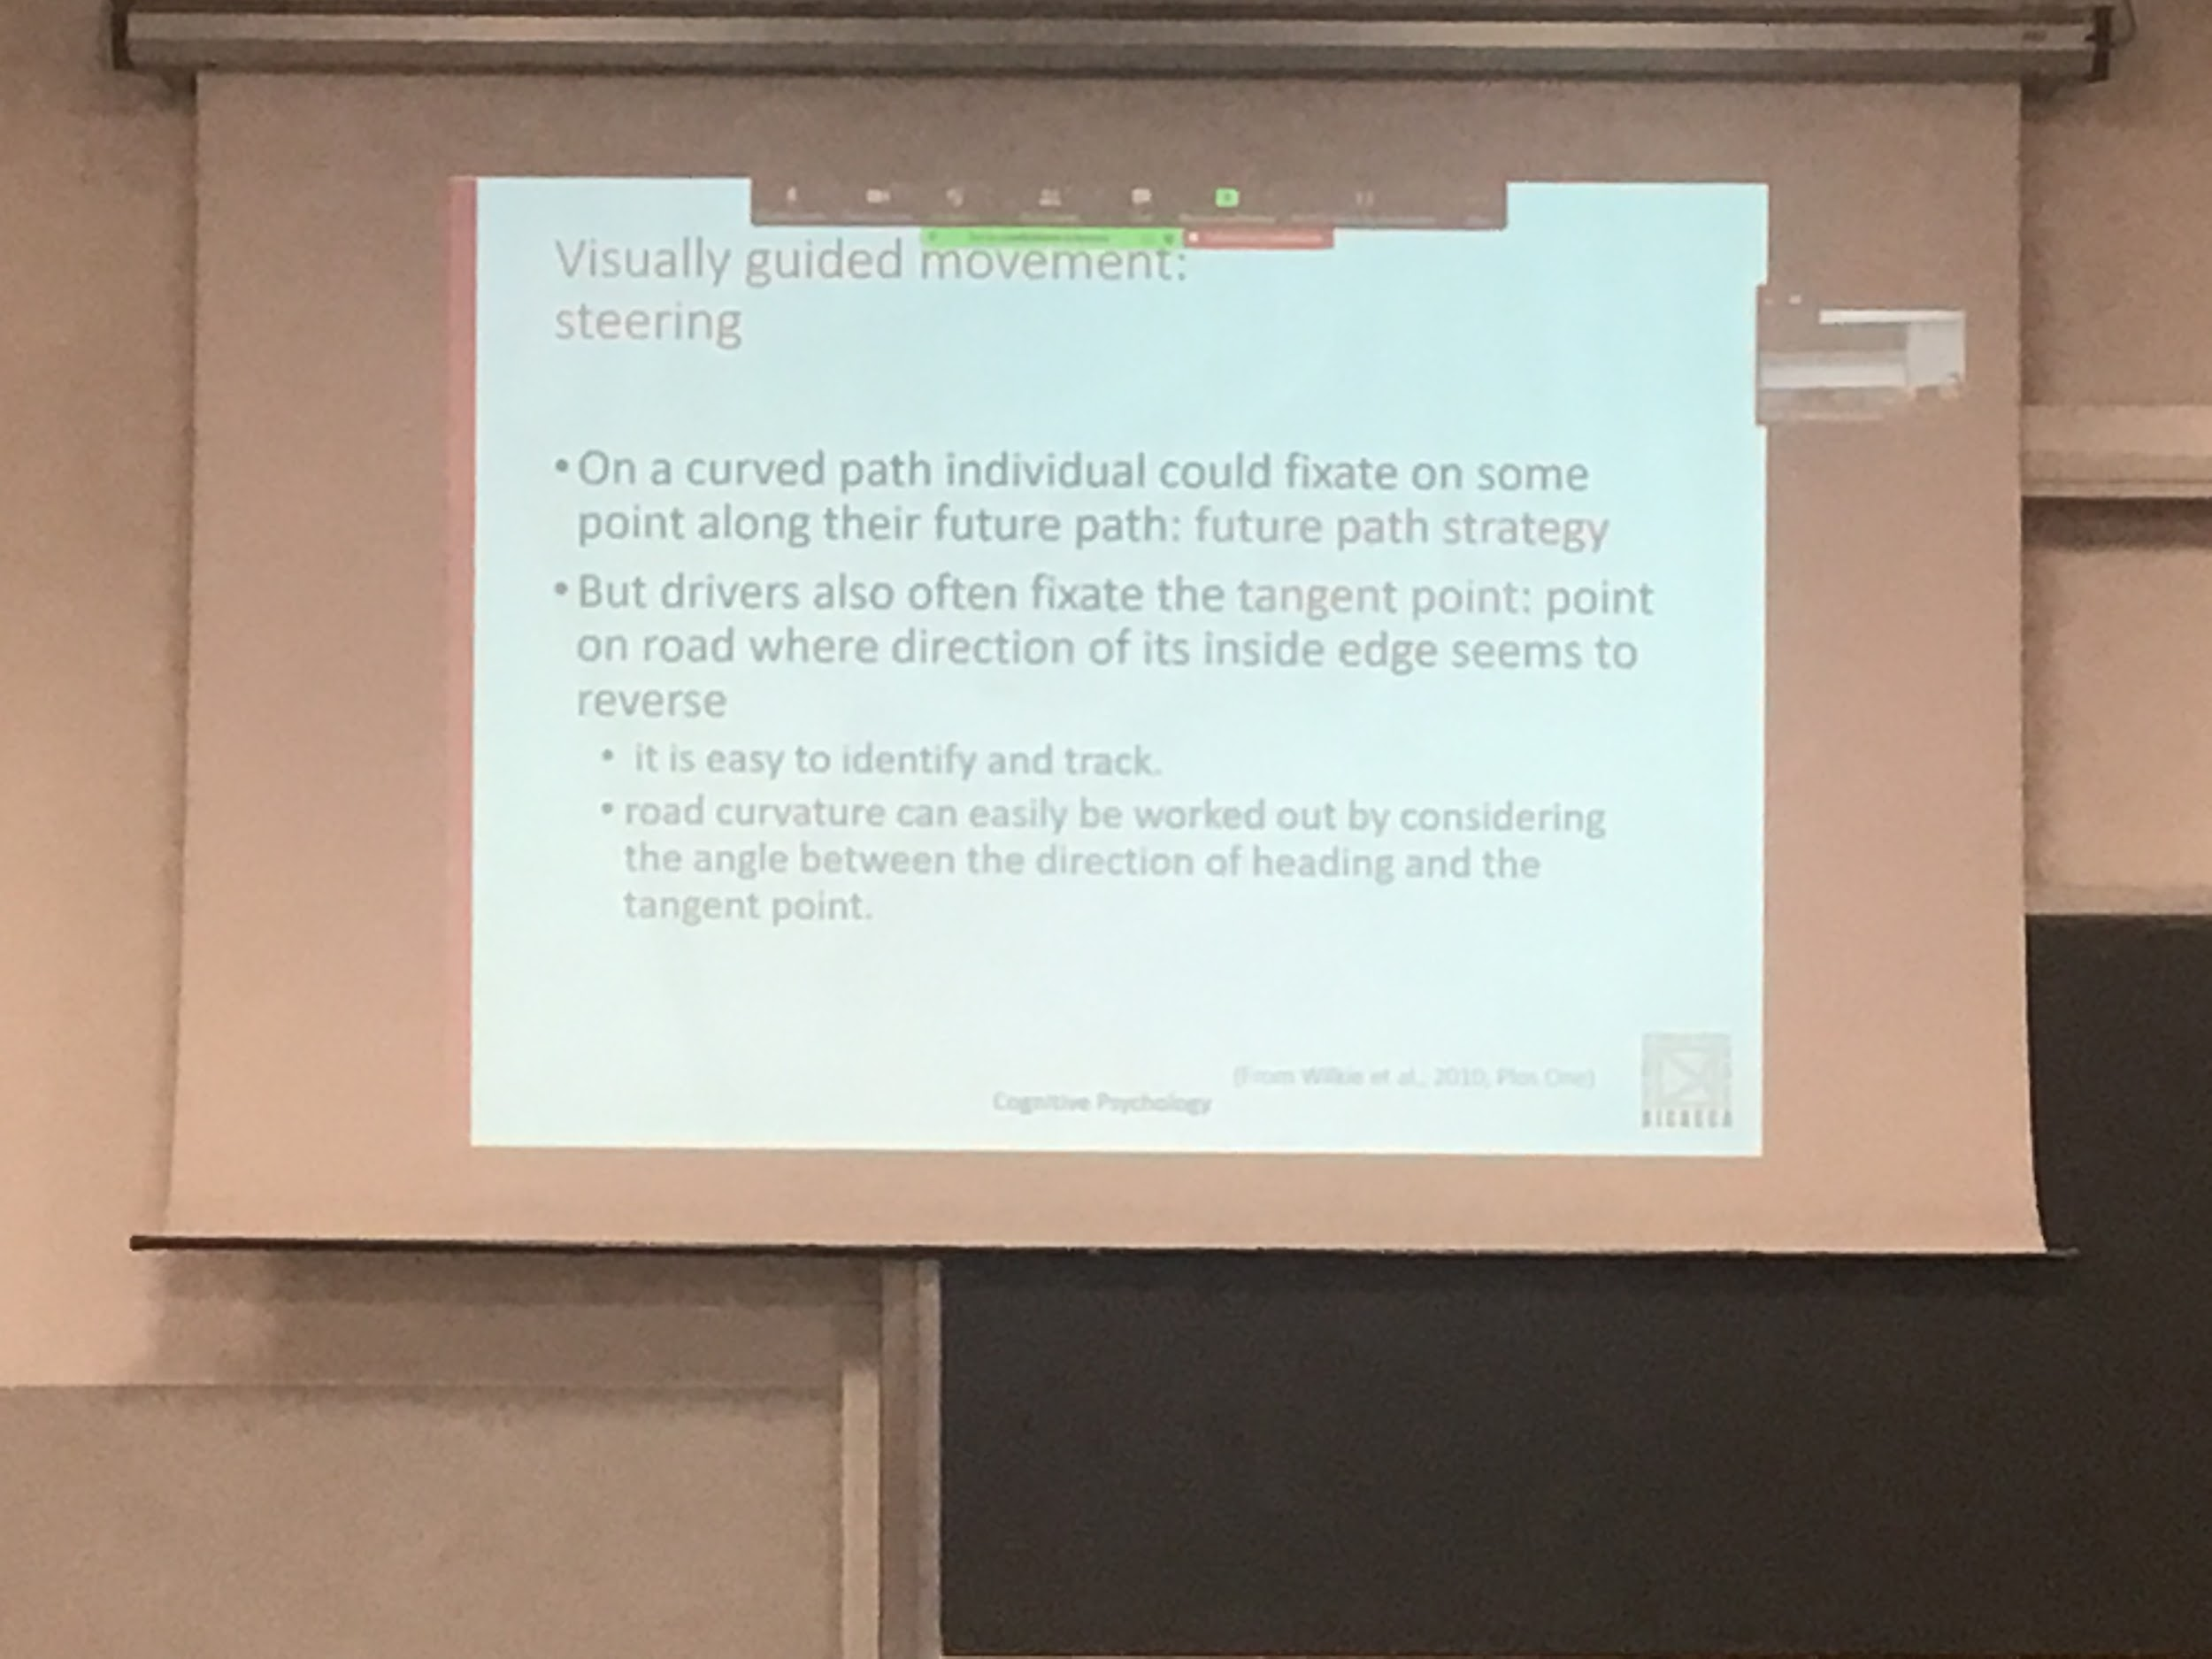

Steering: moving not straight,

Where am I looking when I take a curve path?

Two alternative hypothesis

* Looking at some point along where I am going, where I will be in the future
* We fixate the tangent point, the point of maximum curvature where the road changes loop

Tanged point: point of maximum curvature, easy to identify and to track, knowing that point I can understand how the road curves

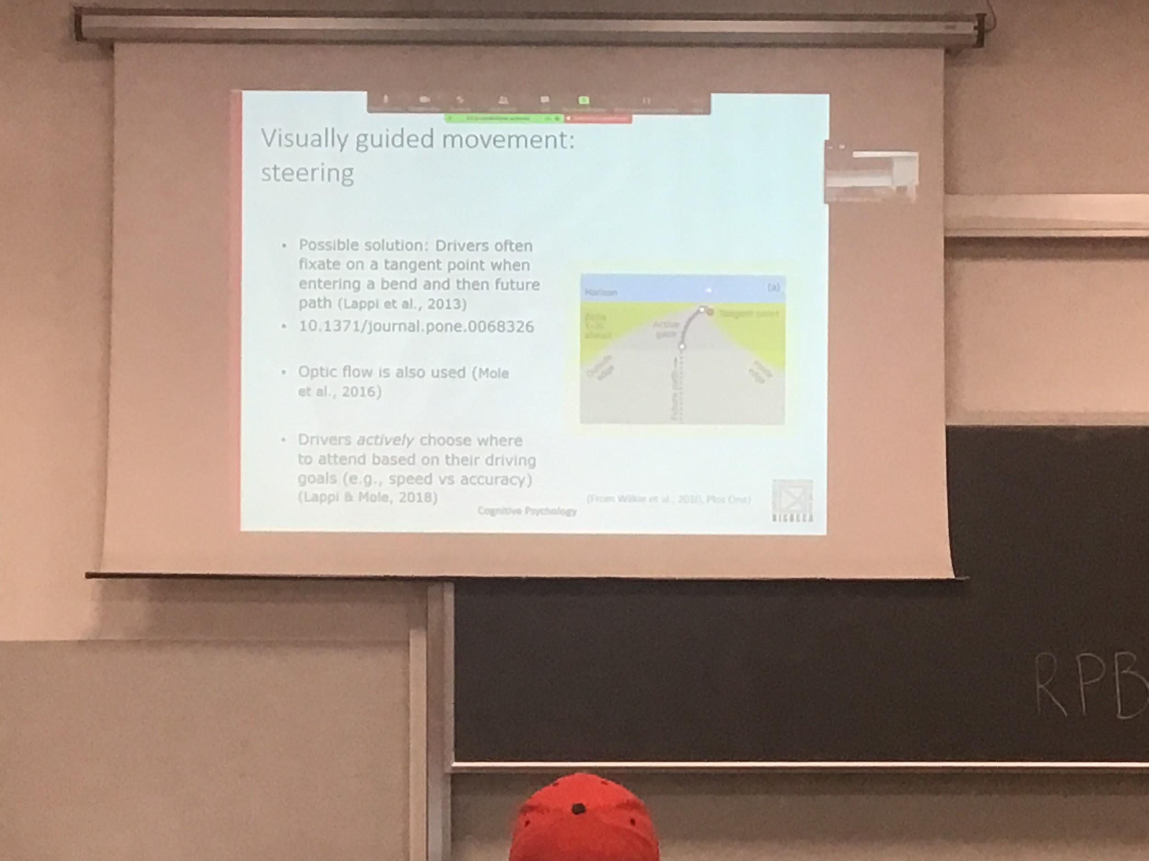

People when driving are not really looking at the tangent point, people look further up what it is the further path

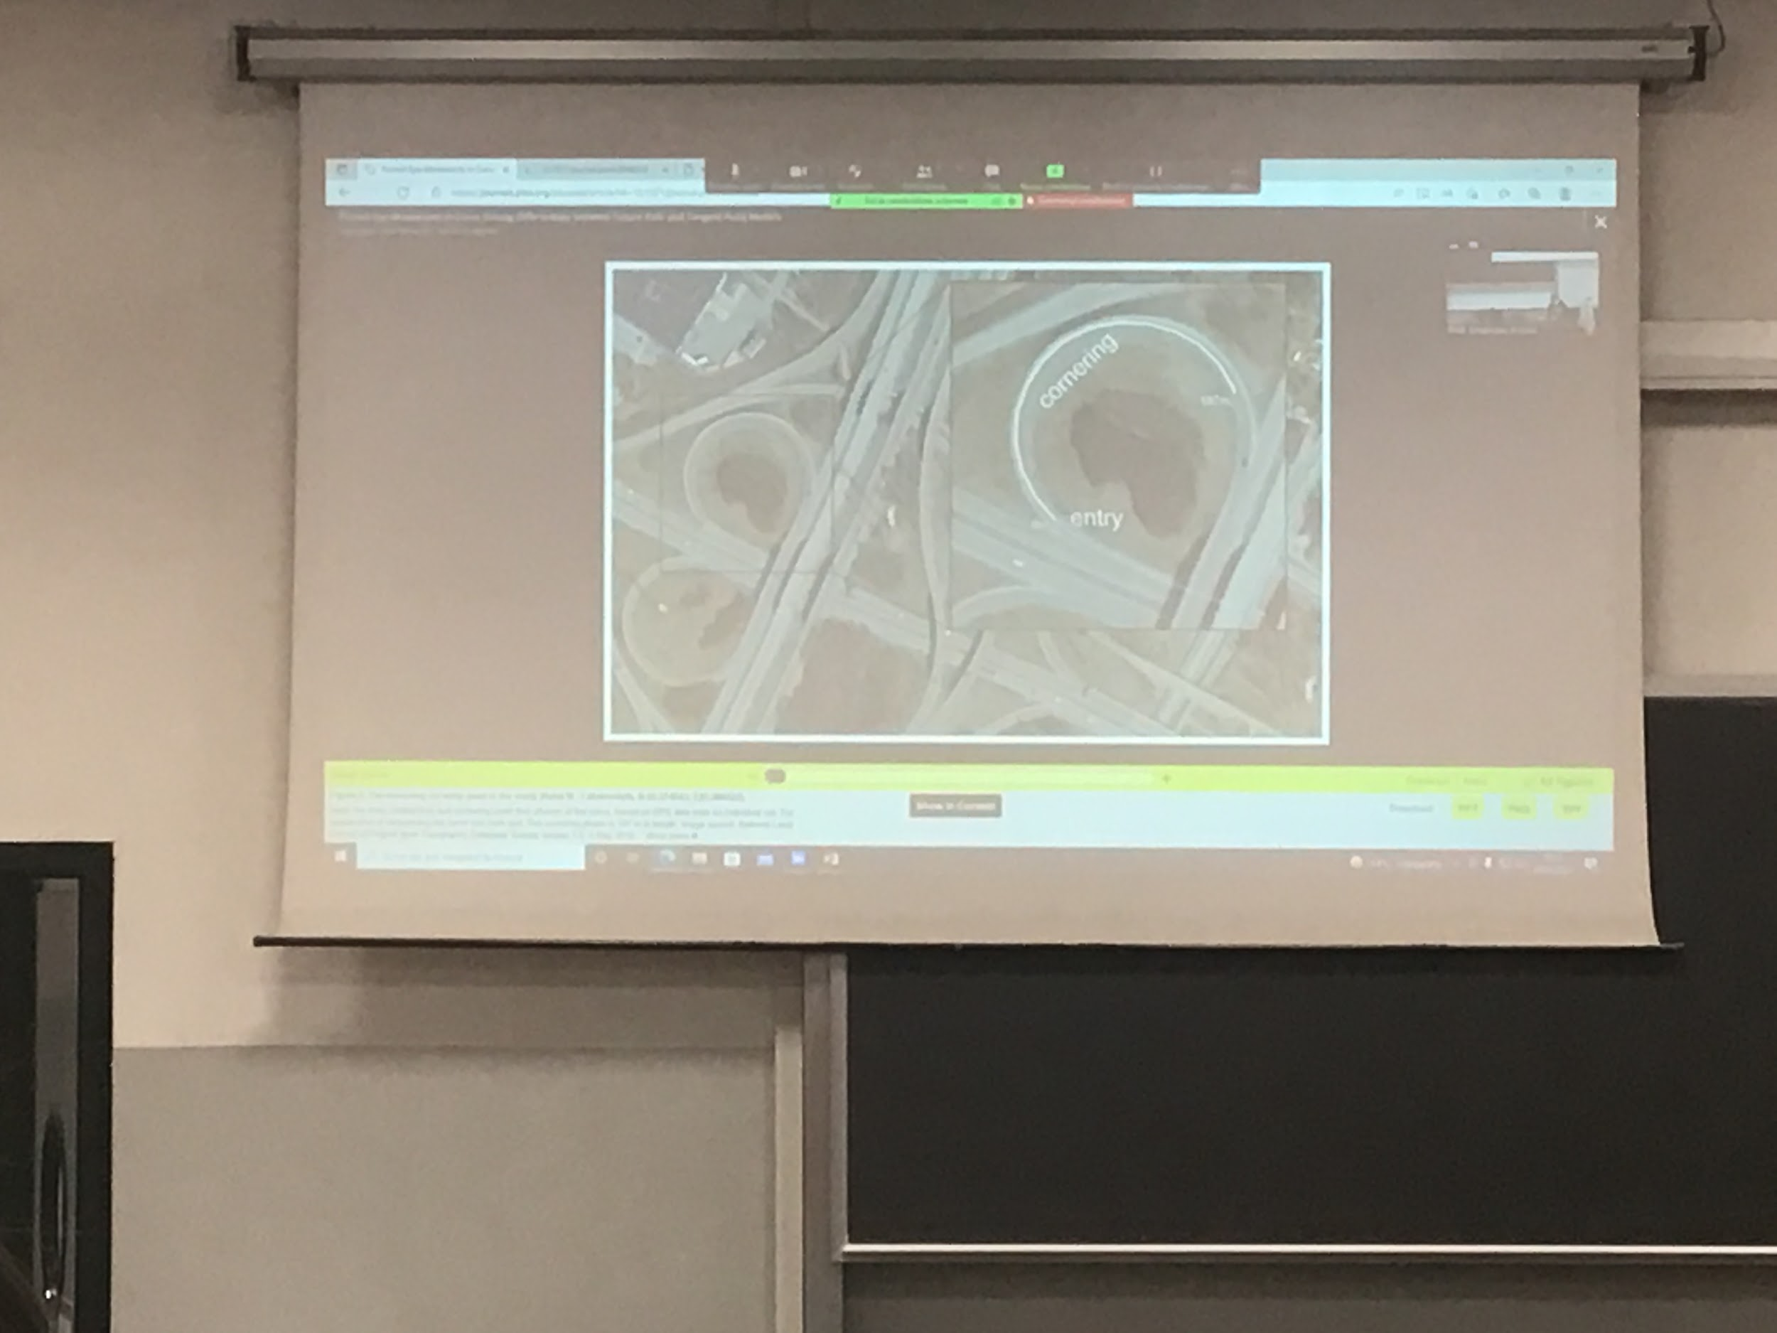

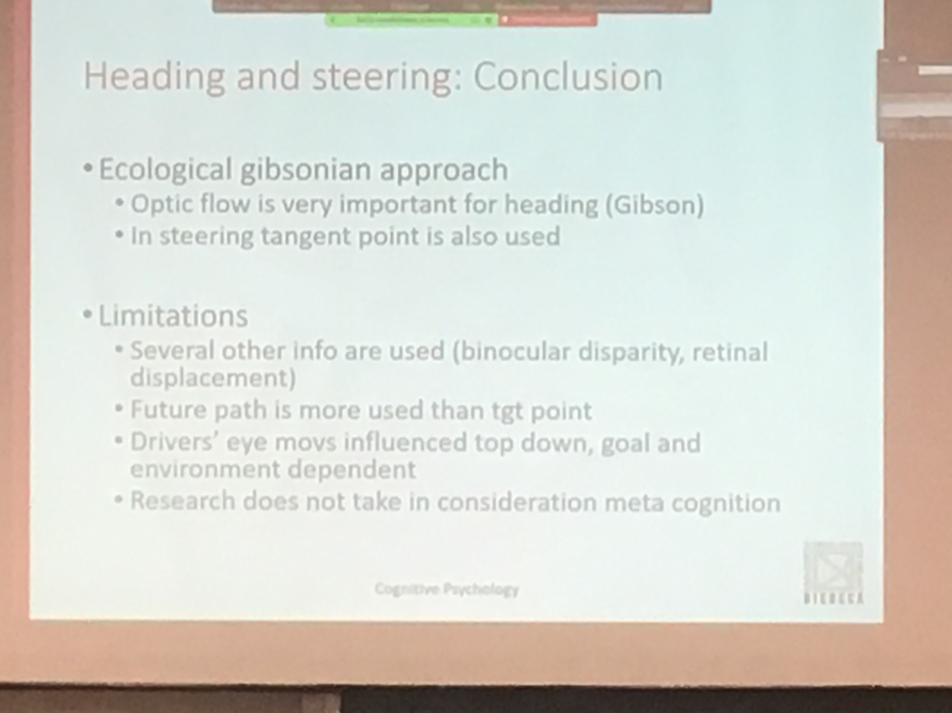

Gibson: optic flow is very important for heading

In reality many other pieces of information on top of tangent point and optic flow are used (binocular disparity: how far away is from you a specific object. Retina displacement of an object in a given time)

The tangent point is define in any given moment

People look at the future path, that is not an invariant, can have different invariantes

Where you look at depends a lot on what you are doing and how often you perform that road, after a while you will not even realise you are curving

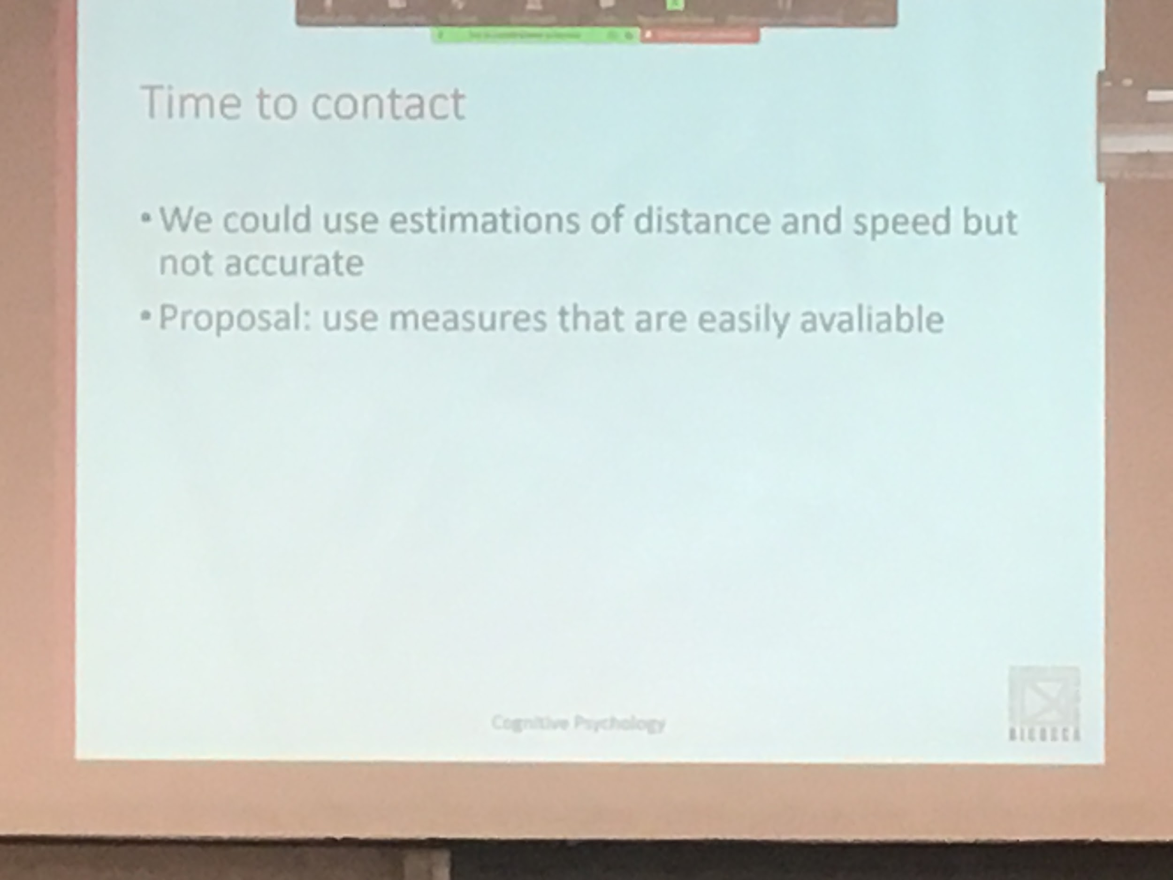

Don’t consider Meta cognition: what you think you are doing, how good you think you are at turning, or driving

INIZIO AUDIO 3

One of the computation that we have to make is calculating what is code in the literature time to contact

Time to contact: How much time will take the object to get in contact with me

We could use some informations like estimating time distance and actual speed

Distance and speed are not easy to calculate

One proposal that has been done is to use some measure that are easily available

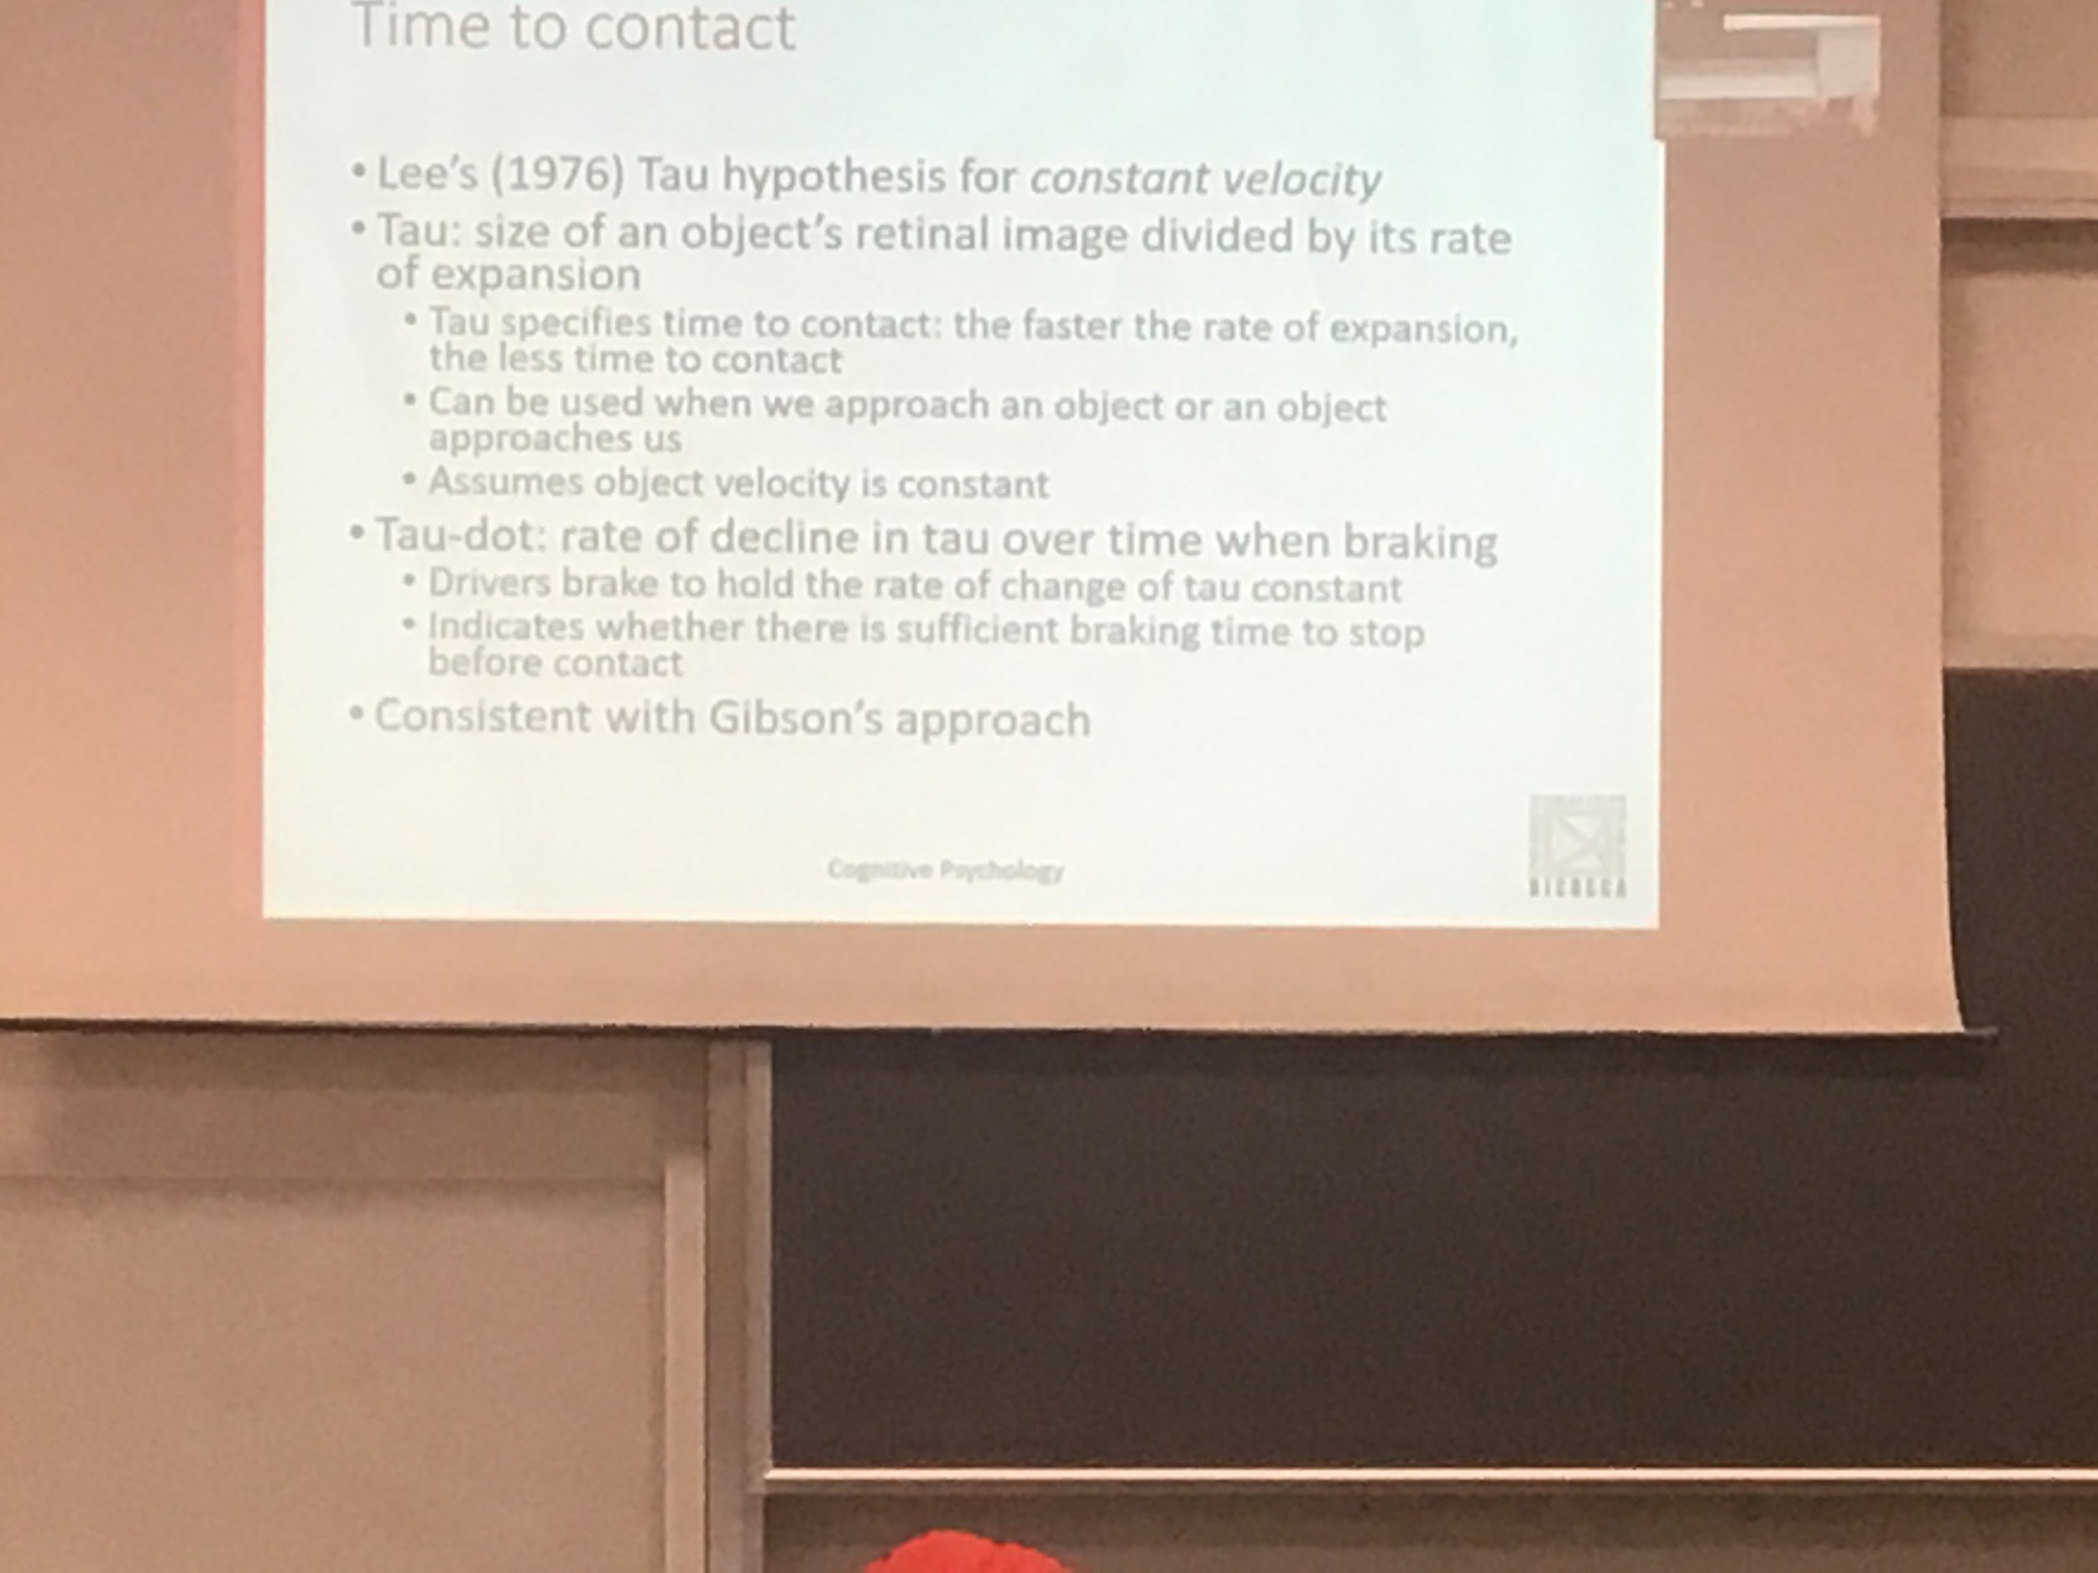

Lee’s proposal that the system computes a parameter called *tau*, is proposal was anticipated by a fictional book

Τau is an invariant easy to compute

The computation of the size of the object in the retina image (how much space occupy in the retina) divided by it’s rate of expansion (what is the increase over time)

Do not need to know the distance of the object, just look at the retina image

Τau is useful if we have constant velocity → can predict where is going to be

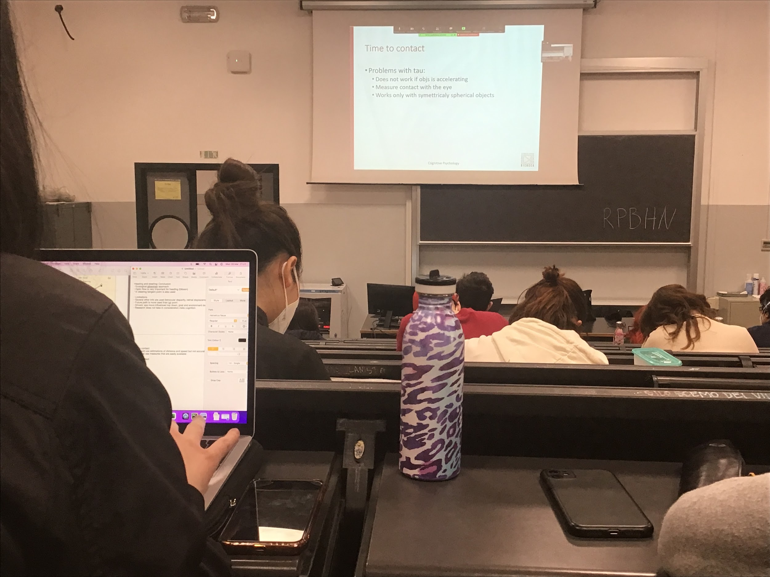

Faster rate of expansion → shorted time to contact

Time to contact can not be enough, might need others

Consistent with the Gibson approach, tau is an invariant, very easily computed from the optical flow

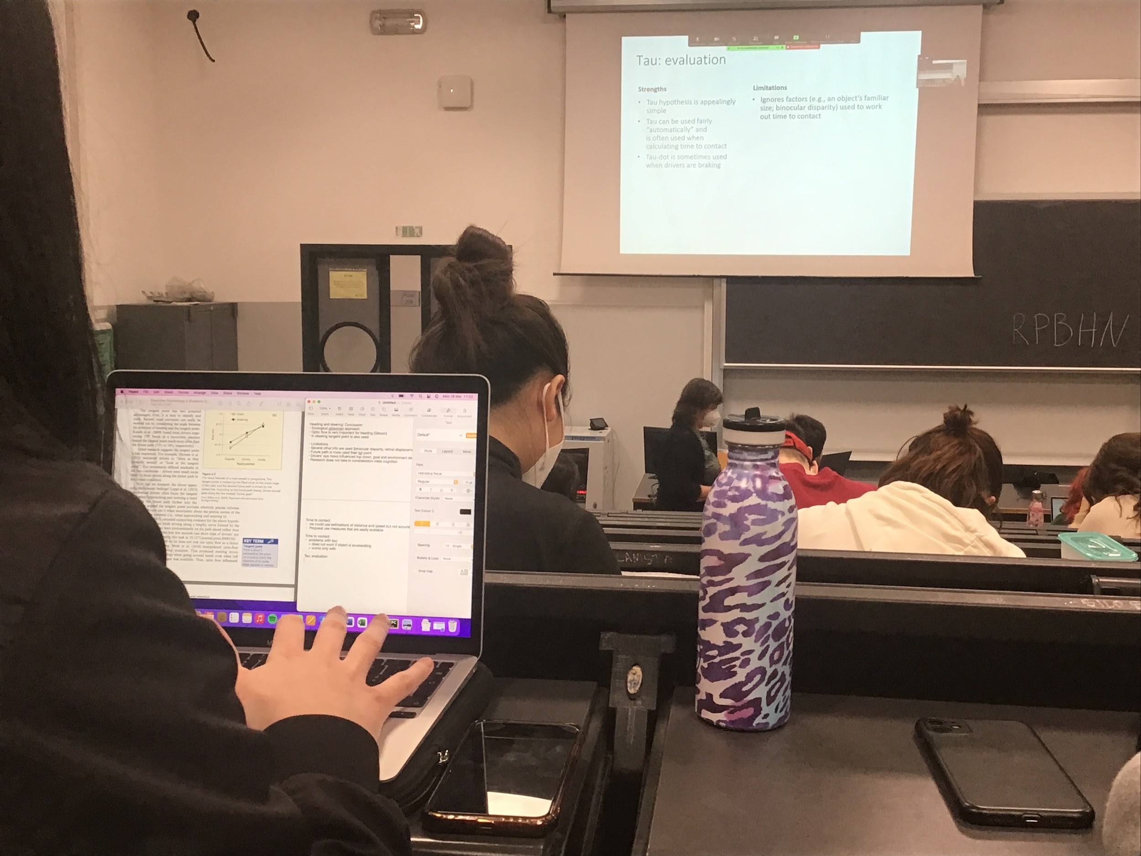

Can be estimated even if we are doing a different task

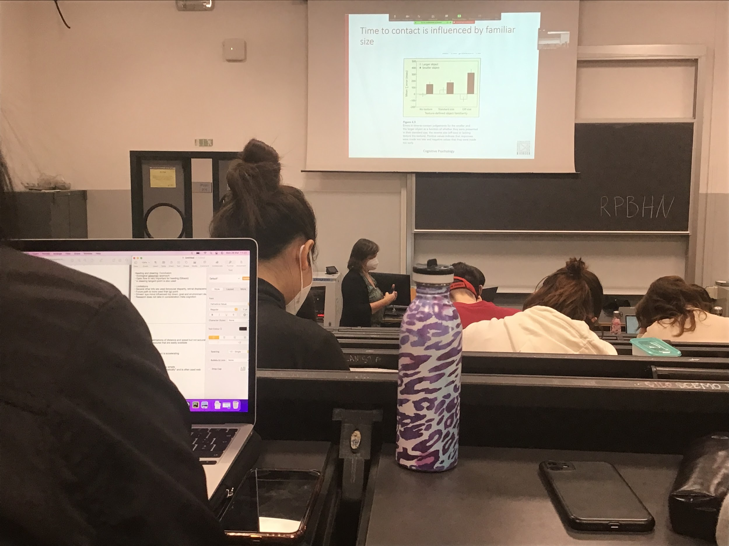

Τau should not be influenced by familiarity

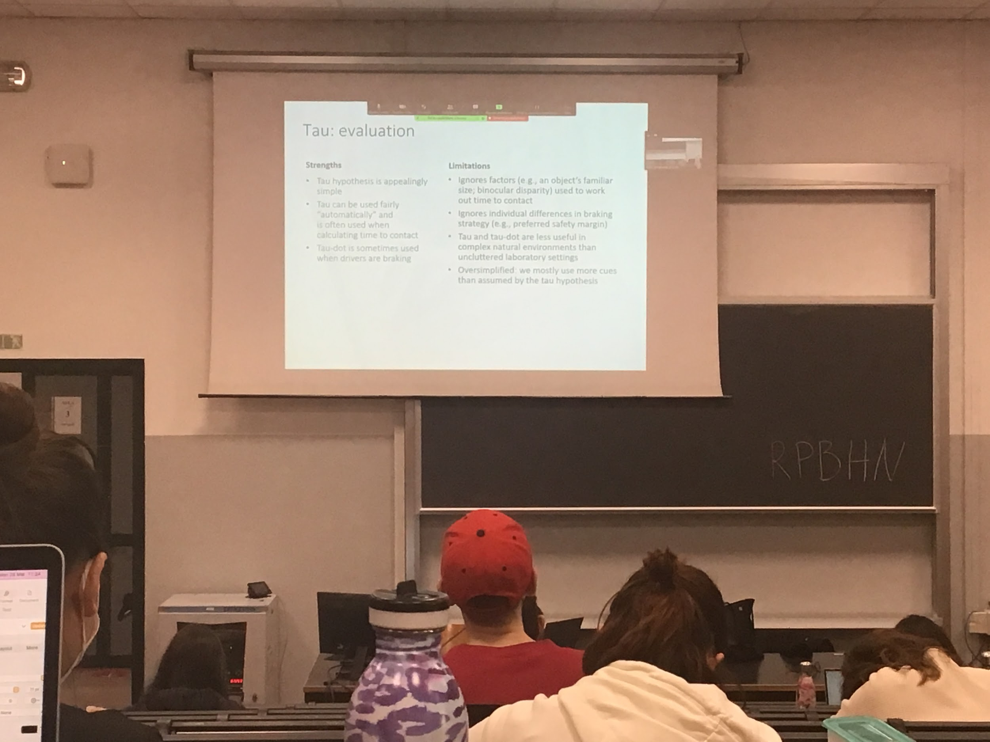

There are people that prefer to start breakin(frenare) very early and people stops in different position

When we have complex images with a lot of things moving is much more difficult to rely on time constant

**Motion perception and action**

**Visually guided actions: contemporary approaches**

All these experiment brought people to come up with different models on visually guided movement

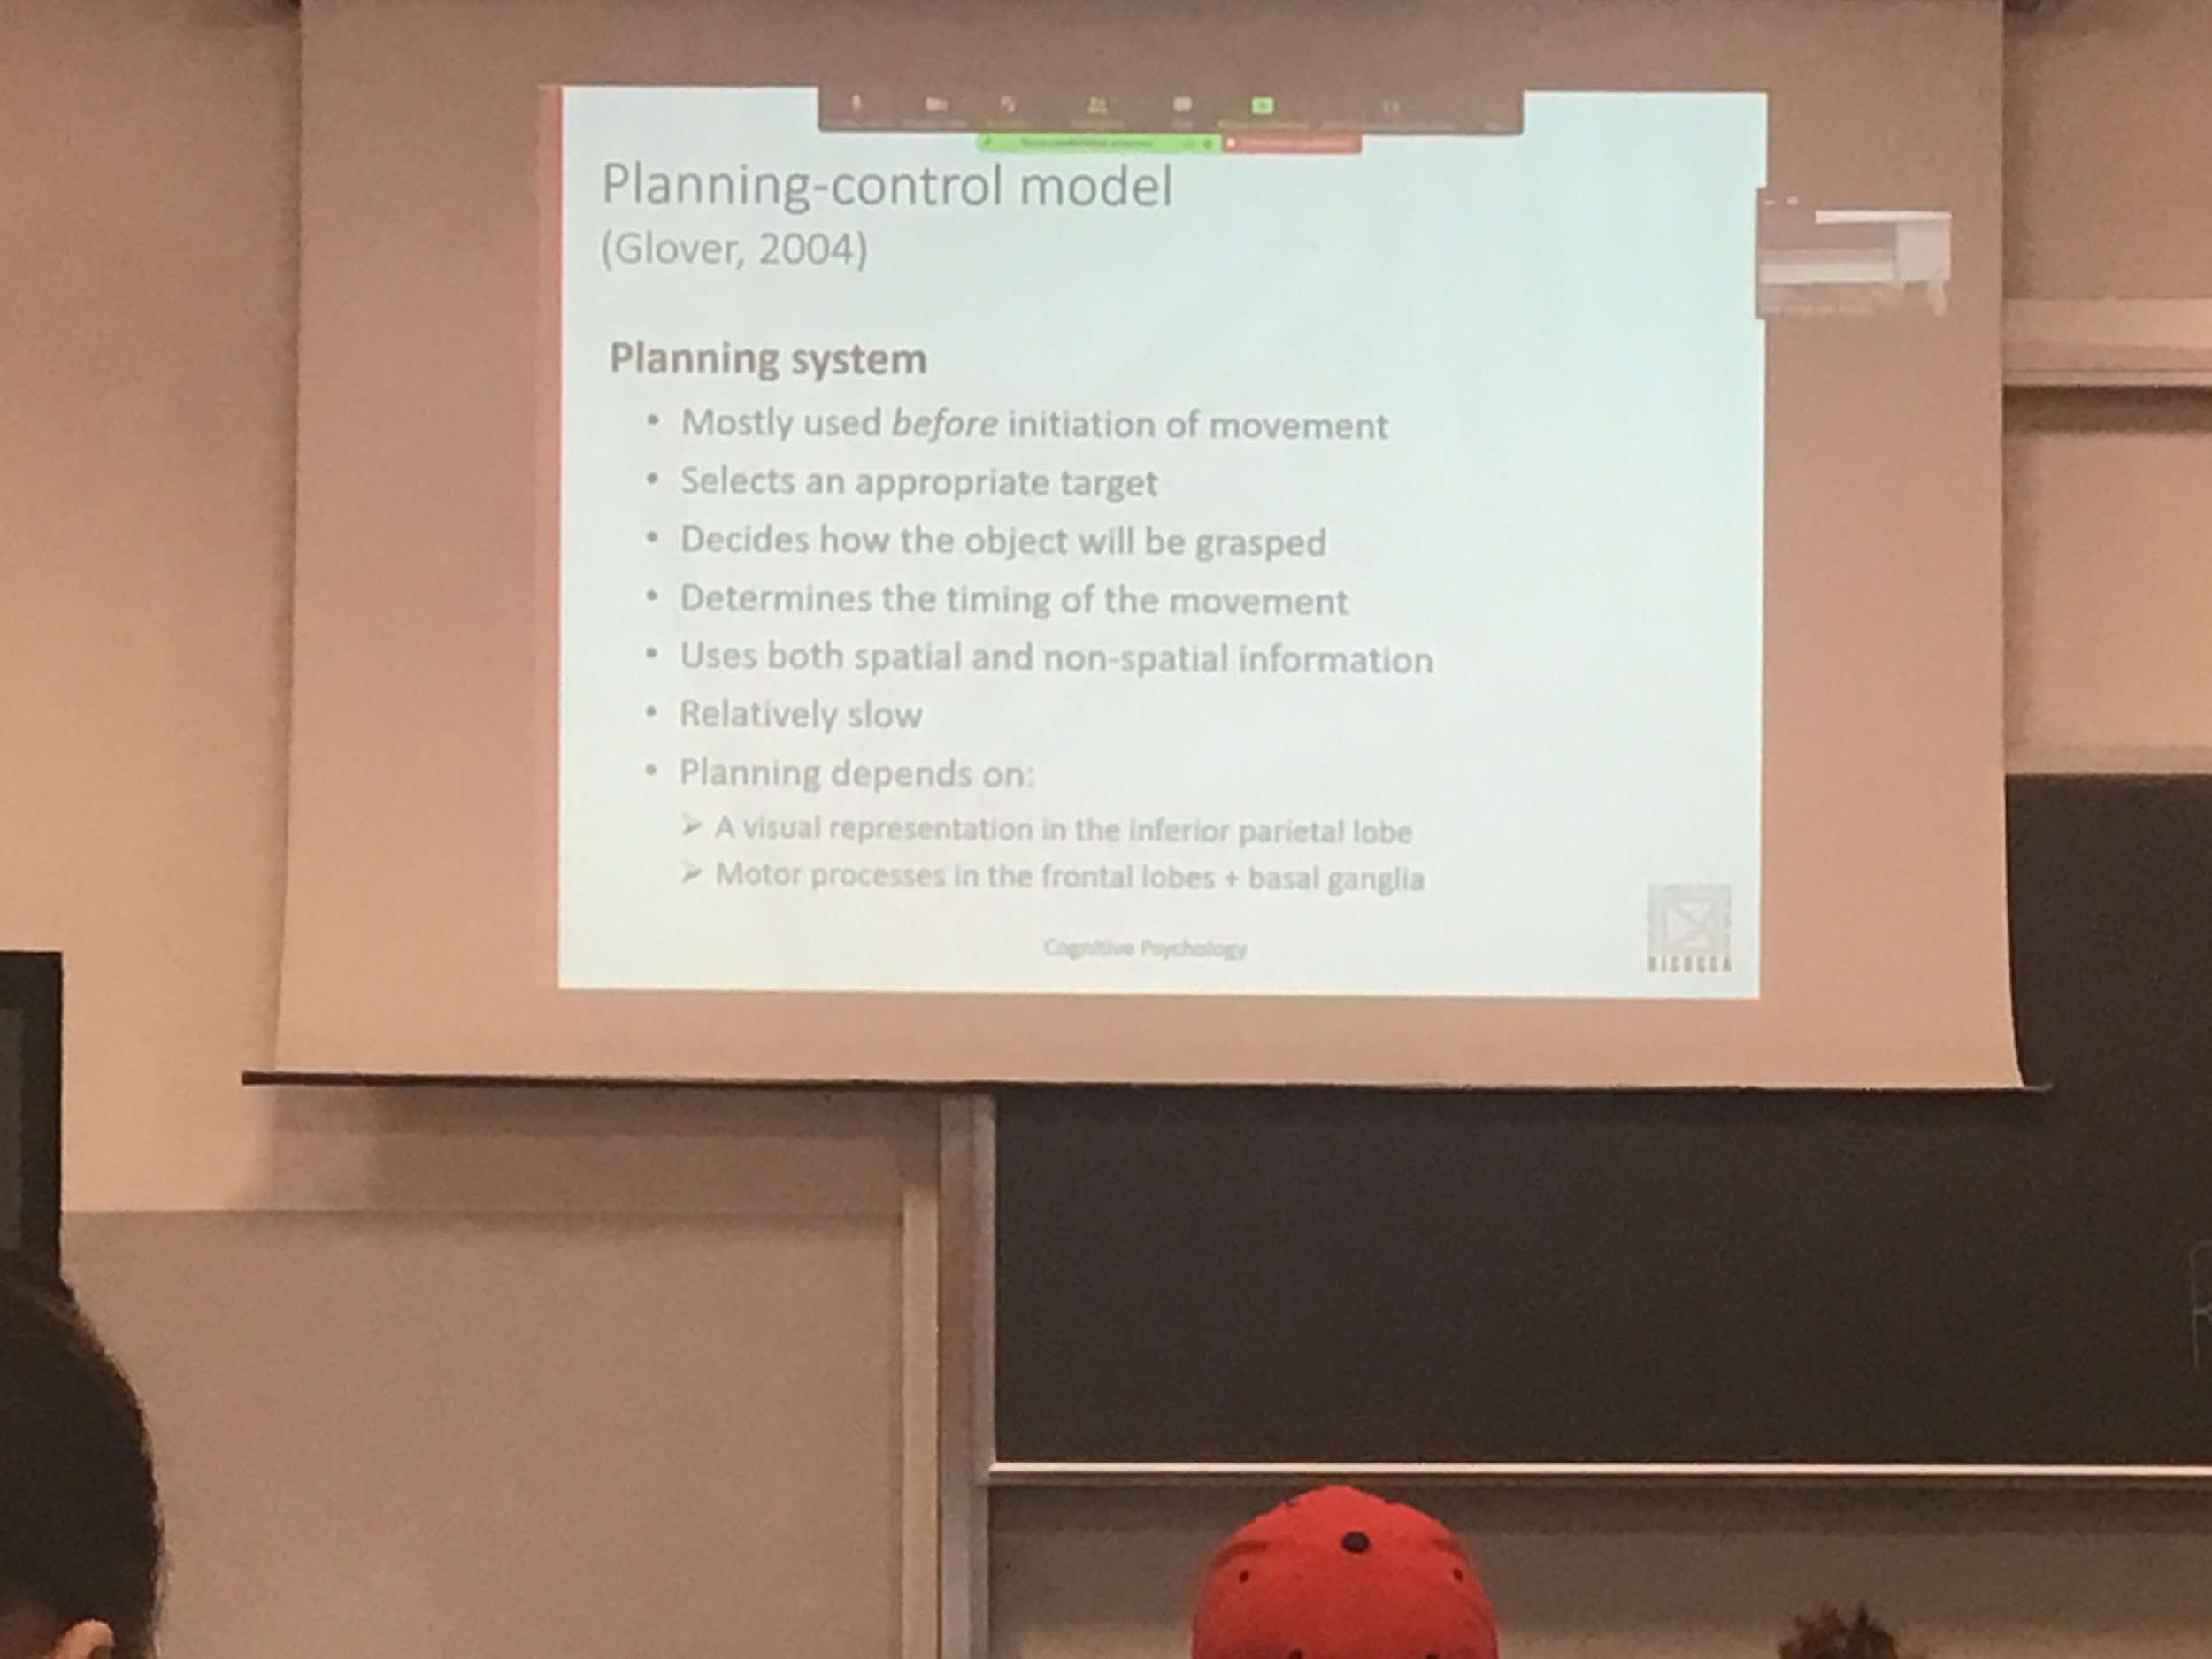

Glover: *Planning-control model*

Each type of movement is done by the system in two steps

Model proposed by glover *palling-control model* each movement is done in two steps

1. Planning, deciding what to do
2. Control, actual perform of the movement and correction of the movement if necessary

Each moment that our muscle perform a movement we need to plan it, what to do with planning decided how to act, how you will grasp the object and how much time you will take to perform that moment

Planning is done before movement initiation

In planning you decide what is your target, what you want to pick up, how to grasp the specific object and how much time you will take to perform that movement

To plan you need spatial information: where the objects are with respect to you. But also non-spatial information, informations about the object you store in memory

The planning system takes a while, depends on visual representation

One of the cases move we made is eye movement, the move is very fast (20ms) but there is is always 100ms to planning

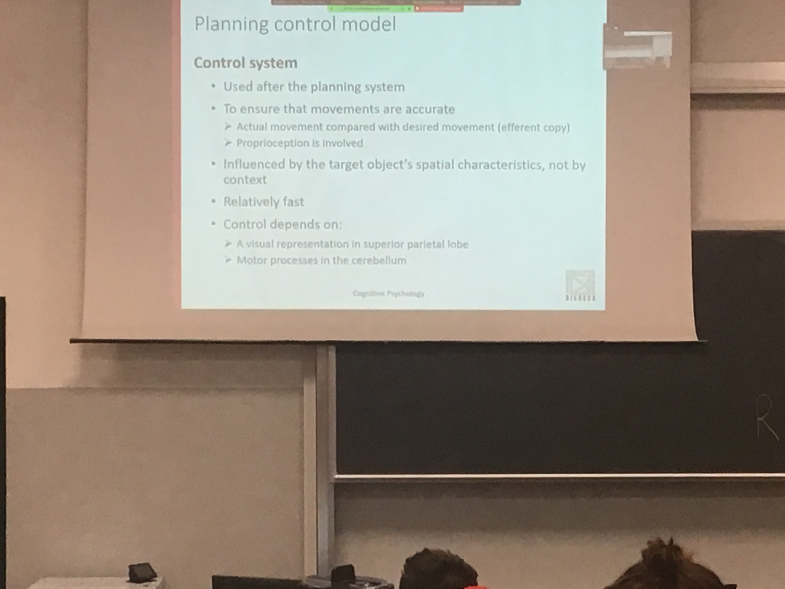

After we have plan the control system come in, the two system can overlap but planning start earlier than controlling

Control the movements we are making and we compare it to what we want to do: control system do a comparison with the efference copy

Proprioception is important: people awareness where your part of the body are, if you move your hand you fill where it is and you understand if your movement was correct

We need the visual representation to have visual feedback of our movement, the motor processes in the cerebellum, outside the brain, old part that commands movement execution

Most errors from the human action come from the planning system

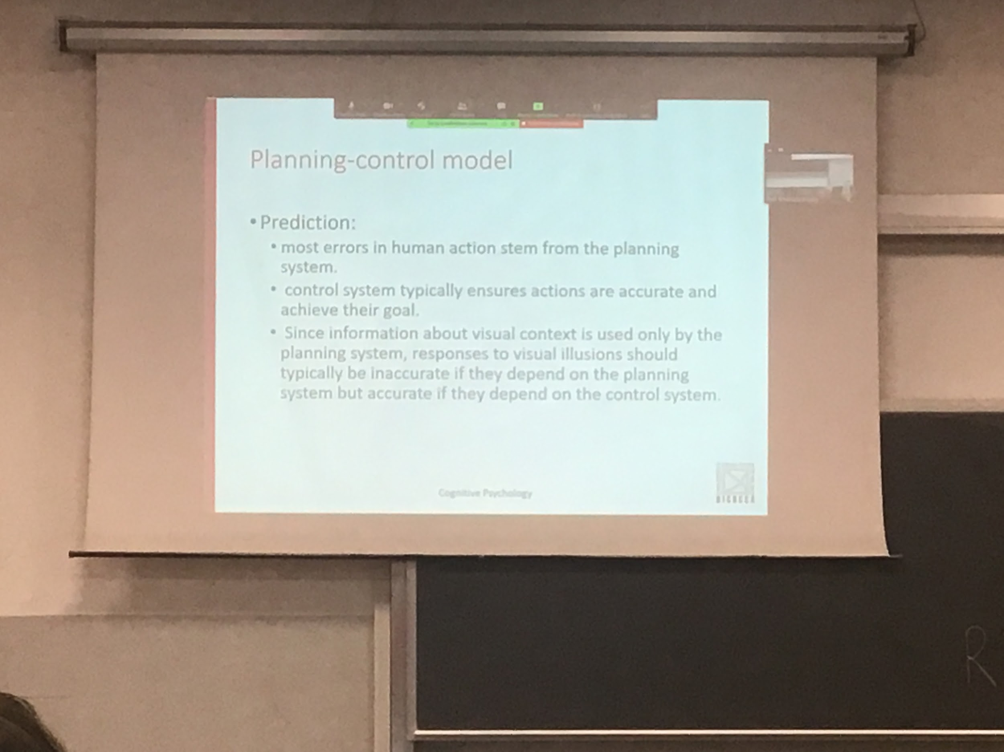

The moment execute by the control system is not so decided earlier, there is continuous update during control

Optical illusion. The response of the visual illusion should be inaccurate if it dependent on the planning system

The planning system perceive the context, intepret incorrectly the size of objects and should not depends on the control system

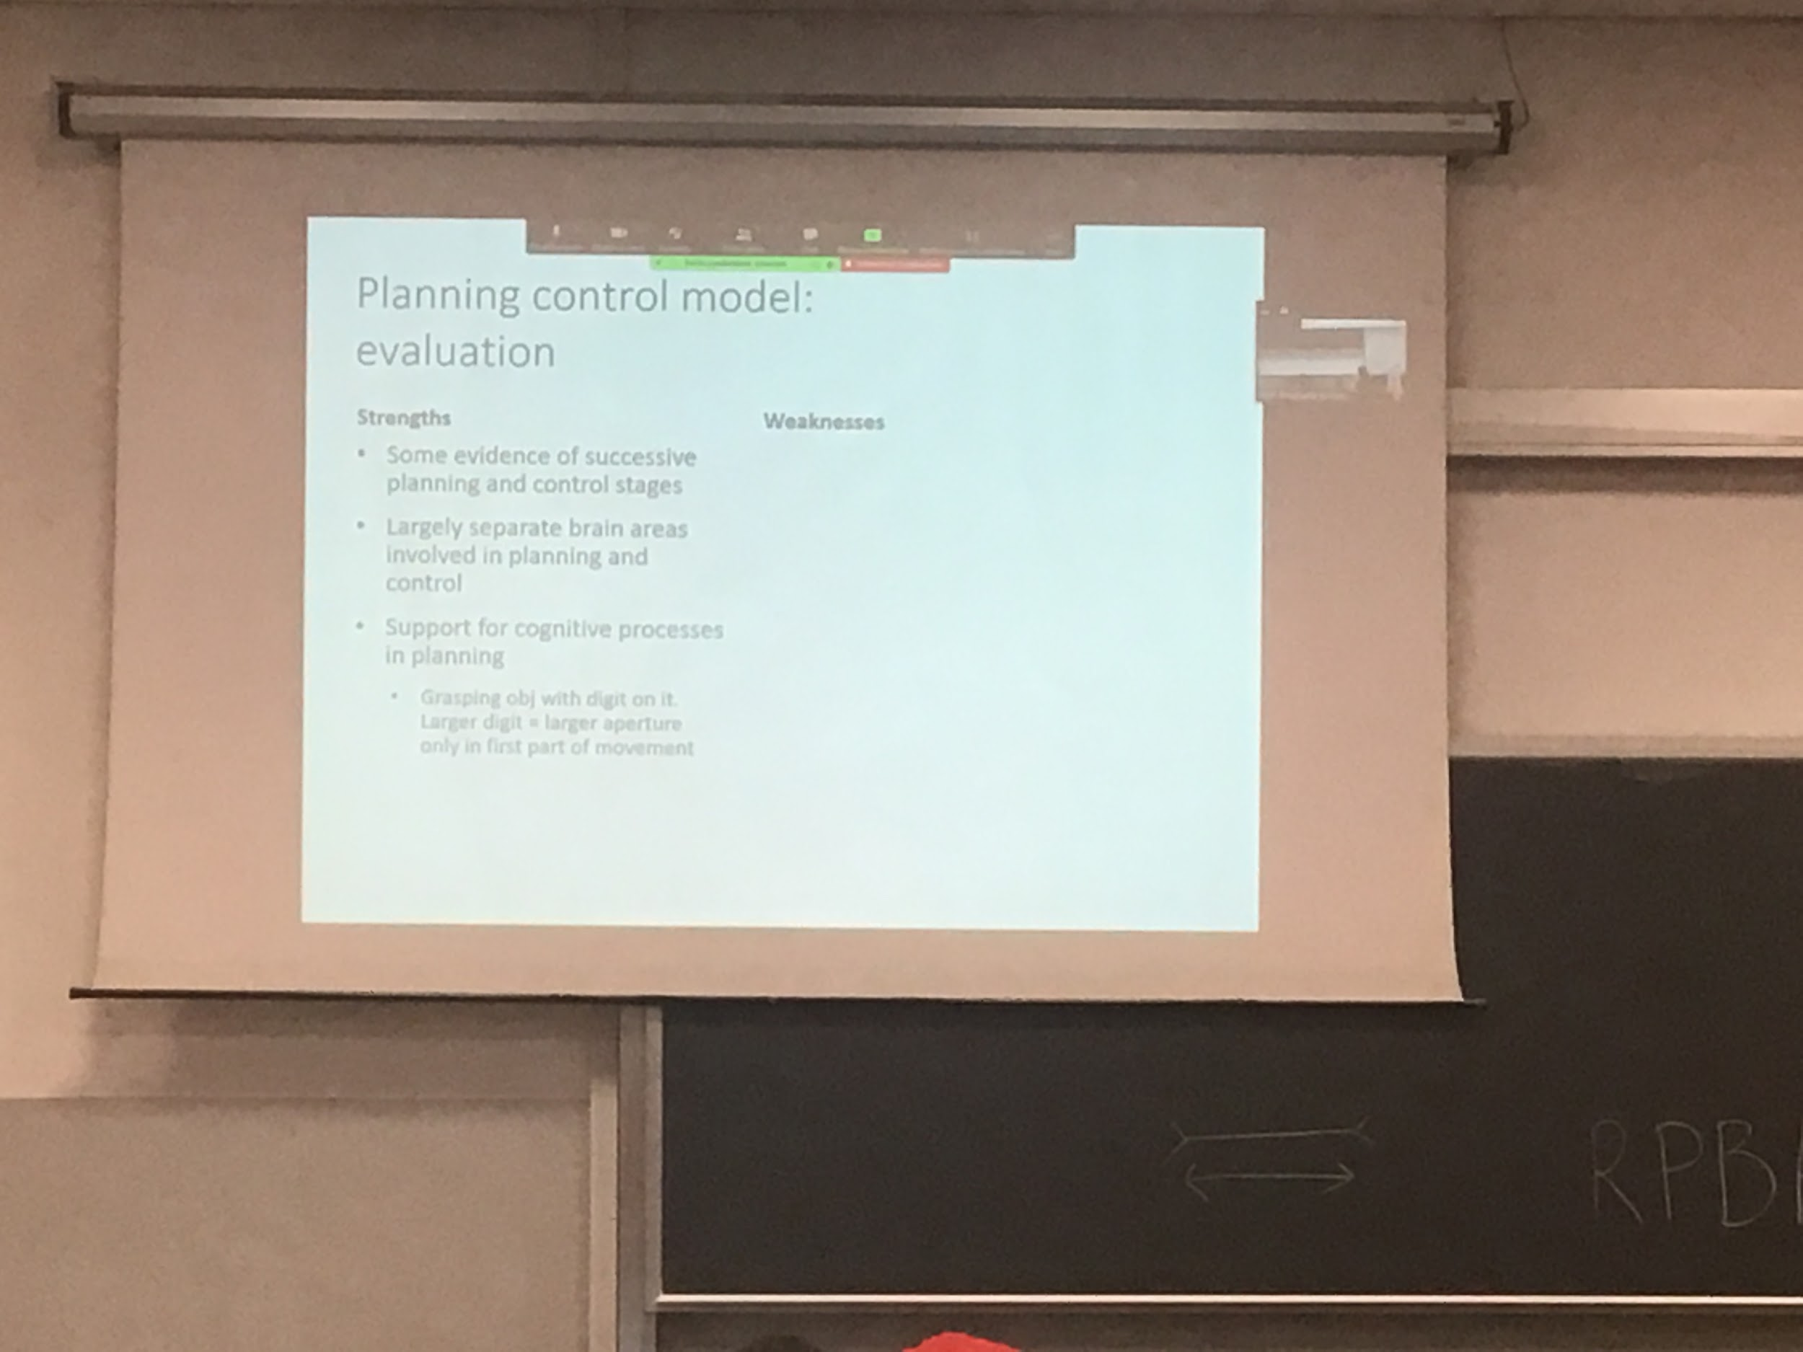

There is evidence of planning and control stages

Evidence that shows that there are separate areas for planning and control, if I ask you to pick up something I can ask you to think to the movement but don’t do it and record activity (related to planning). While if I say to pick it up as fast as you can without thinking that is activity related to control (reduce planning to the minimum)

Influence of cognitive processes in planning:

Planning is influenced by others informations (as cognitive processes) that is not object structure

If I ask to grasp an object and on the object there is a number, usually if I show below 5 you represent the object smaller than what it is and if is more than 5 you think is larger

The is influence of other information that is not exactly the same shape of the object

Some problems with the model

Control does not necessary occurs only at the end of the control phase, sometimes happen earlier

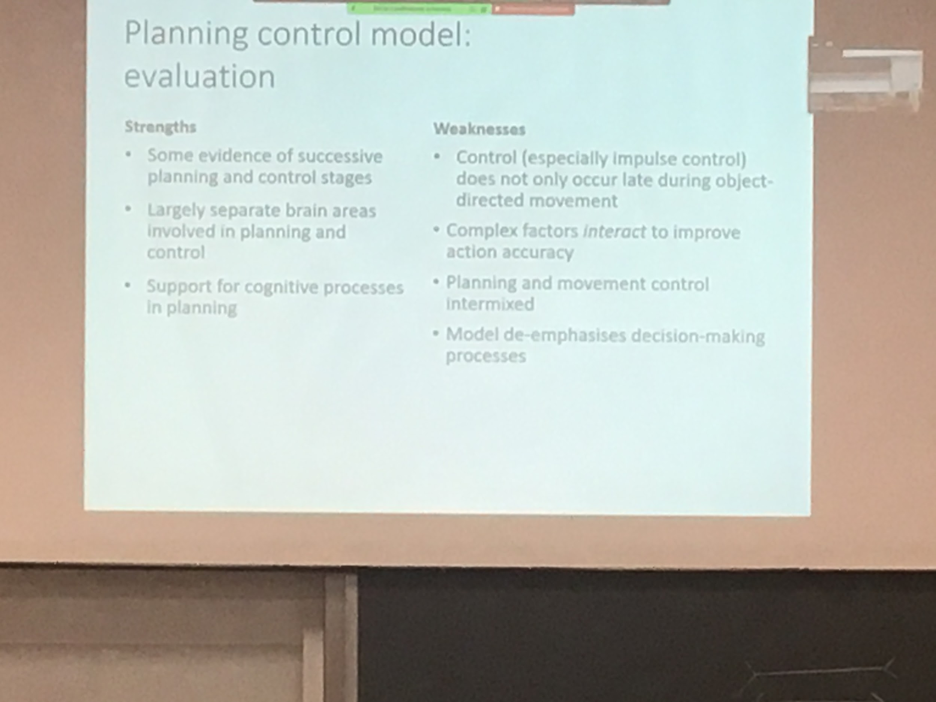

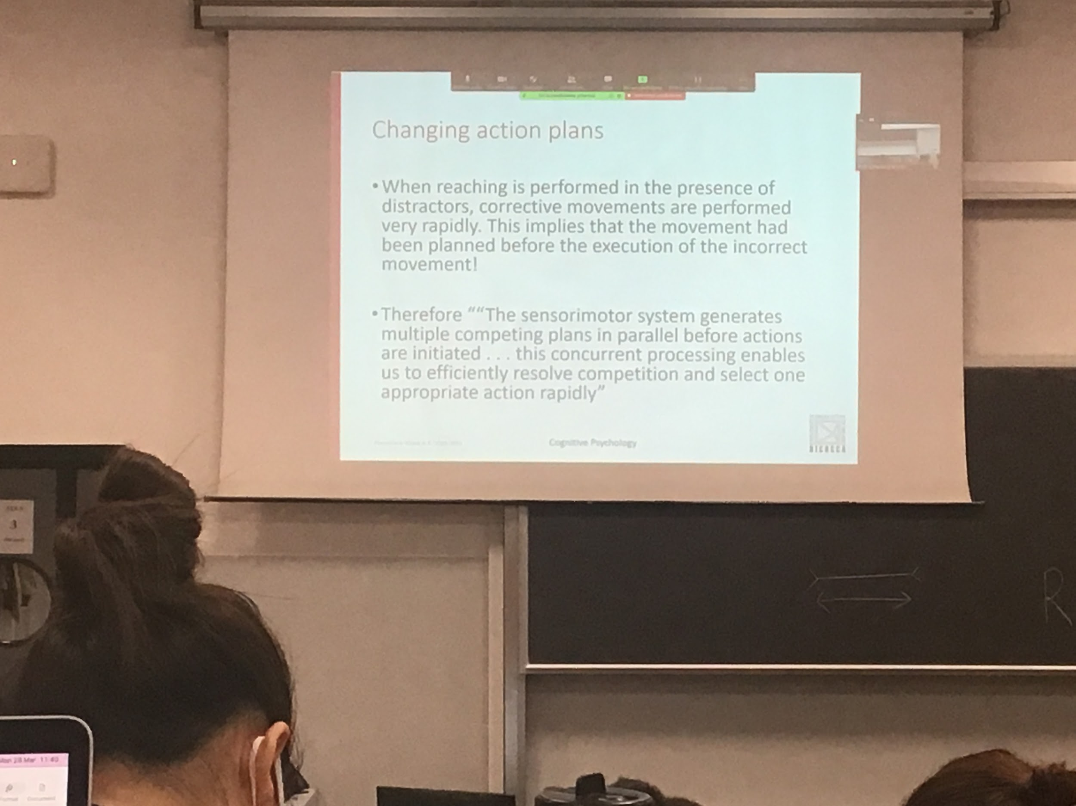

If you have to perform action toward a specific object but you make an error, control realise that the movement is not correct and changing, if actually the command would go back to planning and ask planning to plan a different movement this change would take some time, instead the second movement is done straight away

Hypothesis: the center motion system generates multiple competing plan in parallel before action are initiated, when you have multiple options the plan system plans many possible options and it selects one. But when the one selected is incorrect it can automatically select another one that was already planned

Always there is a plan B, there are always alternative, even in object representation

This planning and action model is modulation is improvement with represent to the original model of miller and (?)

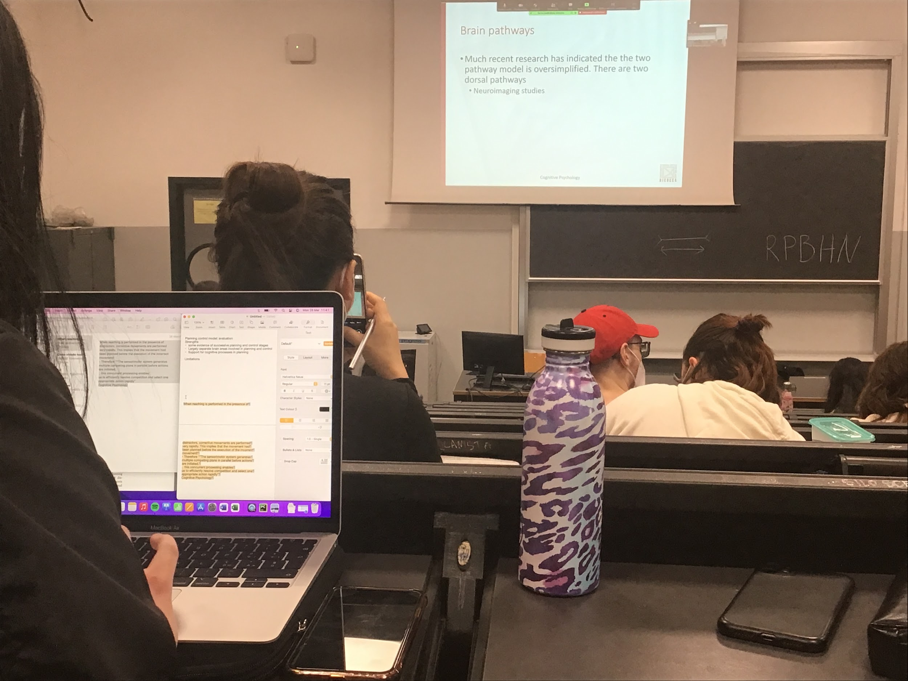

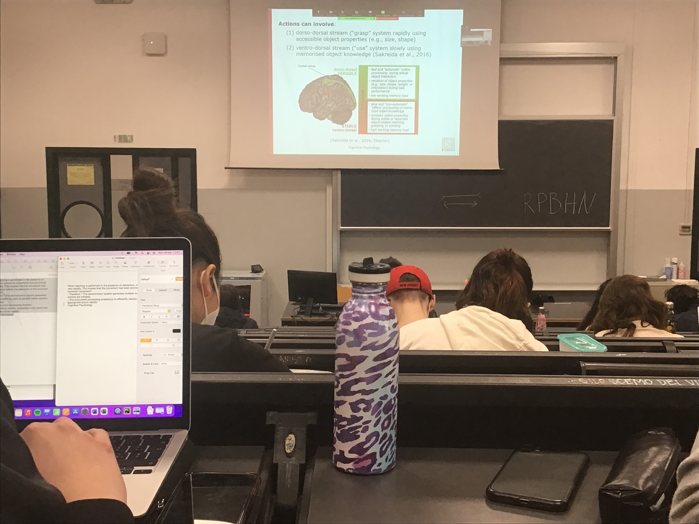

The dorsal pathway is actually not one but two

* dorso-dorsal. Fast and automatic, for grasping system, compute size and shape of an object to compute faster grasping. Fast and aumtatic depends on object properties and requires a low working memory loading, not many resoruces
* Ventro-dorsal. Tell the use of the object, slow

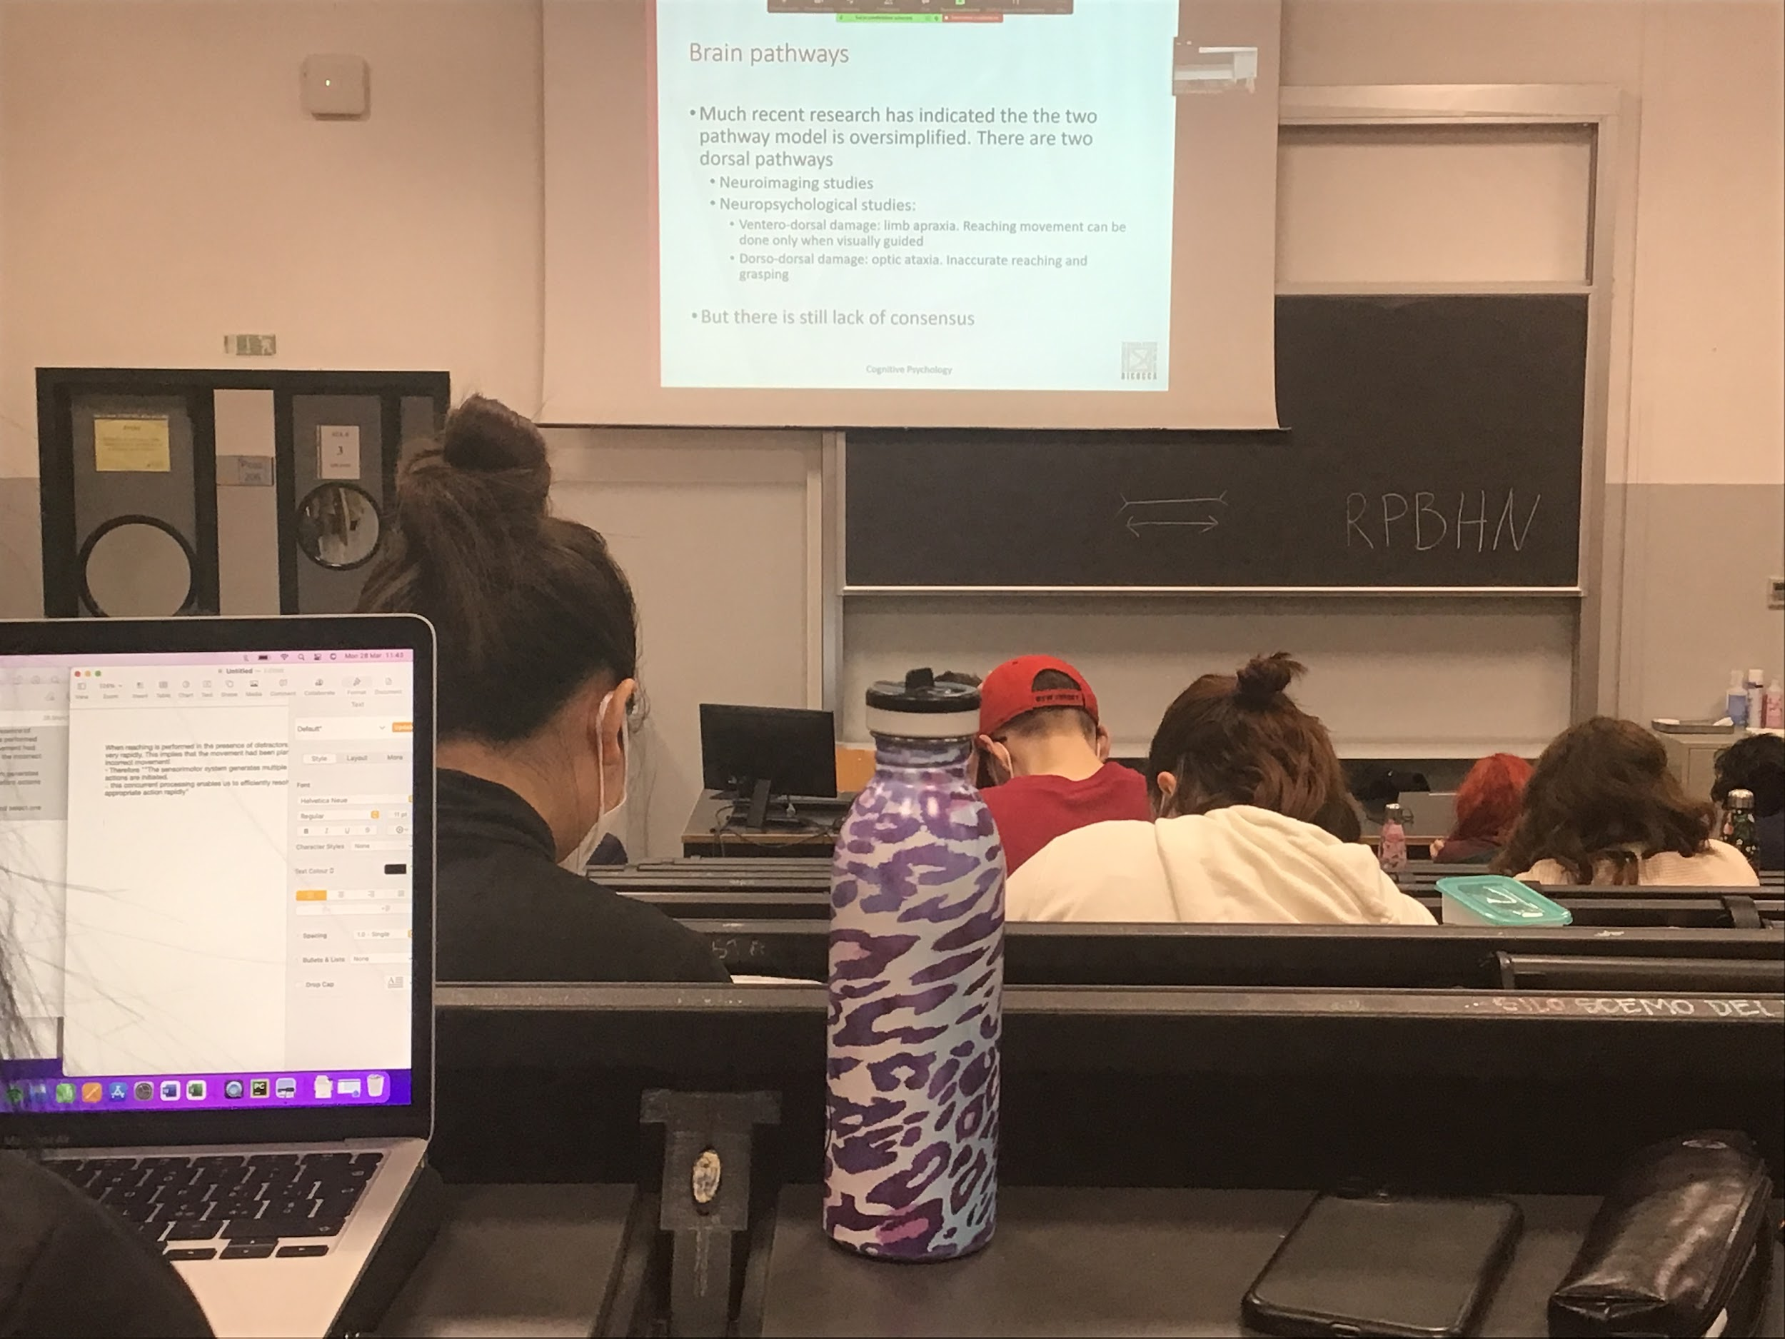

We don’t have 100% that the three roots are great enough

**Motion perception and action**

**Biological motion**

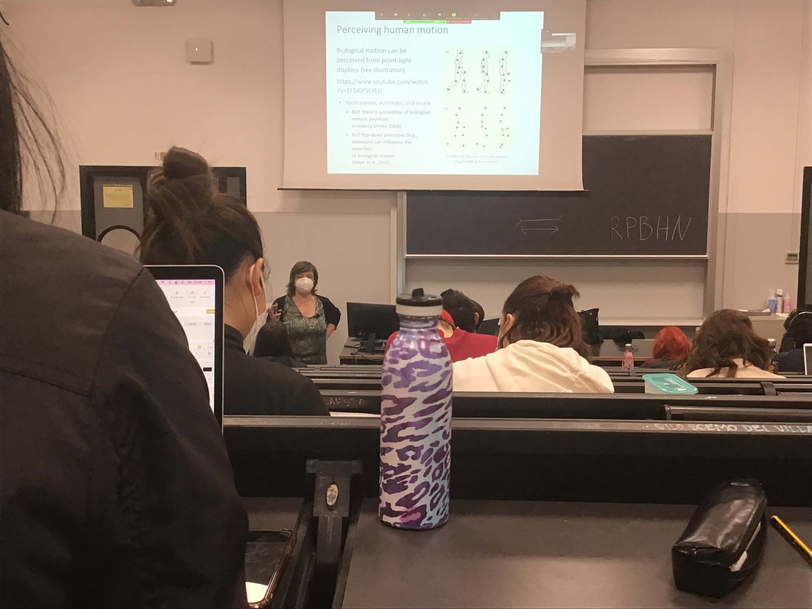

Motion information important to understand how object are in front of us in the environment

A specific motion that is important is biological motion, movement of animals and people

To understand these movement we have to create this place that contains only movement

The study of human motion was done my johannson

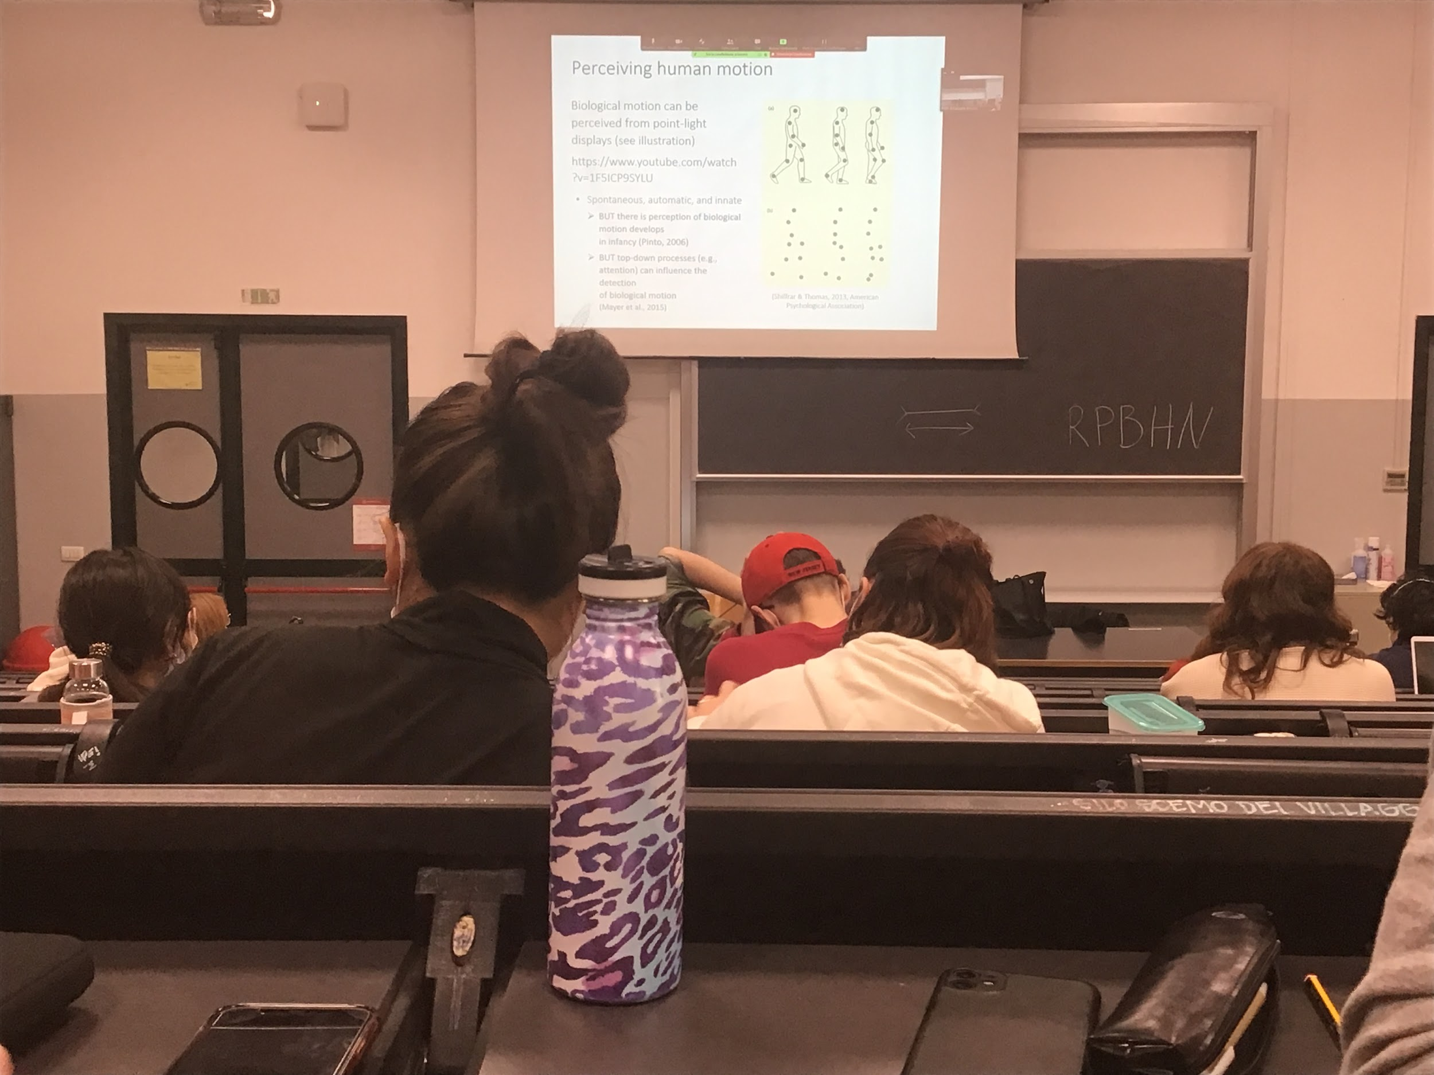

Motion information is computed for the single object but then is grouped differently

With three dots we have the feeling of a body moving, you group the element

With six dots we have a strong impression of body movement

The coding of this structure when it moves have a movement of an animal is spontaneous and done automatically, is innate (if you have newborn and you show them dots that move in a biological way and dots that move randomly, they will prefere the biological movement, able to detect biological movement at birth)

At birth they do not discriminate between different types of biological movement (animals, human…) but after 5 month they can discriminate humans better than the other type of movement

Not completely efficient, good at detecting biological motion but not good at discriminating

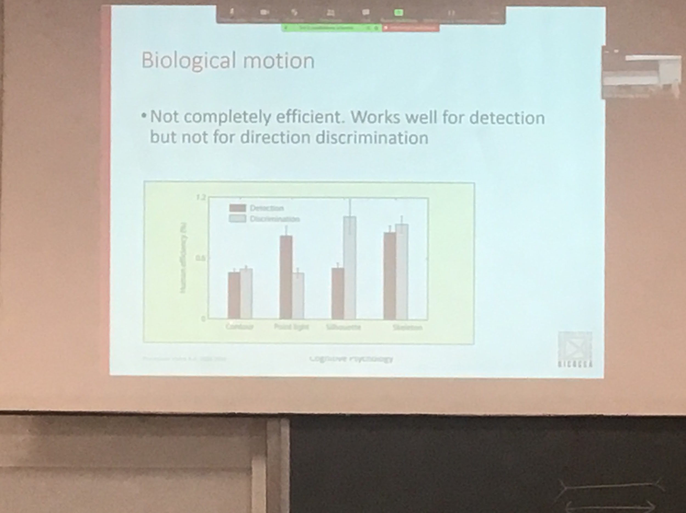

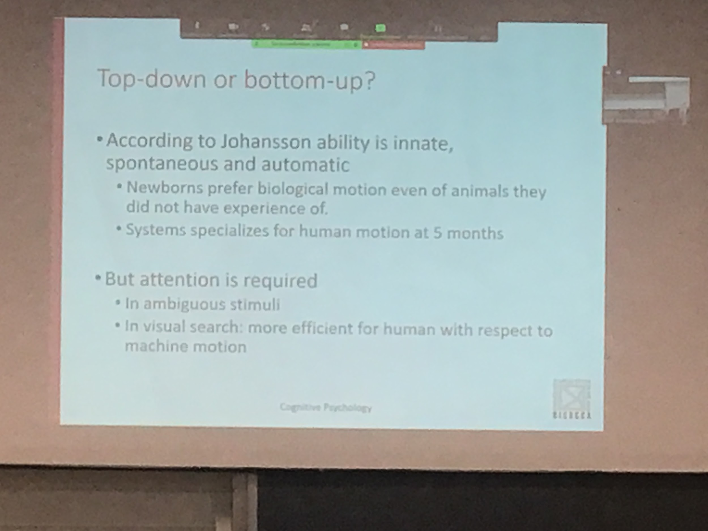

If we use biological motion in visual search task (show many different type of motion and you have to find if one of these motion is biological) your are not perfect but better to discriminate human motion than others

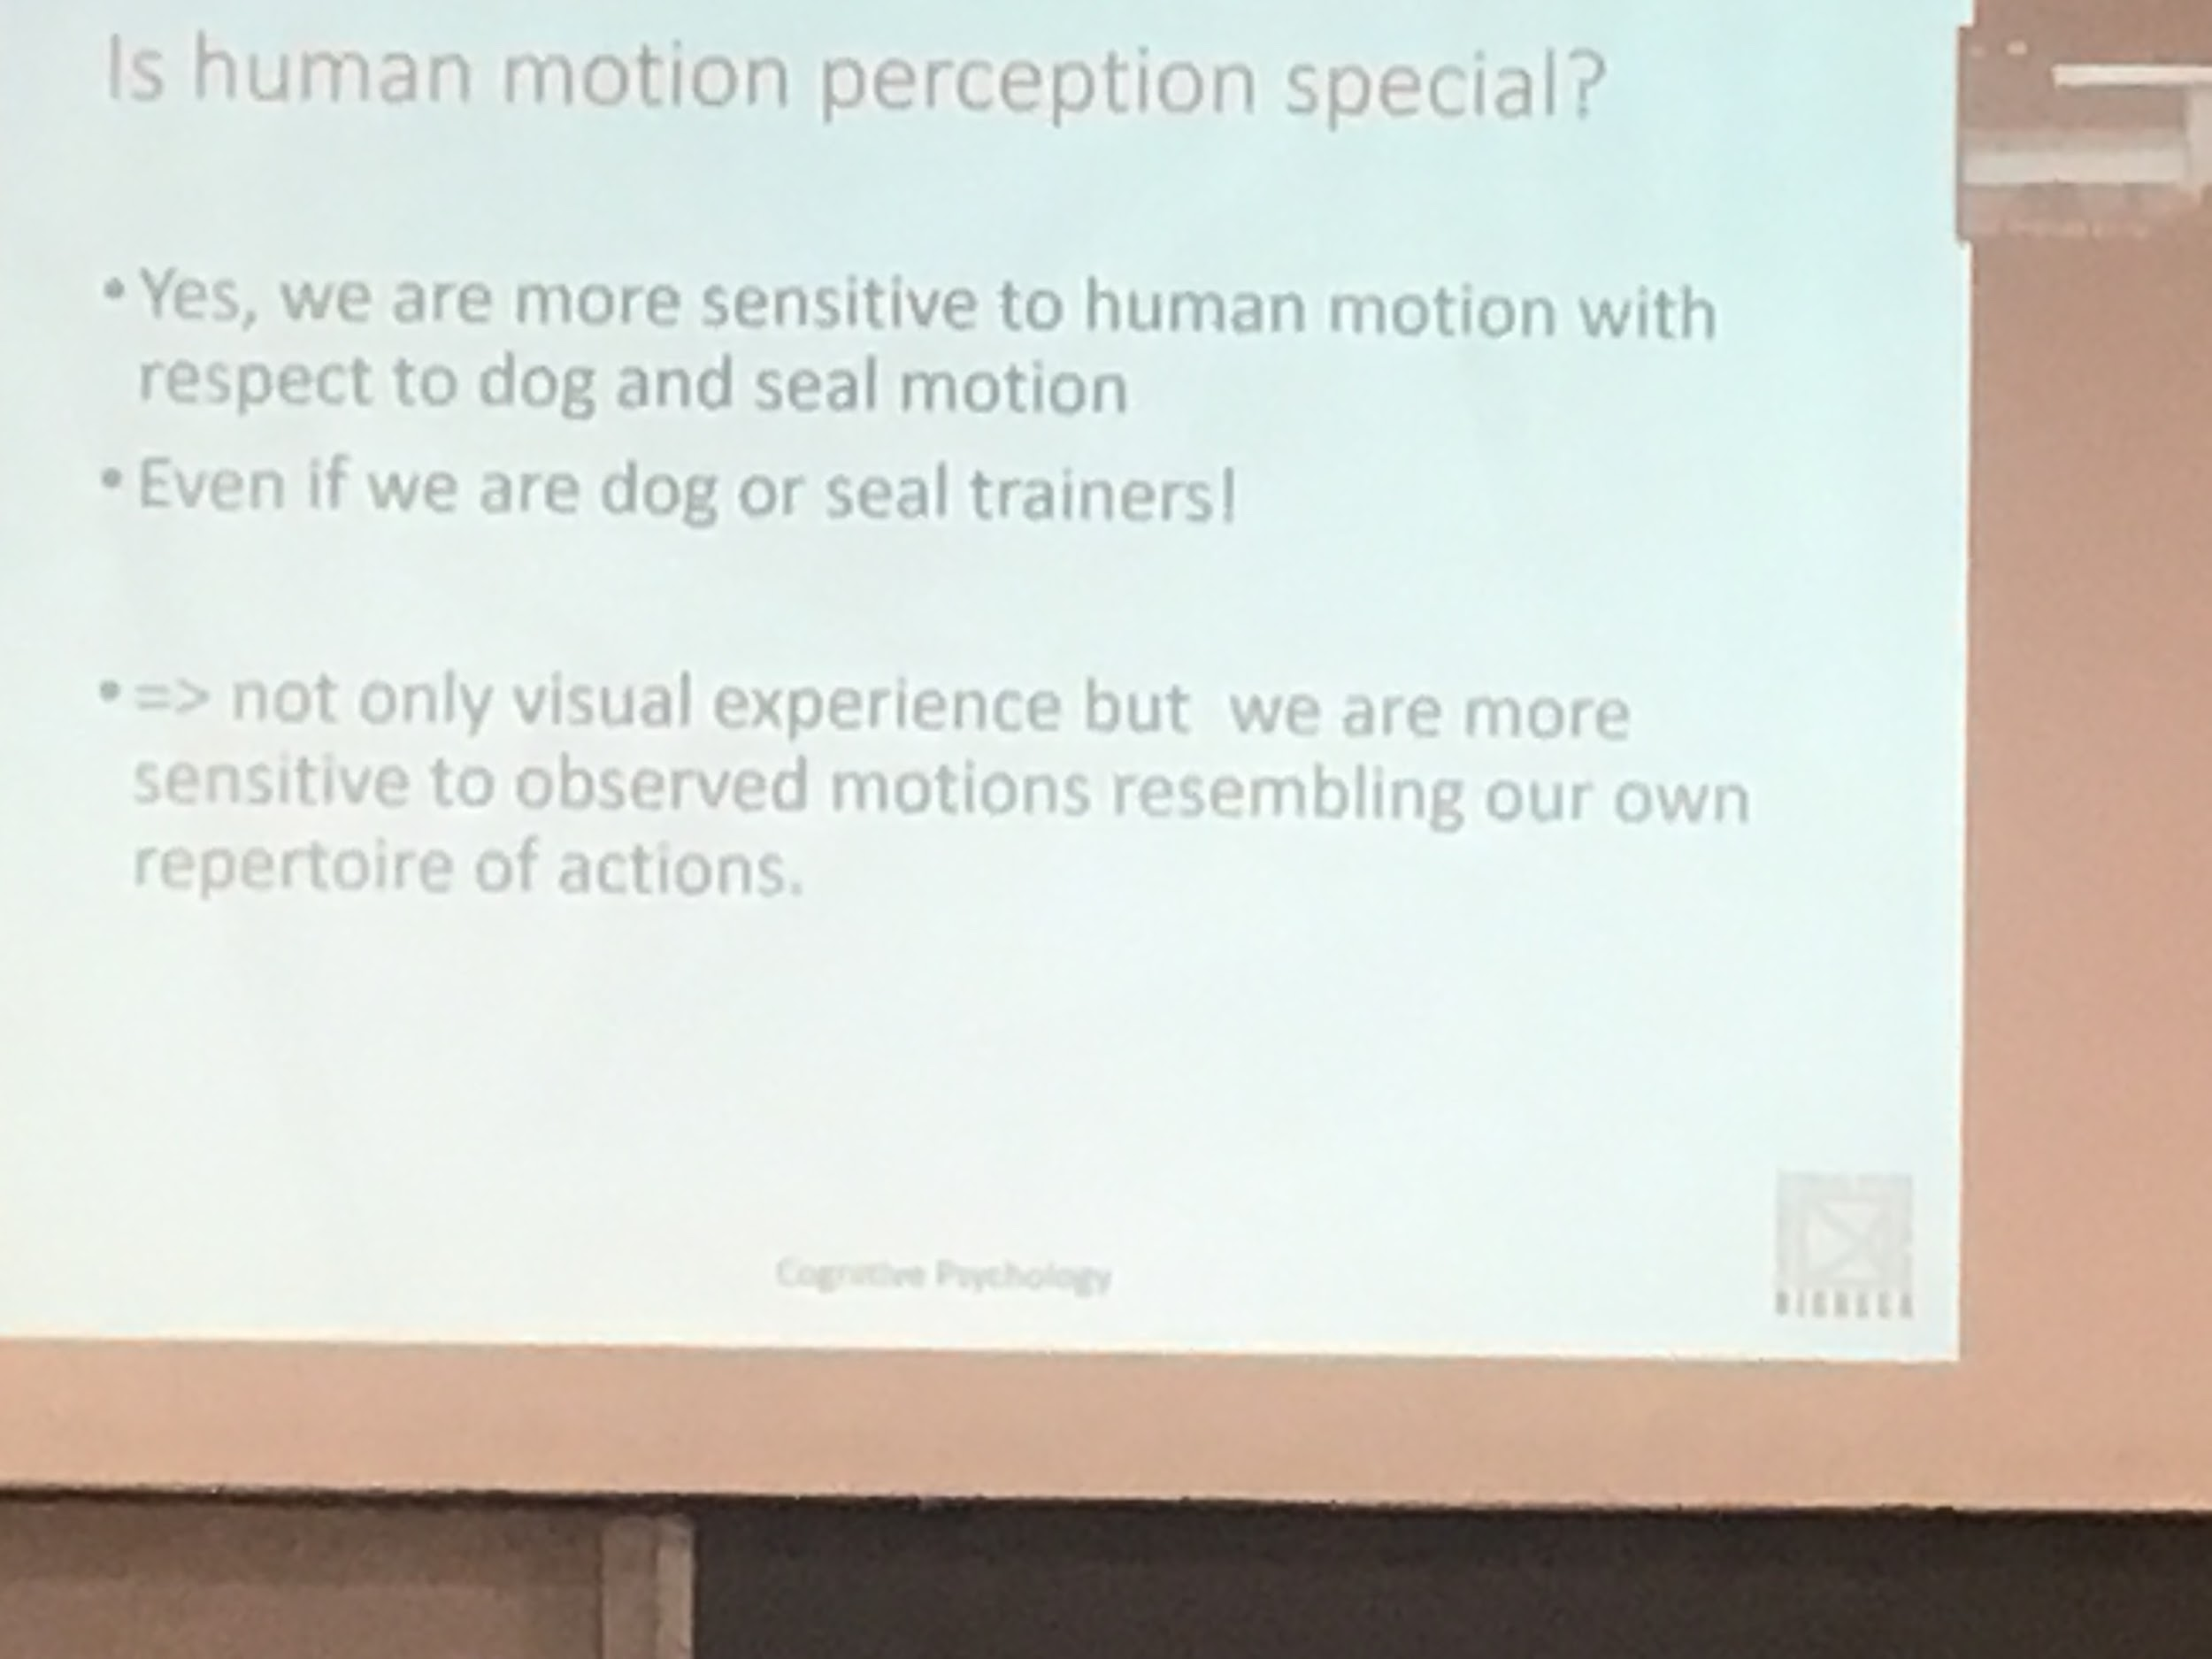

You are better at human motion, but even dog trainers are better in human motion, not experience

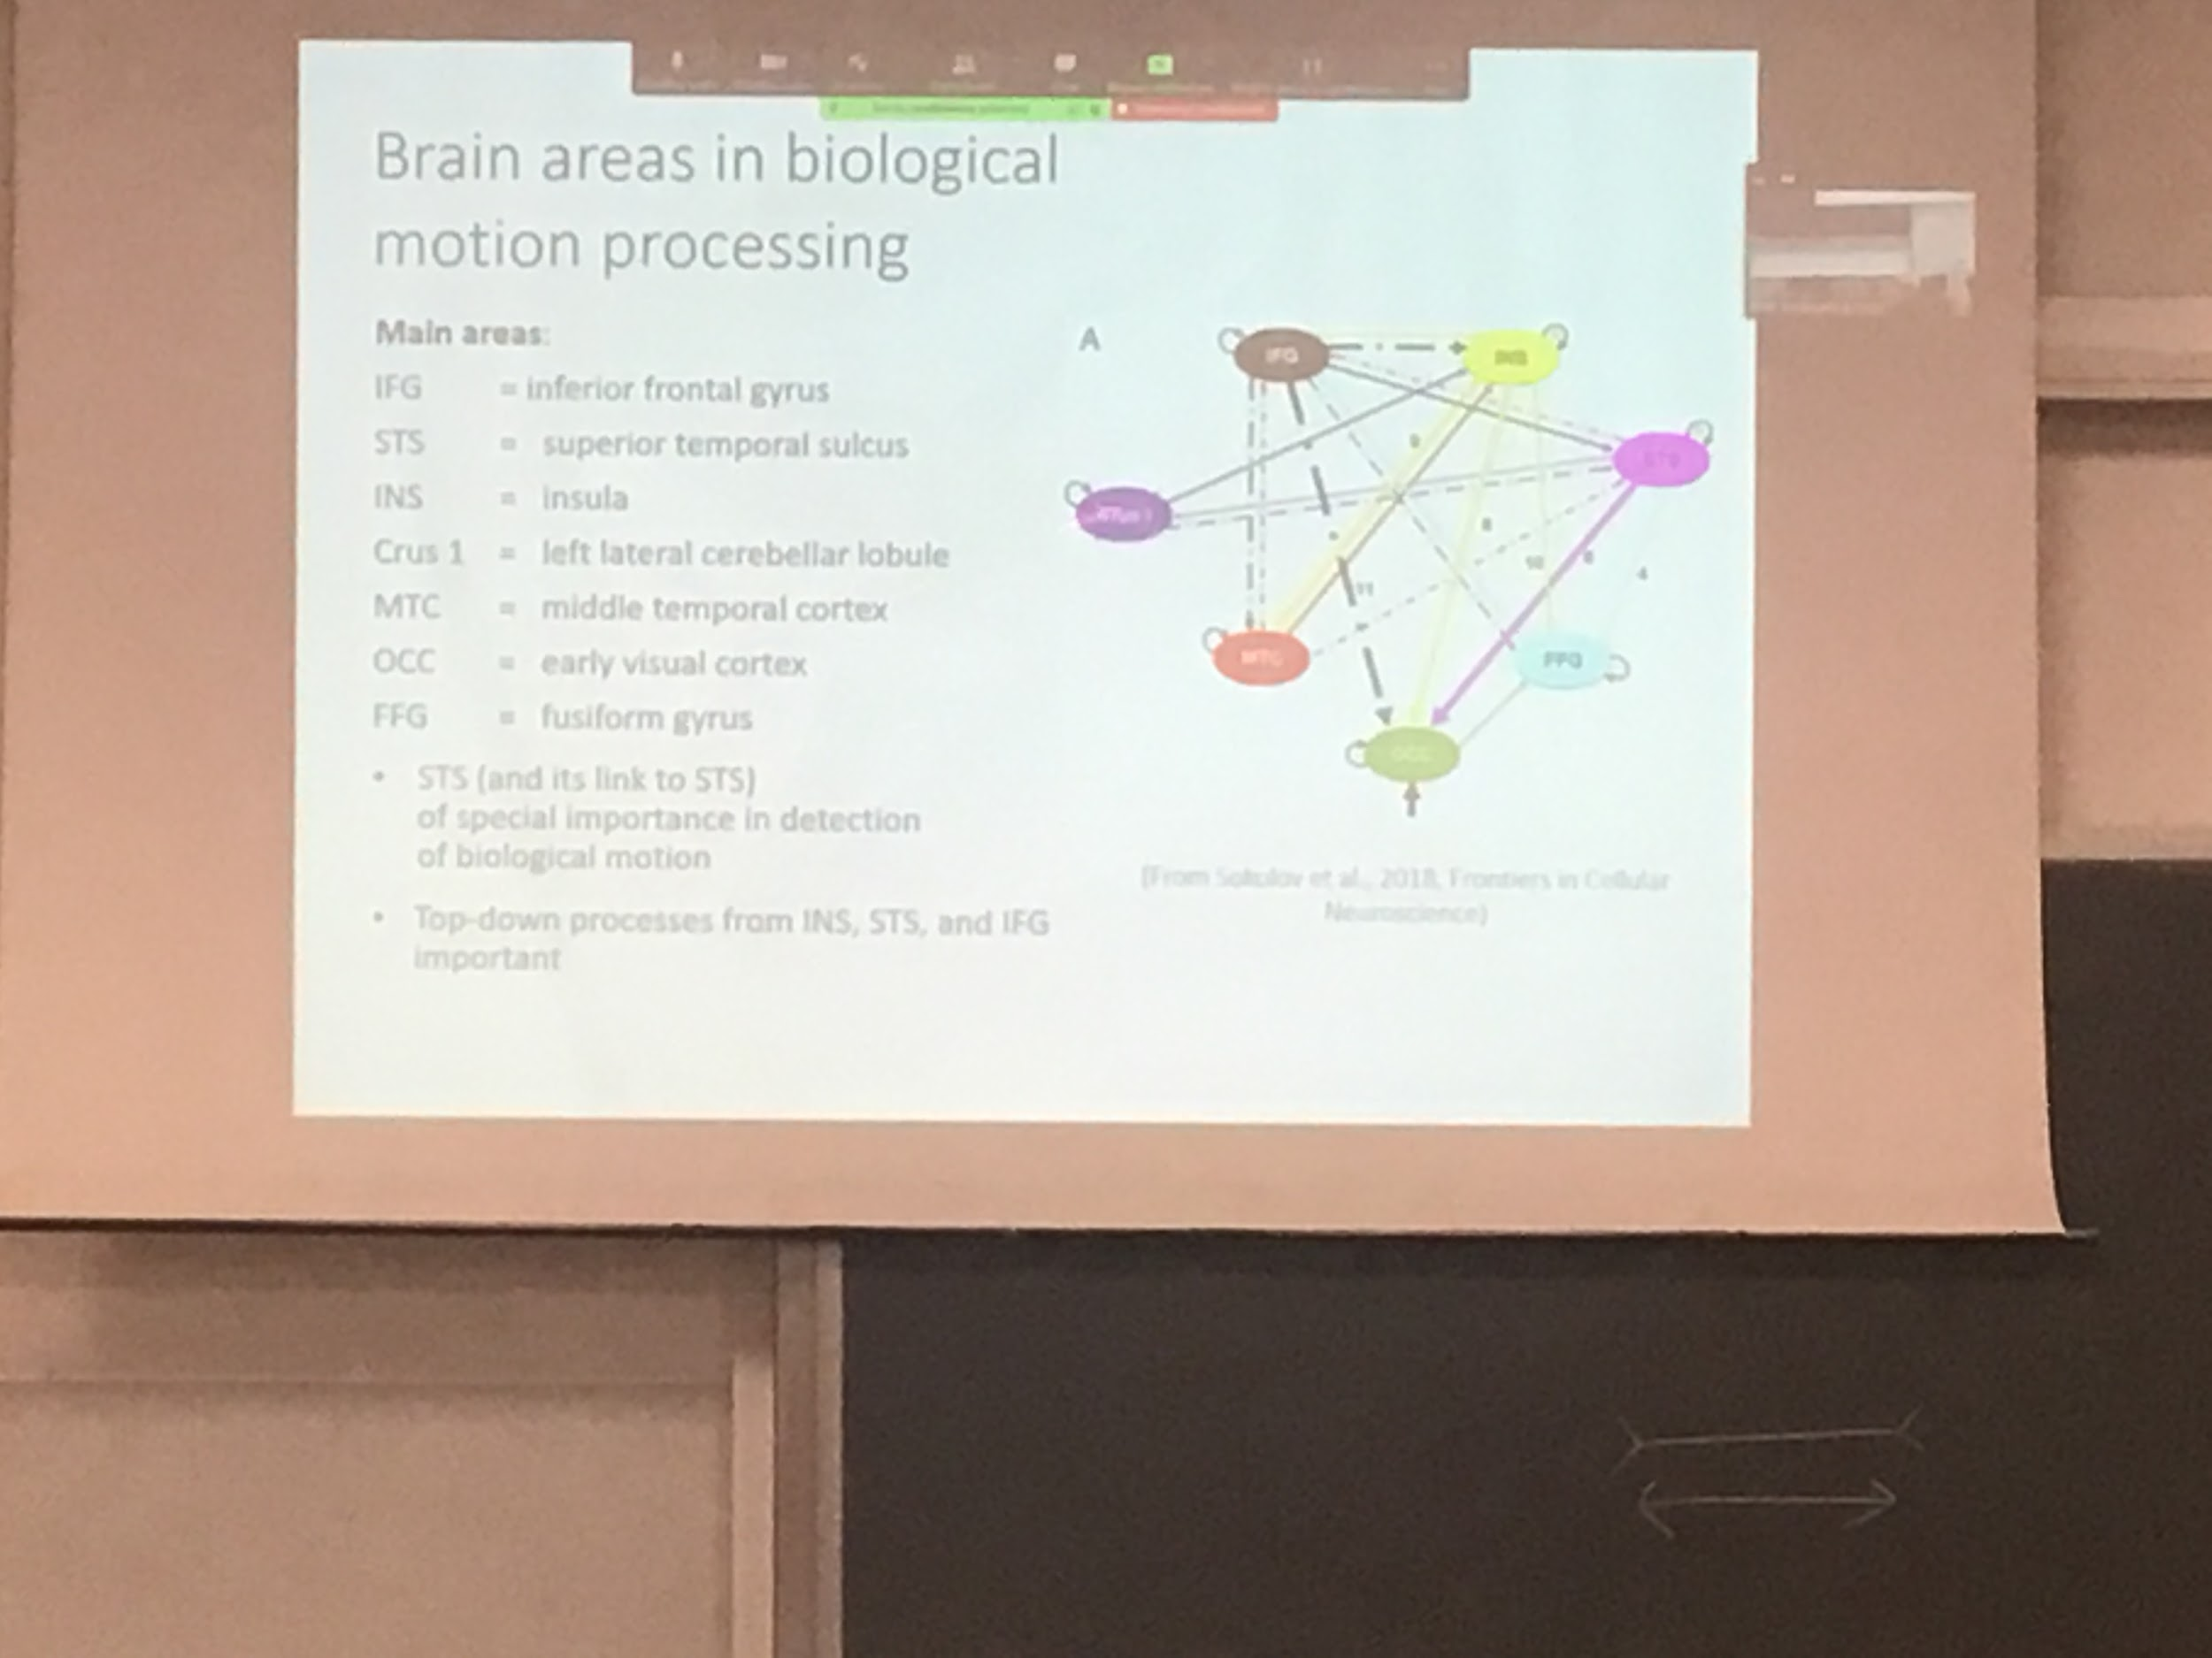

Many areas that interact to detect biological motion

Biological motion is different actual motion

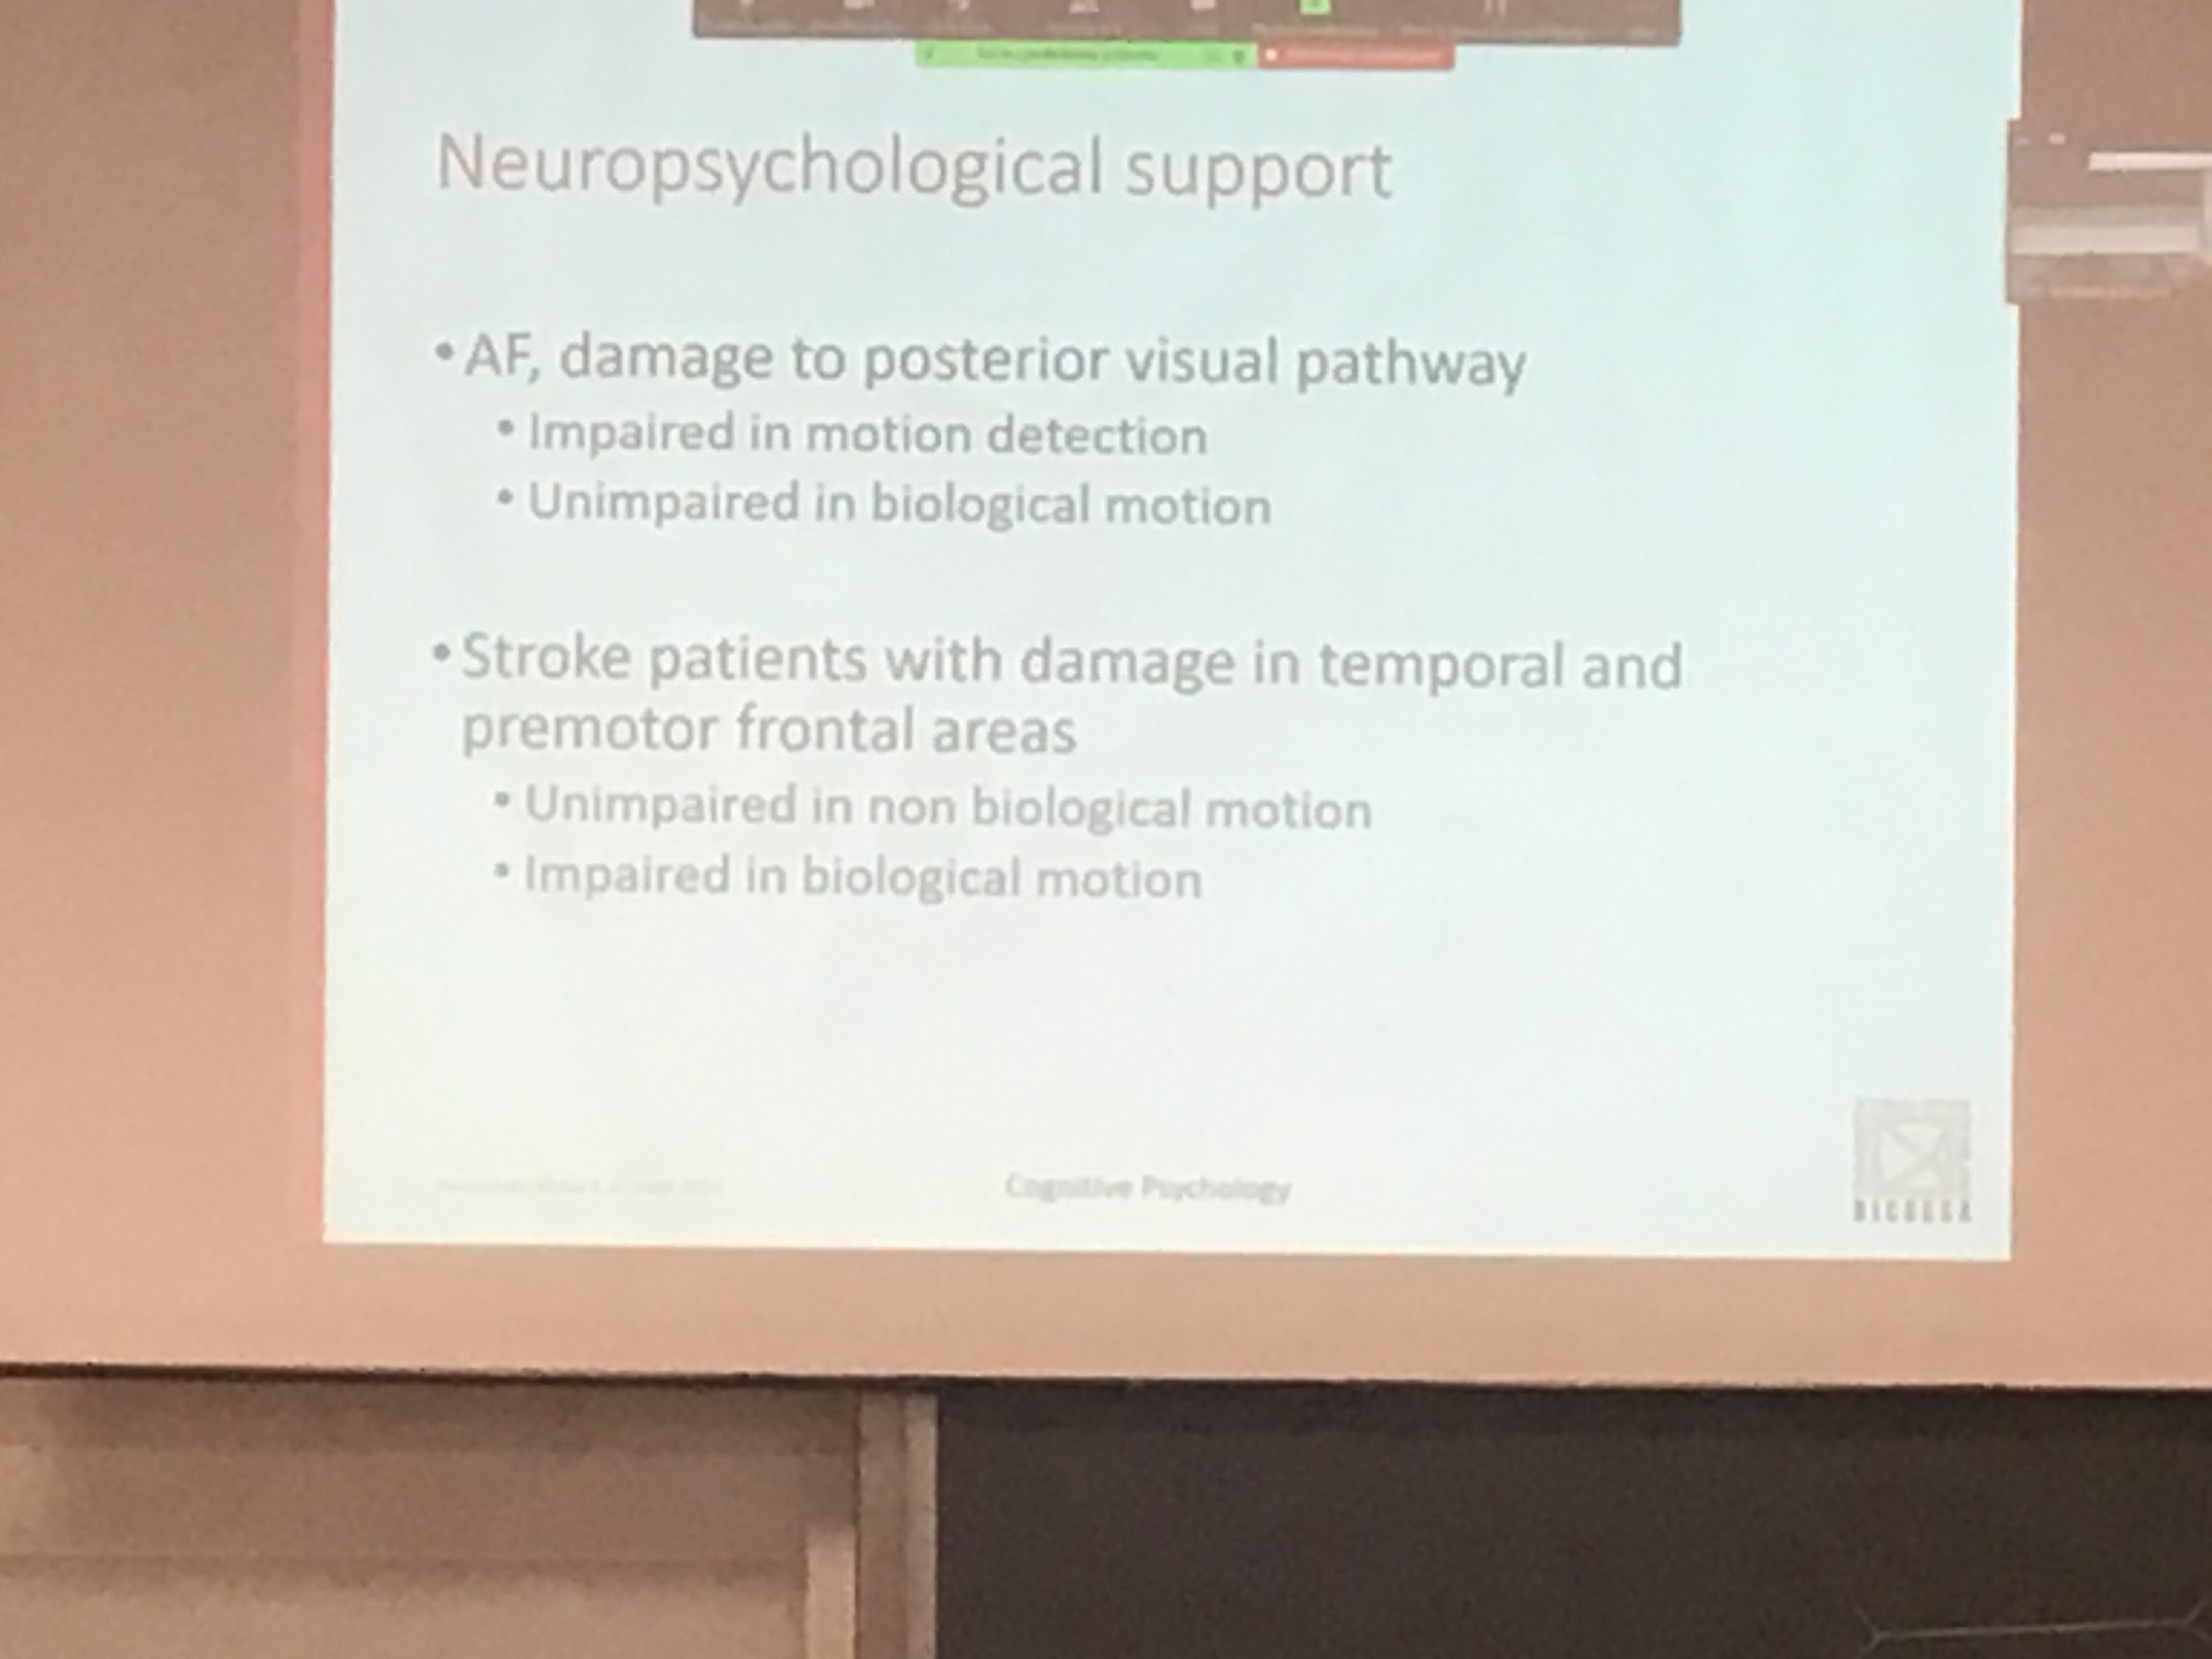

People with impere motion detection but could detect biological motion, while people with different damages have opposite effect

Double dissociation, neuropsychological data support the idea that biological motion is different than standar motion

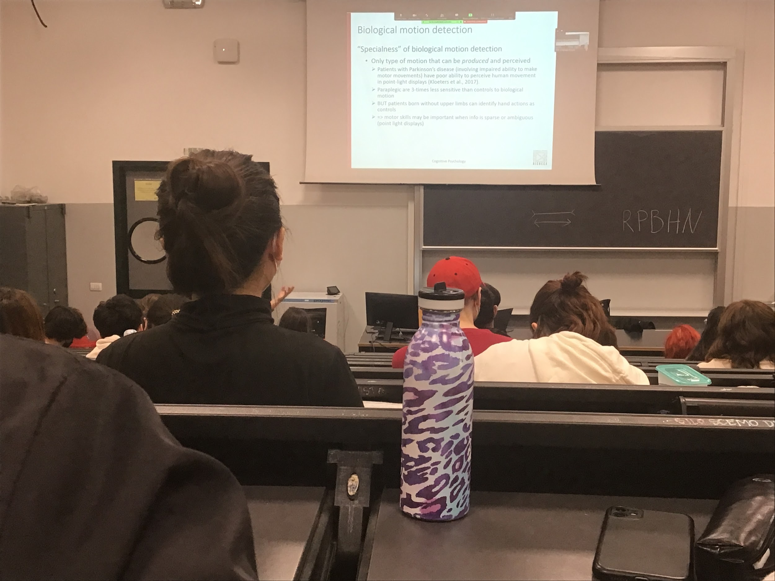

Biological motion is special because is one of the movement that we can perform this type of motion

I can perceive I can detect but I can also perform it